Step 1: Open the link below (press Ctrl and click on the link)
https://claimsdisplay.azurewebsites.net/SAML/

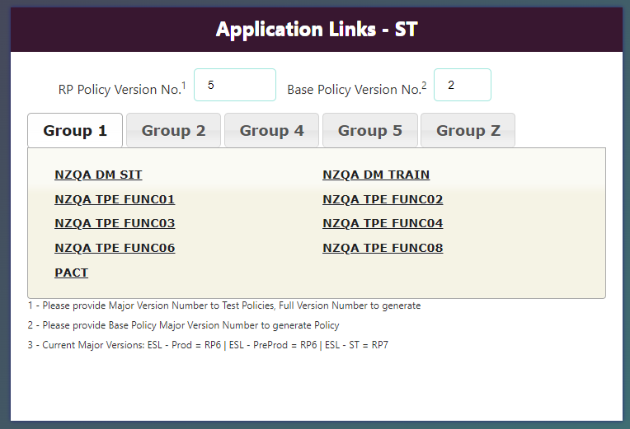
Step 2: Select Prod on top left corner, then Select Group Z
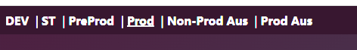

Step 3: Change RP Policy Version No. to 9 (press Tab key after typing) and Click on PUTAKE_NZQALMS application

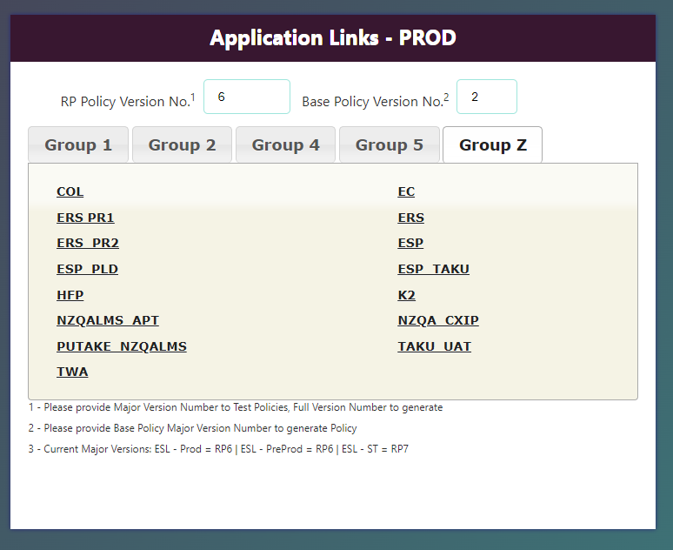

Step 4: You should be able to see ESL login page, put in your ESL username and password
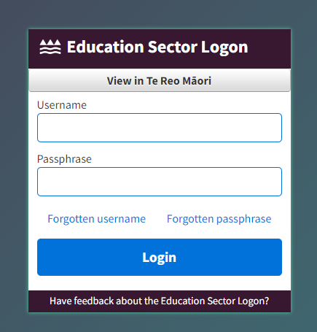

Step 5: You can see your PUTAKE NZQA LMS - ESL login details once you are logged in. Please copy the table and email it back to LMS support team.
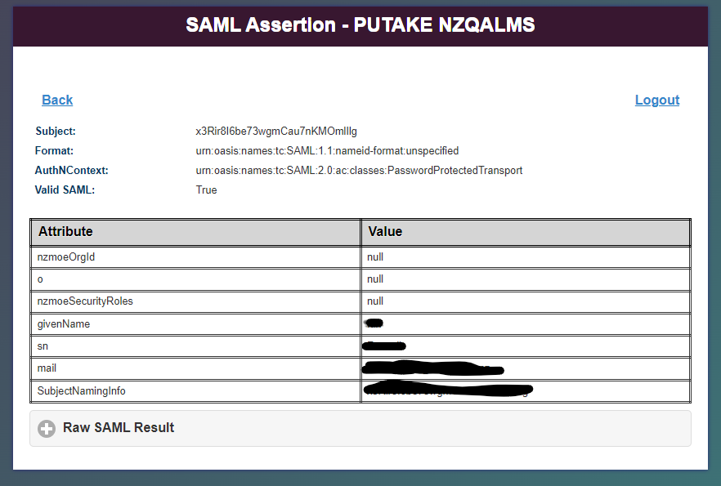

*How to copy a table: Select the table content, press “Ctrl + C” or right click on your mouse, then select Copy

*Open a new Email and paste the table content (press “Ctrl + V” or right click on your mouse and select Paste).

