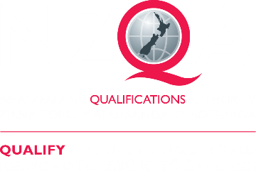

Leading National Assessment seminar

14 June – 1 July 2022

Kaitakawaenga ki te Tumuaki me ngā Pouārahi
Principal’s Nominee and Senior Leaders



Pukapuka Aratohu
Handbook

Contents

Topic | Page
Quality Assurance

School / Kura Quality Assurance | 5
NZQA’s Quality Assurance of school / kura | 12
NCEA Change Programme | 21
Transition arrangements | 23
Implications for assessment practice and assessment leadership | 25
Reminders | 31
Evaluation | 33

Whakataukī


Ehara taku toa i te toa takitahi, engari he toa takitini
Success is not the work of an individual, but the work of many

Quality Assurance of Assessment Practice –

a snapshot of your school / kura

What is Quality Assurance and why is it important?

What do quality assurance processes allow you to do?

How do you know what you need to do?

What does quality assurance look like in your school / kura?

What works well? What could work better?
Prepare for the opportunity to share your school / kura practice

Quality Assurance of Assessment Practice

What is quality assurance and why is it important?
Checking compliance and quality
Systemic overview and review of systems and processes, and ongoing improvement
Internal moderation processes – verification
Evaluation AND?.....

What do quality assurance processes allow your School/Kura to do?
Meet the requirements of the Consent to Assess – keep to the Rules
Ensure students / ākonga get credible assessment opportunities and outcomes and are treated fairly
Tailor your support strategies
Adjust your focus on what needs to be improved, boost your students’ / ākonga and teachers’ / kaiako motivation
Better planning of assessments
Consistently conduct assessments in line with school / kura guidelines
Make sound assessor judgements and provide useful feedback to students / ākonga
Keep accurate records of all assessments
Review practices to contribute to continuous improvement
Make evidence-based judgements
Foster teacher reflection and development
Set strategic direction for departments, school / kura, assessment practice, Kāhui Ako….
AND?.....

How do we know what we need to do?
School / kura Quality Management System Document (QMS), CAAS
NZQA website - MythBusters
School / kura assessment and moderation processes and practices
NZQA assessment and moderation requirements e.g. Assessment Rules based on CAAS
These seminars and other resources
Visits and MNA reports AND?.....

What does it look like in your school / kura?
Monitoring what is happening
Building everyone’s assessment literacy – staff, students / ākonga, whānau
Keeping up-to-date evidence
Meetings with line managers
Department review and defense of the review
Data analysis and goal setting AND?.....

What works well? What could work better?
Good Head of Department discussions  Shared understanding of authenticity  Keeping communications consistent  Upskilling new staff on processes  SLT understanding and support  AND?..... | Everybody checking the accuracy of results  Every teacher following storage requirements  Better alignment between school and department goals and analysis  External moderation follow-up  AND?.....

NZQA’s quality assurance priority: Ensure the credibility of the NCEA qualification, and ensure that assessment is fair, valid, and equitable for all learners.
School / Kura Quality Management Systems -
Maintaining consent to assess for schools / kura

Guide to Requirements for Consent to Assess for Schools – March 2021, page 3

In order to maintain consent to assess, a school must meet the requirements of the rules in section 13 of the Consent to Assess Rules by:

- continuing to maintain, and comply with, the quality management system (see Parts C and D of this document) ....

Examples of failure to meet the requirements of the consent to assess might include, but are not limited to:
- failure to establish a rigorous internal moderation process
- failure to monitor moderation processes and/or act on issues that arise from internal or external moderation
- failure to submit materials for external moderation by the submission date
- failure to include the required material for external moderation
- repeated submission of invalid or incomplete assessment materials for external moderation
- failure to address the identified actions set out in a Managing National Assessment (MNA) report within a reasonable timeframe
- refusal to submit to or not adequately facilitating a Managing National Assessment systems check within a reasonable period of time.

If appropriate steps are not taken to address identified problems, the range of options available to NZQA includes, but is not limited to:
- further MNA systems checks
- refusal to accept internal assessment results for candidates as reported by the school
- imposition of conditions on consent to assess against standards on the DAS
- withdrawal of consent to assess in the relevant DAS sub-fields, domains or standards.

Discuss: Does your school / kura have a Quality Management System document?
Discuss: Does your school / kura have a quality management system?
Consider: Do your staff know the importance of keeping Consent and Assessment rules?

Your Quality Management System document:
- To be granted consent to assess against standards a school must prepare a Quality Management System (QMS) document that addresses the requirements in Appendix 1 of the Consent to Assess Against Standards (CAAS) rules. This document requires the school to outline how, through their context, charter, strategic goals, policies and practices, they will ensure credible assessment of standards on the Qualifications Framework.
- There is a template to support you to prepare your QMS document: Template for schools to develop their QMS document. The key headings for assessment are:
  - Student information and support
  - Development and delivery of programmes
  - Assessment and moderation
  - Reporting on student achievement
  - Achievement of goals and objectives
School / Kura quality assurance of assessment practices – leadership, ownership, and capability
We are in a period of significant change. Effective assessment practice is about ongoing self-review so that you know that your practice is fit for purpose.
Quality Assurance is a shared responsibility. Good leadership, shared ownership, and developed capability will give you confidence that every aspect of senior assessment in your school / kura is working as it should.
You will be able to anticipate and identify risks, review practices and process, and implement and evaluate responses more easily.

Effective assessment leadership
- Is strategically aligned with school / kura goals, purpose, and actions
- Means that the leadership role of the PN is supported
- Has clear roles and responsibilities
- Means leaders know how the school / kura is meeting student needs and how priority learners are supported
- Involves the Board of Trustees seeking specific feedback from stakeholders
- Involves professional learning supporting effective practice
- Is proactive and self-sustaining
- Involves anticipation, planning, response, and review
- Sustainability and continued improvement
- Involves interactive and cyclic review

Your strengths:

Effective assessment ownership
- Involves shared understanding and responsibility
- Means there is not a single point of failure
- Involves organisational ownership of outcomes, processes, and responses
- Means honesty and clarity about issues and challenges
- Involves shared responsibility for better communication, assessment practice improvement and student achievement outcomes
- Is student-centred

Your strengths:

Effective assessment capability
- Means NCEA is only part of the teaching, learning and assessment picture. Teachers / Kaiako have a deeper understanding of the contribution of assessment to learning and student pathways
- Means data analysis is at all levels, is used to track student / ākonga and teacher / kaiako goals, and is used to inform practice, contexts, change and resources
- Means everyone is working towards equity of opportunity and equity of outcomes for all students / ākonga
- There is collective and collaborative action at all levels
- Quality assurance is valued for its professional learning component
- Teachers / kaiako reflect on assessment purposes and processes and seek constructive feedback

Your strengths:

Consider: Is quality assurance a shared responsibility in your school / kura?

The following template may be useful in your school / kura self-review processes – the example is for internal moderation.

- What would it look like for monitoring progress towards qualifications?

- What would it look like for ensuring that programmes meet student needs?

Shared Ownership - Quality Assurance of internal moderation
– who does what in your school / kura?
What is in your teacher handbook and student information?
Useful resources:
- Internal Moderation cover sheet
- Principal’s Nominee handbook
- Effective Practice Guide
- Mythbusters
Effective Assessment Leadership, Ownership, and Capability will allow you to:

Scenarios to illustrate risk, review, response; and leadership, ownership, capability

- Consider a situation where, overall, a class of students / ākonga performed poorly in an assessment activity, a high proportion did not achieve, and even those who did achieve, did not do as well as the teacher / kaiako thought they should have.

What are the risks in the situation?
What could be reviewed and how, with what evidence?
What kinds of responses and follow-up could be called for?

- Consider a situation where the teacher / kaiako of a subject has received ‘Not Consistent’ and ‘Not Yet Consistent’ feedback from the external moderator for the past two years. The moderator has indicated that less than half of the grades given do not fit with the standard.

What are the risks in the situation?
What could be reviewed and how, with what evidence?
What kinds of responses and follow-up could be called for?

- Consider a situation where an assessment programme includes 4 achievement standards – 2 internals and 2 externals. Most of the students / ākonga in the course only complete the 2 internal standards.

What are the risks in the situation?
What could be reviewed and how, with what evidence?
What kinds of responses and follow-up could be called for?

Discuss:
- What is an assessment situation you have dealt with at your school / kura, where the risk / review / response approach could have been, or was, helpful?
Review for Credible assessment

Credible assessment for national qualifications is
- Valid – it is standard-specific and the assessment measures what it is intended to measure
- Authentic – the evidence produced by student is their own and accurately measures what they know and can do
- Verifiable – the evidence is recorded in a way that allows a second pair of eyes to confirm the grade and ensure that teacher judgments are consistent with the standard.

This template may be useful for whole-school review of assessment processes and procedures.
An overview of NZQA’s Quality Assurance
– What we do…

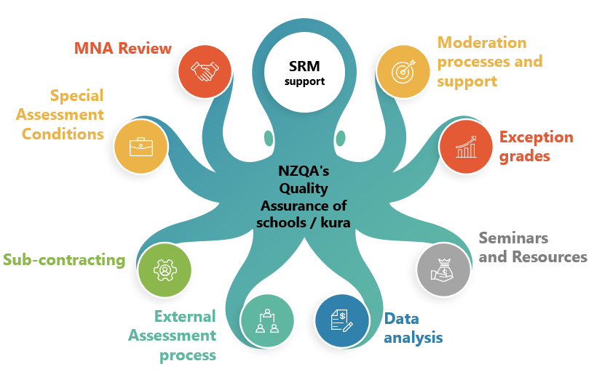

Discuss: What does NZQA do for each of the above?
Discuss: What are the positives and challenges of each of these for your school / kura?

Managing National Assessment Review

What we do:
- Support school-wide internal moderation processes
- Evaluate the extent to which the school has effective policies and systems that ensure credible internal assessment for national qualifications
- Generate a report of our findings, to inform the ongoing cycle of review
- Triangulate process, practice, and outcomes

Developments:
- More focus on the identification of risk and response by the school
- The introduction of an interim MNA report in 2022 that focuses on school effectiveness in managing assessment and moderation processes and practices
- Inviting feedback from schools / kura through Customer Experience Seminars to inform the new MNA process and report format.

How does this link to our school / kura self-review?

Moderation processes and support

What we do:
- Provide assessor support, including though Pūtake and subject pages
- Receive requests from schools / kura to moderate specific standards
- Write a report summarising moderation outcomes
- Provide templates for review
- Moderate individual standards, and respond to queries and appeals of moderator decisions
- Use new selection criteria for external moderation

How does this link to our school / kura self-review?

External Assessment Processes

What we do:
- Process reviews and reconsiderations of exam grades for learners
- Investigate alleged breaches of the rules
- Digital marking and return of student / ākonga exam scripts
- Provide guidance on managing exams
- Provide and train examination centre workers to supervise end of year exams
- Carry out examination centre audits
- NCEA Online - moving towards a digital-first model of external assessment

How does this link to our school / kura self-review?

External assessment exceptions
(Derived Grades and Unexpected Event Grades)

What we do:
- Support schools / kura to develop processes to ensure evidence collected for externally assessed standards is standard specific, valid, authentic and verifiable
- Collect school / kura-generated results for use as exception grades if required
- Carry out derived grade audits
- Receive and make decisions on Derived Grade applications
- Declare Unexpected Events
- Provide access to the Assessment Master platform for school / kura practice exams

Developments:
- Development of digital systems to ensure the timely and accurate management of exception grades, breaches and Special Assessment Conditions

How does this link to our school / kura self-review?

Special Assessment Conditions

What we do:
- Receive and evaluate applications for Special Assessment Conditions
- Offer seminars to support schools / kura in management of Special Assessment Conditions
- Carry out Special Assessment Condition audits

Developments:
- Investigating the use of new assistive technologies in assessment practice

How does this link to our school / kura self-review?

Subcontracting
(including extending Consent to Assess)

What we do:
- Assess applications to extend schools’ / kura consent to assess by Memoranda of Understanding with consented providers
- Assess applications from schools to have unconsented providers assess students / ākonga (third-party subcontracting arrangement)
- Monitoring that schools / kura have subcontracting arrangements with other consented organisations (with Memoranda of Understanding)

Developments:
- Introducing a digital system to ensure that each school / kura has relationships with consented and unconsented external providers that are visible to NZQA

How does this link to our school / kura self-review?

Data analysis

What we do:
- Alert schools / kura to any inconsistencies in their results
- Support schools / kura to analyse their own data

Developments:
- More dynamic statistics and reports, to identify quality assurance issues

How does this link to our school / kura self-review?

‘and Liaison’… (School Quality Assurance and Liaison team)

What we do:
- School Relationship Manager relationship – asking questions, getting advice, different approaches to resolving issues, providing resources
- School / kura visits, seminars, ongoing availability
- Liaison with the rest of NZQA – Data, Moderation, other teams

Developments:
- LNA seminars specifically for kura

How does this link to our school / kura self-review?

The refreshed Managing National Assessment review:
- a cycle of continuous improvement

The refreshed MNA process reinforces a continuous improvement model of review. School Relationship Managers will remain in regular contact with their assigned schools / kura, completing on-site visits where possible alongside communication at a distance.

The MNA will put greater focus on the school / kura self-review process, requesting evidence of changes because of self-review and the justification behind these changes. To support schools / kura in this process, evaluation indicators will be created in consultation with schools and kura. Additional support documents for ensuring credible assessment will also be created and made available.

Our approach to the MNA will be underpinned by Te Tiriti and co-created with kura.

The focus of the MNA review will be on continuous improvement, allowing for intervention earlier when an issue is identified and the ability to resolve issues raised prior to the review.

New in the MNA report

- Action items have always been signalled during the review and written in the report.
- Now these will be followed up with who has responsibility, the steps that need to be taken and the time frame for acting on them.
- Items for Consideration will continue to be included in the report.

Action | Responsibility / Steps | Timeframe
External and internal review
 |  | Immediate / Within XXX
 |  | Immediate / Within XXX
Credible assessment practice to meet student / ākonga needs
 |  | Immediate / Within XXX
 |  | Immediate / Within XXX
Quality assurance to ensure the reporting of credible results
 |  | Immediate / Within XXX
 |  | Immediate / Within XXX

The 2022 MNA Leaflet

Highlight / annotate the leaflet

- What are you confident about?
- What needs work?
- What do you need to ask about?

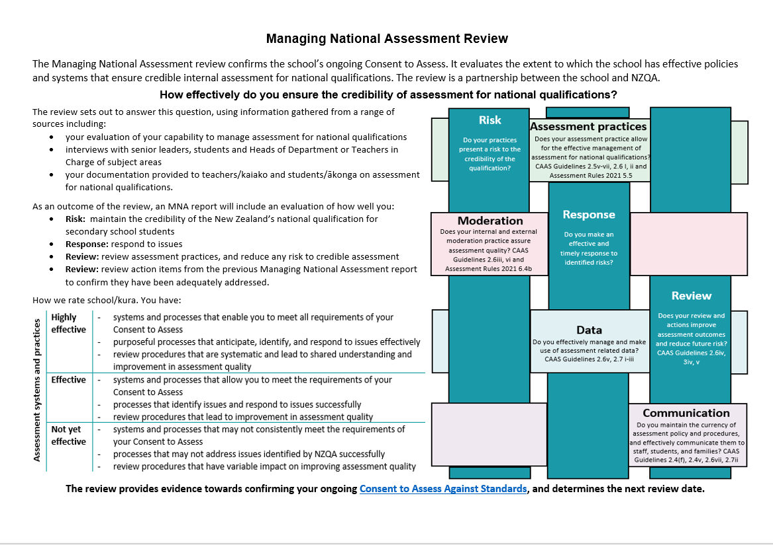

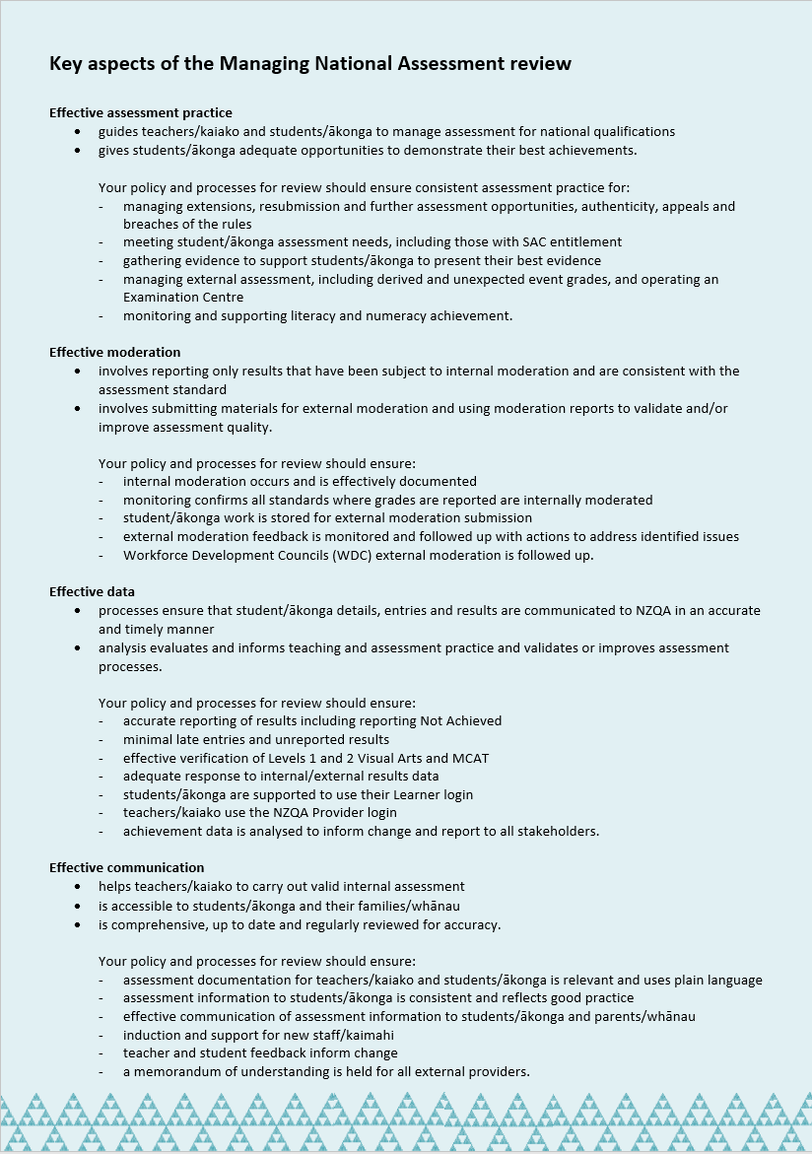
MNA Visit Guideline questions

Guidelines for the Principal’s Nominee

The purpose of the meeting with the Principal’s Nominee is to gain an understanding of
- how effectively the school / kura ensures the credibility of assessment for national qualifications and meets student / ākonga needs
- how self-review
  - informs improvements in assessment
  - identifies issues that present a risk to the school’s / kura Consent to Assess
- the school’s / kura capability to respond to this risk.

Focus questions
The key questions asked of the Principal’s Nominee will be:
- how effective is the school / kura in ensuring the credibility of assessment for national qualifications?
- how do you know?

Guidelines for Teachers / Kaiako

Focus questions
I will ask questions on how you (and the teachers / kaiako in your department if applicable):
- gather evidence of student / ākonga achievement
- manage both group and individual student / ākonga assessment needs
- ensure the quality of assessment materials before use
- ensure that teacher / kaiako judgements are at the national standard
- engage with the wider professional community
- address any concerns raised by external moderation reports
- ensure entry and result data reported to NZQA is accurate and timely
- review assessment practice and communicate this with senior management and the Board.

Please have available:
- evidence of your internal moderation processes for a sample of standards
- analysis of results
- evidence of any follow-up action of external moderation reports.

Guidelines for Students / Ākonga

I would like to discuss:
- does the information the school / kura provides help you to make decisions
- how the school / kura is supporting you to meet your future plans and assessment needs
- evidence the school / kura collects to recognise your achievement
- your understanding of school / kura procedures for managing assessment including missed or late assessments, special assessment conditions, derived grades
- how the school / kura helps you keep track of your achievement, including the accuracy of entries and results they send to NZQA.

Consider: Would these questions be a useful tool in your self-review kete?
External Moderation and Assessor Support:
- more support for internal assessment
External moderation of internally assessed standards ensures that assessment judgements are at the national standard. It provides evidence of the effectiveness of your school / kura quality assurance processes and needs to inform your self-review.
Selection of work for external moderation in 2022
- Submit six samples for each N/A/M/E standard (Achievement standards and some Unit standards). At least one at each grade level if possible.
- Submit four samples for each N/A standard (mostly Unit standards)
- No longer randomly selected
You need evidence that:
- materials are submitted for external moderation as requested by NZQA
- moderation reports are used to validate and/or improve assessment quality
- external moderation outcomes are used to evaluate the effectiveness of internal moderation processes.
- the response has been effective at further developing teachers’ / kaiako understanding of the standard, especially at grade boundaries
Remember:
- You can request standards by completing your Assessment Plan in Term 4
- You can submit materials at any time until your due date
Assessor Support
The NZQA Moderation team is increasing the amount and range of support available to assessors.
You can expect to see:
- Exemplars and moderator commentary based on pilots
- Pre-assessment support from NZQA moderators
- Q&A webinars with moderators
- Up-to-date FAQs
- Further online support opportunities and Best Practice Workshops
- Refreshed moderation reports
- More resources on Pūtake, NZQA’s Learning Management System
Remember:
- You need to use your Education Sector Logon (ESL) to access Pūtake
- You can self-enrol, choose which resources or activities are of most relevance to you, and then work at your own pace to do as much as you need.
- Each NCEA subject page has been updated with a list of modules for each subject.
- Teachers / kaiako can use the Request for clarification of an internally assessed standard form to seek further clarification from a moderator on how to interpret a standard.
- Assessor support is available on Te Aka for pilot schools / kura and the Ministry of Education NCEA Education site.
- PN handbook has some templates that could be used to monitor moderation processes.
Consider: What assessor support would help your staff / kaimahi?
Consider: How do you know? What do you need to find out?
NCEA Change Programme
– a whole-school / kura perspective

Ministry of Education message June 2022 - The new standards for literacy and numeracy are due to become mandatory next year. However, this is subject to the sector being ready for the change. There will be an announcement in the next couple of months on this. The decision on implementation will take into account the feedback being received from the sector. In summary, our messaging is to prepare for the change for 2023, but implementation will simply not occur if the sector is not ready.
Feedback can still be submitted at ncea.review@education.govt.nz

NCEA Change – What is happening in 2022?

NCEA Change – What is planned for 2023?

NCEA Change – What is planned for 2024?

The Planned Transition – an overview:

The Transition – finding out what’s next:

Where to get updates and detailed information:
NCEA Education – the Ministry of Education’s NCEA Change Programme site
NCEA Change Programme indicative timeline – January 2022 timeline (MOE)
Understanding how NCEA requirements are changing – the main changes, including transition arrangements and exclusions (MOE)

Some important reasons to check the links. Do you know…?

- …what your current Year 10s will need for their Literacy / Numeracy?
- …what the implications are for your Y11s who do not complete Lit/Num this year?
- …what the impact will be on your multilevel, and international students / ākonga?
- …what you will need to do with students / ākonga who transfer to your school?
- …if there will be an impact on your staffing, timetabling and course design for 2023? 2024?

The new structure of the qualification:
- 60 credits at each level
- No standards tagged with Literacy / Numeracy | Te Reo Matatini me te Pāngarau
- Literacy co-requisite required for any level
- Numeracy co-requisite required for any level

The new standards:
- 4 per subject
- Total of 20 credits available per subject
- 2 internals – marked by the school / kura
- 2 externals – marked by NZQA markers. At Level 1:
  - 1 Common Assessment Activity (non-exam external - during term 2, 3, or 4)
  - 1 Examination (during the end of year NCEA exam period)
- Built in accessibility and inclusivity for most students with SAC entitlements
Schools / kura may still determine the makeup of courses, after the pilot phase, using achievement standards and/or unit standards.

Mana ōrite mo te mātauranga Māori
- where possible, te ao Māori and mātauranga Māori are being built into achievement standards for use across English and Māori-medium settings. This includes the availability of more Māori centred contexts for exemplars and more inclusive standards and assessment resources.

Yet to be decided
- any changes to University Entrance
- Vocational Entrance Award

Discuss:
Who in your school / kura has oversight of the changes?
What will be your challenges?
How up to date are your teachers / kaiako with the changes in their subject?

Common Assessment Activities (CAAs) – these may be:
- Online in Assessment Master
- Scanned and marked in a digital platform
- Digital submission – including portfolios
- Mixed – both Assessment Master and uploaded file submitted

Examples of types of Common Assessment Activities (CAAs) | Time available
Stimulus material provided 1 (or 2 weeks) prior to assessment date for students / ākonga to familiarise themselves with context for questions | 90 minutes
Evidence gathered / prepared over time and submitted as a report, portfolio or performance | submission
One off 60- or 90-minute assessment | 90 minutes
Two 45-minute independent assessment sessions - on consecutive days | 2 x 45minutes
Students / ākonga use class time to prepare and upload material that is used to support answers | 90 minutes
Exam - by submission of evidence | submission

For each standard, you may need to know when:
- Entries must be submitted
- Resource materials will be available
- The date(s) or window of assessment
- The submission due date
- The results release date
- The derived grade application due date (not available for all CAAs)
- The reconsideration and review close date

Standard | Term | Stimulus material released | Assessment date | Assessment method | Results release date | Reconsideration and Review closing date
e.g. 92026  History 1.3 | Term 3 | 7/08/2022 | 15-08-22 to 19-08-22 | Assessment Master | 6/10/2022 | 3/11/2022

Common Assessment Activities timelines
There will be key dates to monitor for each CAA, which will vary according to the standard and assessment specifications. You do not have to do everything yourself, but you do need to know that it is being done.

Implications for 2023
- Compulsory Literacy and Numeracy | Te Reo Matatini me te Pāngarau external assessments offered through three one-week windows at the end of terms 1, 2 and 3
- Nb. Te Ao Haka will be fully implemented at all levels in 2023

Full implementation - Implications for 2024 and beyond
- Compulsory Literacy and Numeracy | Te Reo Matatini me te Pāngarau external assessments offered through three one-week windows at the end of terms 1, 2 and 3.
- CAAs in each subject at Level 1 in 2024, managed by the school / kura

2022 Pilot Standards - Common Assessment Activities by week

 | Literacy and Numeracy |  Te Reo Matatini me te Pāngarau | New Zealand Curriculum | Te Marautanga o Aotearoa
TERM 2
Wk. 7 |  |  | Toi Ataata 92085  Pāngarau 92067
Wk. 8 |  | Health Studies 92010  L1 Te Ao Haka 91979 | Toi Puoro 92090  Te Reo Rangatira 92075
Wk. 9 | Literacy (Reading) 1 - 32403  Literacy (Writing) 1 - 32405  Numeracy 1 - 32406  Pāngarau 1 - 32412  Te Reo Matatini 1 - 32414 | Music 91950  Mathematics & Statistics 91496  Geography 91936 | Ngā Mahi a te Rēhia 92063  Tikanga ā-iwi 92081
Wk. 10 |  | Religious Studies 91919  Digital Technologies 92007  Te Reo Māori 92094, or week 1 T3
TERM 3
Wk. 2 |  | L1 Te Ao Haka 91978 | Hauora 92058 (DS)  Pūtaiao 92071 (DS)  Hangarau 92054(DS)
Wk. 3 |  | Commerce 92031  Physics Earth and Space Science 92046
Wk. 4 |  | Agricultural and Horticultural Science 91930  History 92026
Wk. 5 |  | Materials & Processing Technology 92015  Social Studies 92050  PE 92019 (DS)  Design & Visual Communication 92002 (DS)  Science 91923 (DS)  Drama 91943 (DS)
Wk. 7 |  |  | Pāngarau 92068
Wk. 8 |  | Chemistry and Biology 90923  L2 Te Ao Haka 91982
Wk. 9 | Literacy (Reading) 2 - 32403  Literacy (Writing) 2 - 32405  Numeracy 2 - 32406  Pāngarau 2 - 32412  Te Reo Matatini 2 - 32414 | Japanese 91959  Korean 91963  Lea Faka-Tonga 92039  Mandarin 91955  Te Reo Māori kūki’airani 92043  Spanish 91974  French 91966  German 91970  Gagana Sāmoa 92035  Visual Arts 91914 (DS)  English 91926 (DS) | Hauora 92059
Wk. 10 |  | L2 Te Ao Haka 91983  Te Reo Māori 92095 (DS)  L3 Te Ao Haka 91986 (DS)
TERM 4
Wk. 2 |  | Health Studies 92011  Commerce 92030  Visual Arts 91915  L3 Te Ao Haka 91987
Wk. 3 |  | Digital Tech 92006  Music 91951 (DS)
Wk. 4 |  | NCEA examinations begin 7 November  Social Studies 92051  Materials & Processing Technology 92014  Design & Visual Communication 92003  Dance 91938 (DS)  Dance 91939 (DS)  Physical Education 92018 (DS)  Drama 91942 (DS) | NCEA examinations begin 7 November
Wk. 6 |  |  | Toi Ataata 92086  Ngā Mahi a te Rēhia 92064 (DS)  Toi Puoro 92091 (DS)  Tikanga ā-iwi 92080 (DS)  Pūtaiao 92072 (DS)  Hangarau 92055 (DS)  Te Reo Rangatira 92076 (DS)
Wk. 7 |  | NCEA examinations end 2 December | NCEA examinations end 2 December

**A derived grade (DG) is not available for these standards. (DS) = digital submission.
*** Please note - dates accurate at time of publication.

Considerations when managing CAAs
- Supervision
- Special Assessment Conditions
- Impact on school / kura events
- Education outside the classroom
- Impact on internal assessment calendars
- Impact on multi-level, junior, and multiple assessments at the same time
- Internal timetabling arrangements
- Availability of rooms and technology

Consider: What impact could the CAA timelines have on your school / kura?
SLT –
HODs –
Teachers / kaiako –
Students / ākonga –
School culture / kura kaupapa -
Implications of NCEA Changes on assessment leadership, ownership and capability

Discuss: What are your next steps to support the successful implementation of NCEA Changes in your school / kura?
In your discussion, consider Leadership, Ownership and Capability / Risk Response and Review.

e.g.
- Get all HODs to report back on the assessment specifications for the standards in their learning area.
- …

Implications of NCEA changes on internal assessment practice

Our principles of assessment practice and quality assurance are not changing.
Your assessment practices may need to amend to implement the new standards effectively.

For example – There will be fewer standards available for each subject, and they will be larger than many old standards. Collecting evidence of achievement generated during the teaching and learning process may be helpful in ensuring that students / ākonga are ready to be assessed, and may reduce the risk of a student / ākonga not achieving at their best in a single high-stakes assessment event.

Assessment practice changes to consider could include

- Including assessment milestones / checkpoints
- Collecting evidence using different methods and offering students more choices
- Reviewing assessment due dates, extension policies and assessment programmes
- Collecting naturally occurring evidence
- Assessing students / ākonga when they are ready
- Checking authenticity in different ways, over a longer period
- Ensuring equal support for ākonga Māori
- Ensuring equal status for mātauranga Māori
- Assessment methods, contexts and assumptions that include all learners
- Any other implications?

Discuss: How could you amend your internal assessment practice at your school / kura to prepare for the new standards?

e.g. How you will monitor that students / ākonga are ready to be assessed?
e.g. How will your learning areas plan to offer contexts that are relevant and engaging for Māori students / ākonga?
Reminders

Changes to University Entrance Literacy Standards
As communicated to the sector in 2018, there have been changes to the list of standards that contribute to University Entrance Literacy. These changes took effect at the end of 2021. Students / ākonga must gain all elements of UE according to the requirements that apply at the time of awarding; this includes the Literacy component. It is worth checking if students / ākonga who believe they completed University Entrance Literacy in 2021 are relying on any of the expired standards to gain UE this year; if they are, then you may need to review their assessment programme to ensure they meet the 2022 requirements.

External Moderation requirements in 2022
As part of the Review of NCEA Achievement Standards, NZQA is reviewing the external moderation requirements for schools, to ensure they are fit for purpose when new achievement standards are introduced.
- Level 1 Achievement Standards will not be moderated, unless requested by schools / kura.
- The sample size requirement has been reduced from eight to six samples of student work, per standard.
- Random selection of student samples has stopped.
- Samples must include:
  - one sample each at N, A, M, E and two more from A, M, E
  - If E is not available, replace with M
  - If no E or M, replace with A
  - If no E, M or A, send a maximum of two Ns only
- Where schools / kura only have access to a stored random sample then select six pieces that best meet the criteria.

Data file errors
Ensure you only report results for standards that you have consent to assess
If you enter students for a standard for which your provider code does not have Consent to Assess, you will receive a data error, and the entry will not be processed. Errors will also be generated by entries for pilot standards, including Literacy and Numeracy | Te Reo Matatini me te Pāngarau standards if your school or kura does not have approval to participate in the pilots.
You will find any errors identified in your Data File Submission page in your provider login.

Moderation report options
When you open a moderation report, you have options available at the bottom. You can Query, Appeal, and Download the report.
You can also provide Feedback to our moderation team on the usefulness of the report. There are three feedback questions, each with a drop down with 4 answers to choose from – see below:
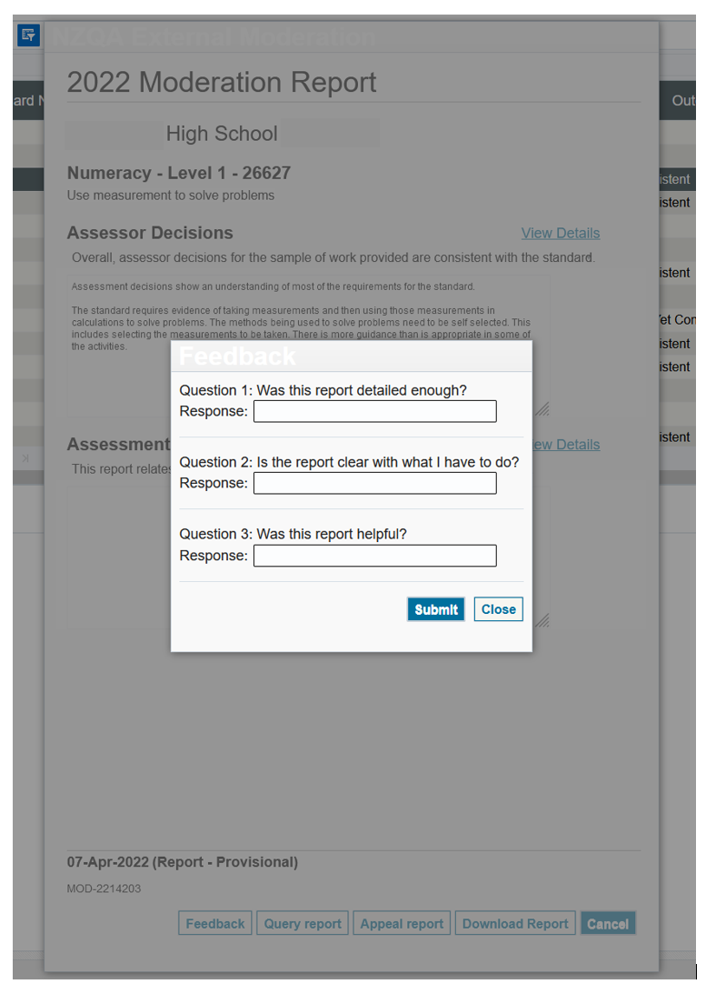

Have you bookmarked these sites?
- NCEA Education
- Te Aka (only if you’re a pilot school / kura)
- Pūtake


Workforce Development Councils
Six Workforce Development Councils (WDCs) were established on 4 October 2021 through the Reform of Vocational Education (RoVE). The role of the WDCs is to ensure the vocational education system meets industry needs and gives a stronger voice to Māori business and iwi development. WDCs will set standards, develop qualifications and help shape the curriculum of vocational education. Success for WDCs will mean employers - including Māori business owners - are confident that vocational education graduates are ready for work and that the future skills needs of their industry will be addressed by the vocational education system.
The WDCs are:
- Waihanga Ara Rau – Construction and Infrastructure
  - industries including Construction, Concrete, Plumbing, Infrastructure, Water, Gas, Electricity, Telecommunication and Roading
- Toi Mai
  - industries including Creative, Technology, Entertainment, Hairdressing and Barbering, Makeup Artistry, Skincare, Journalism, Radio and Television Broadcasting, Gambling, and Sports & Recreation.
- Toitū te Waiora – Community, Health, Education and Social Services
  - industries including Care Services, Disability Services, Education and Education Support Services, Funeral Services, Health Services, Public Order Safety, Regulatory Services, Skin and Nail Therapy Services, Social Services, and Urban Pest Control.
- Hanga-aro-rau – Manufacturing, Engineering and Logistics
  - industries including Manufacturing, Processing, Extractives and Drilling, Transport, Postal, and Warehousing.
- Muka Tangata – People, Food and Fibre
  - industries including Dairy, Sheep and Beef, other livestock, Arable, Horticulture, Fishing, Seafood Processing, Winemaking, Aquaculture, Livestock farming, Sports Turf Management, Silviculture & Harvesting.
- Ringa Hora – Services
  - industries including Advisory Services, Aviation, Cleaning Services, Business Services, Contact Centres, Financial Services, Hospitality, Local Government, Real Estate, Retail, Security Services, State Sector, and Tourism and Travel.

What the WDCs mean for your school / kura:
- You may no longer have consent to assess some vocational standards. Check carefully.
- You may find it more difficult to gain consent to assess specialised skills.
- The moderation requirements for some standards may change.

Principal’s Nominee resources - now in one place!

Evaluation and Survey

