

Leading National Assessment
Seminar

20 February – 8 March 2024

Kaitakawaenga ki te Tumuaki me ngā Pouārahi
Principal’s Nominees and Senior Leaders



Pukapuka Aratohu
Handbook

Contents

Topic | Page
NCEA structure and transition  - The structure of the qualification  - Te reo matatini me te pāngarau | literacy and numeracy  - The dedicated co-requisite unit standards in 2024  - New level one achievement standards  Implications of the new achievement standards  - Building teacher assessment capability  - Authenticity  - Universal design for assessment | 4  6  7  12  14  16  17  19
Quality Assurance  - Data accuracy  - Managing National Assessment reviews  - Internal moderation and the new standards in 2024  - External moderation in 2024 | 22  23  24  25
External Assessment processes  - Special Assessment Conditions (SAC)  - Derived grades  - Over time external assessments  - Digital exams and digital first policy | 27  28  30  32
Handy resources and links | 33
Appendix 1 – 2024 Level 1 external assessments  Appendix 2 – 2024 Level 1 NZC standards with mātauranga Māori embedded | 34  37
Evaluation | 38



“Ko te manu ka kai i te miro, nōna te ngahere.
Ko te manu ka kai i te mātauranga, nōna te ao.
The bird that partakes of the berry, theirs is the forest.
The bird that partakes of knowledge, theirs is the world.”

Te Kere Ngataierua, Te Āti Haunui-a-Pāpārangi

NCEA structure and transition

Please note: The information in this handbook is accurate in mid-February 2024. Check NZQA and Ministry of Education updates regularly to ensure you are aware of any changes.

Assessment in your school / kura will change as you implement the new standards and the changes to the qualification.

The NCEA Changes will continue to ensure the five principles of a strong NCEA qualification are met –

coherence, credibility, equity and inclusion, pathways, and well-being.

Remember these key aspects of the NCEA Change Programme

- Make NCEA more accessible
- Equal status for mātauranga Māori in NCEA
- Strengthen literacy and numeracy requirements and assessments
- Fewer, larger standards
- Simplify NCEA’s structure
- Clearer pathways to further education or work
- Keep NCEA Level 1 optional

The structure of the qualification
- Minimum of 80 credits for each Certificate, including
  - 60 credits at a level or above
  - 10 credit te reo matatini or literacy co-requisite required for any level
  - 10 credit te pāngarau | numeracy co-requisite required for any level.

How the qualification works
- Credits from a lower level are no longer used
- Each qualification can include credits from a higher level
- Both achievement standards and unit standards can be used. Always check for exclusions
- If a standard contributes to the co-requisite requirement, it will not be used towards the minimum 60 credits required to complete the qualification
- Certificate endorsement requirements have not changed. 50 credits at excellence, or a mix of 50 credits at excellence and merit, or 50 merit credits are required.
- Course endorsement requirements for 14 credits including a minimum of 3 external and 3 internal credits have not changed. All standards completed by a student will be included in endorsement calculations, including those used to complete the co-requisite requirement. Level 1 course endorsement exceptions for Religious Studies and Physical Education have been removed.

The new Level 1 achievement standards
- 4 per subject
- Total of 20 credits available per subject
- 2 internals – marked by the school / kura
- 2 externals – marked by NZQA markers –submission or examination or Tūmahi Aromatawai Pātahi,
- Built-in accessibility and inclusivity for most ākonga with SAC entitlements.

University Entrance
- University Entrance is still under review.
Te reo matatini me te pāngarau | literacy and numeracy
Transition and Updates

Options for completing the co-requisite in 2024 – 2025


NZQA list: Literacy and numeracy assessment standards.
MOE list: Standards approved for NCEA co-requisite for 2024 and 2025.

The dedicated co-requisite unit standards in 2024

Dedicated co-requisite standard assessment dates 2024 (Assessment Matters 14/09/2023)

In 2024, two assessment opportunities for each Common Assessment Activity and Tūmahi Aromatawai Pātahi, each two weeks long.
Standard and opportunity entries
Schools and kura should submit entries for the May / June assessment opportunities in the 1 April file. Kura should also make entries in the May / June TAPA as soon as possible.
Schools must indicate which assessment opportunity students will be entered in. Each entry is digital by default. Students who have not achieved in one assessment can be entered in the next assessment opportunity after further learning.
Schools will be able to see in which assessment opportunity students have been entered under ‘Key Indicators’ . Track and manage your entries well. Data file processing, and filtering entries into Assessment Master takes time. There is no guarantee that late entries can be made.
Results will be released about eight weeks after each assessment opportunity. They will remain visible for schools and students unless they are replaced by an improved grade from another assessment opportunity.

Special Assessment Conditions
Text-to-speech will only be available for Writing and Numeracy using NZQA-authorised methods.
In 2024, no application, using either the notification or approvals gateway, is required for the use of special assessment conditions for the dedicated co-requisite standards.
PDFs are only intended for the use of SAC students who require them to overcome barriers to assessment. After completion, student work needs to be sent to NZQA. Schools should save a copy of the original student work securely until results are released, and then destroy the original.

Awarding qualifications and endorsements
Any standard used for meeting the co-requisite requirement cannot also contribute to meeting the remaining NCEA credit requirement for achieving the qualification.
The best possible arrangement for students will be calculated at results release – standards are not pre-assigned to one requirement or another.
Course endorsements are calculated separately to the co-requisite and the NCEA qualification. Students can use credits to meet the requirements of a course endorsement or certificate endorsement regardless of whether these credits have been used towards meeting the 20 credit co-requisite.
If a student exceeds the number of credits required for the co-requisite, the additional credits will be counted towards the minimum credit requirement for NCEA. For example: if a student achieves 11 credits for literacy through English standards on the additional list, the remaining 1 credit not used for the co-requisite will count towards their NCEA credit requirement.

Additional standards with usage restrictions
Eligibility for standards with usage restrictions will be determined from MOE enrolment records.
If a student was eligible for any usage restricted standards at any point during the year, that eligibility remains until results are calculated the following year.
Translations
Literacy standards will not be translated, as they are specifically English language literacy assessments. Te reo matatini and te pāngarau standards will not be translated as they are specifically Māori-medium assessments.
Numeracy assessments will be translated into Cook Islands Māori, Niuean, and Tokelauan. They will be available as a PDF download for students who require them.
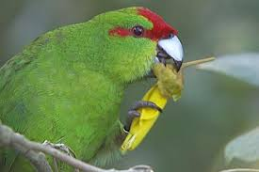
Availability of papers
Teachers will have access to the assessment platform for the purposes of administering the assessment only. Schools may not access students’ answers outside of the assessment session or make any copies of either student answers or the assessment task.

School feedback
A national assessment report will be available. A brief collated report will be given to each school for their students who did not achieve. This will be similar to the report available to a student in their learner login.

Exclusions with the 26*** literacy and numeracy standards
Literacy and numeracy unit standards with standard numbers 26*** will not contribute to the co-requisite requirement from 2024. They are excluded by the new dedicated co-requisite standards, so students will not get credits for the 266** standards if the 324** standards are used. They may still be used to contribute to the minimum 60 credit NCEA certificate requirement if the additional standards are used to gain the co-requisite. See the full list for exceptions and eligibility requirements for these standards.

Grade Point Averages
Some tertiary institutions have acceptance criteria that include a calculation of a student’s Grade Point Average (GPA). No standard, including a dedicated co-requisite standard, can be removed from a student’s Record of Achievement, including to improve a GPA.

Questions:

How will your teachers help students to complete the co-requisite requirement?

Tracking readiness? Accessing e-asTTle or similar results? Teaching across the curriculum? Making entries? Checking entries? Explaining how it works? Using the additional standards? Checking standards with eligibility requirements? Overseeing transferring students’ readiness? Monitoring progress? Compiling strategies for classroom use? Leading professional learning?

Questions and Scenarios for 2024
Do you know or can you find…?

- Can I still get credits from the English standards I did in Year 10?
- Do I have to do all 4 new standards in each Level 1 subject?
- Where can I find the Māori concepts embedded in a new standard?
- When will we get exemplars?
- Do I need to run a practice exam for Physical Education 1.4?
- Can I get my Numeracy assessment translated into Samoan?
- Can we do the Level 2 pilot in Commerce this year?
- What does ‘built in accessibility and inclusivity’ mean?
- Will University Entrance be harder now?

True or False?
- Wiki gained 50 Level 1 credits in 2023, in addition to all three Lit/Num dedicated unit standards. She will be studying at Level 2 in 2024 and is planning on completing 75 Level 2 credits. This will give her Level 1 and Level 2.
- Frannie completed two 26*** Numeracy unit standards in 2023. While the credit value of the standards will count towards his NCEA Level 1, they will not be able to be used towards meeting his Numeracy co-requisite.
- Marion gave birth to her pēpē in 2023 and is starting 2024 in a Teen Parent Unit. She will get literacy through US26622, 26624, and 26625 while she is there. As she plans to return to mainstream school in Term 3 2024, these unit standards will not count towards the co-requisite.
- Jane has met the Numeracy requirement already, via the old system, but not the literacy requirement. She has been told that she cannot combine the old and new systems to reach the 20-credit Lit/Num requirement. Therefore in 2024, she must enter for all three standards required for the Lit/Num requirement.
- Frank lives part-time in Niue, and part-time in Christchurch. He is therefore able to include selected standards from Vagahau Niue to count towards the co-requisite.
- Stephen has just arrived from Australia. He is going straight into Level 3 with the plan to complete University Entrance. He will complete at least 14 credits in each of Level 3 History, Physics, Physical Education, Visual Arts and Social Studies, including requirements for UE literacy. This will guarantee him UE.
- In 2023, Geoff achieved Religious Studies L1 90816 (6 literacy credits) and Chemistry L1 (4 Numeracy credits). To complete Level 1 in 2024, Geoff needs to do standards worth 50 credits and then 4 literacy credits and 6 Numeracy credits from the additional standards list.
- In 2024, Noema is doing Te Reo Rangatira and English. She can use a standard from each one to meet the te reo matatini requirement.
Answers:
Do you know or can you find…?
- Yes. If, however you do standards that are mutually exclusive, you can only use the credits once for the minimum 60 credit requirement. Excluded standards will each appear on your Record of Learning.
- No. It is important to cover the curriculum so that you are prepared for Level 2 and have a coherent understanding of the subject, but you don’t have to assess everything.
- The standards that require matauranga Māori address this in explanatory note 2.
- Exemplars are available now on NZQA subject pages.
- No. Each PE external assessment is an over-time submission. There are no derived grades available, so NZQA does not require you to submit a grade from a practice examination for these standards.
- No. Translation for the numeracy standard is only available for realm nations languages (Cook Islands Māori and Niuean).

- No. There are no pilots in 2024.
- Standards have been developed to remove barriers due to cultural assumptions; assumptions that unfairly disadvantage some learners with disabilities; contexts that exclude some learners; and to allow for more inclusion of local histories and contexts.
- Not yet decided. Consultation for any changes arising from the UE review is due to begin in 2024.

True or False?
- True.
- True.
- False. Her enrolment at the TPU means she will remain eligible to use these standards for the rest of the year, even if she returns to school.
- False. She just has to complete literacy.
- True, as long as he is enrolled at Niue High School at some point during the year.
- False. He will still need to complete the co-requisite literacy and numeracy requirements
- False. The standards he completed in 2023 can no longer contribute to the co-requisite requirements.
- False. English is not on the te reo matatini additional standards list.

New Level One Achievement Standards
*See Appendix 1 for details.
Note these are accurate at the start of February 2024. Keep track of any updates to the assessment specifications.
List of all new standards and numbers and credits

Course design
The MOE encourages schools to develop courses to fit the learning matrices, to support a coherent programme of teaching and learning. The new standards together cover all areas of significant learning within a subject area. It is important to cover the curriculum so that your students are prepared for Level 2 and have a coherent understanding of the subject.
You still have flexibility to develop courses to meet the needs of your students, including developing assessment programmes that include:
    - Standards from multiple subjects
    - Unit standards – assessed either by the school or external provider
    - Flexibility to meet the needs of individual students in the course
    - A range of contexts and assessment opportunities to meet student needs.

Course endorsement requirements have not changed. However, there are no longer exceptions for Religious Studies and Physical Education at Level One.

You can use the sample Internal Assessment Activities as source materials to develop your local assessment activities that reflect the priorities and preferences of your school, kura, and your learners.

Exclusions
The exclusions list prevents the use of credits from standards that recognise similar outcomes contributing to the credit requirements for an NCEA. This prevents ‘double-dipping’.
When two standards are mutually exclusive, you cannot use the credits for both to achieve a qualification or course endorsement or co-requisite requirement. All standards will still appear on a student’s Record of Achievement.
The old Level 1 standards have expired and are no longer achievable. Credits that have been gained will not be lost. If standards are mutually exclusive, students will get the highest credit value of the two standards.

Use of Explanatory Note 2 (EN2) for mātauranga Māori in NZC Achievement Standards
Each Level 1 subject includes mātauranga Māori indicated in the Learning Matrix and other learning materials based on the subject.
Some standards require the inclusion of specific mātauranga Māori concepts or values for the competency being assessed. For these standards, the requirement is always located in EN2.
For these standards, the requirement is phrased: ‘As part of the evidence provided, students must show understanding of…’. This requirement will be backed up in other resources, including assessment activities.

Exemplars
Exemplars are available on NZQA subject pages. In some cases, there are exemplars currently available that won’t align with the new standards as they were prepared for the pilot standards. Use with care. These exemplars will be removed when new exemplars are available.

Derived Grades
Examined standards are eligible for derived grades.
Submitted standards completed over time are not eligible for derived grades. Ensure that students have the opportunity to complete their submissions well before the due date, so that you can manage any unexpected events.


New Level Two Achievement Standards
New Level 2 achievement standards are expected to be finalised in Term 4 of 2025, ready for implementation in 2026. There are no Level 2 pilots in 2024.

Discuss:

What are the implications of the Appendices for your school calendar?

For your usual assessment calendar / oversight of timing?

Implications of the new Achievement Standards

2024 is the year to review if your school assessment practices are still fit-for-purpose for the new standards.

What does your school need to review and/or change?
ü / X | Assessment ownership and capability
- Which learning areas and teachers need the most support in implementing the changes?
- How will we work together as a staff? What is whole-school, and what is subject-level?
- How will we ensure that our middle leaders and teachers are up to speed with
  - Mana ōrite mō te matauranga Māori
  - Shifts in teaching, learning and assessment practice in their own subject areas
  - Planning their programmes to assess fewer, larger standards
  - Their understanding of guidance, feedback and feedforward
  - Designing courses that lead to coherent pathways
  - Using the existing L2 Achievement Standards in 2025

ü / X | Assessment Policy
- How do our assessment policies need to change to reflect the changes in how and when the standards are assessed?
  - Assessment submission - late, missed, assess when ready, multi-level and differentiated entries
  - Special Assessment Conditions - for co-requisites, for internals, for externals
  - Is our Further Assessment Opportunity policy still fit-for-purpose?
  - Do we have a consistent understanding of using Feedback and Feedforward?
  - What is our shared understanding of 'assess when ready'? How will we ensure consistency across the school?
- What does mana ōrite mō te matauranga Māori mean for us - at a school / subject / classroom level?
- What does Universal Design for Assessment look like in practice? How accessible are assessments for our students?
- Authenticity - are we clear and consistent in our messages to students about producing their own work?
- Does everyone know when and how generative artificial intelligence may be used?
- Are our moderation practices - critiquing, verifying, documenting, and monitoring – fit-for-purpose? - e.g., if most work is going to be digital?

ü / X | Managing Systems and Resources
- How will student work be stored securely, especially for subjects new to digital submissions?
- How will we track student progress - especially literacy and numeracy in 2023?
- Who will have oversight of entries for te reo matatini me te pāngarau | literacy and numeracy standards?
- How prepared are we for digital submissions and exams?
  - Are we familiar with the digital assessment platform?
  - Do students have digital skills?
  - Do students regularly use their MyNZQA learner logins?
  - Are there enough devices? How often do we check them?

ü / X | Planning
- Will we still have an assessment calendar? How will we manage crunch points?
- What will courses look like? Will all Achievement Standards in a subject be offered in or across courses?
- Will our use of Unit Standards change?
- What will literacy and numeracy look like in student programmes? How will we track if they're ready to be assessed for the co-requisite standards?
- How will students monitor their progress towards standards where evidence is collected over time?

Discuss / note / prioritise

There are implications of the 2024 changes for how you manage courses, entries, and assessment practice.

There are also many implications for teachers in getting to know the new standards and developing teaching and learning programmes to meet the needs of students / ākonga.

Use the review questions on the previous page to help you identify next steps.

School leaders – next steps:

e.g. Review staff capability in the English department
1.

2.

3.

Building teacher assessment capability
Building teacher assessment capability in your school – what works? – permission-giving, purpose, framework, resources, ownership, workshops, thumbscrews? New teacher resources are available.
Give teachers permission and support to build their assessment capabilities / practice
What will a good assessor do and consider when using the new achievement standards? How can you make the best use of teacher time and resources?
e.g. Discussing Feedback and Feedforward could help to develop teacher capability in a range of areas, depending on need and school requirements.

Discuss

How do you develop teachers’ assessment practice? What is effective? How do you know?

Support available – Ministry of Education Teacher Only Day resources, Pūtake (NZQA’s Learning Management System), School Relationship Managers, other Principal’s Nominees, National Implementation Facilitators, Professional Learning Development contracts, subject associations, kāhui ako.
Useful resources: Assessment capability (Education Hub) Assessment Capability (NZCER)
Authenticity
Given changes to technology, standards, and processes, it is timely to review how you understand and manage authenticity.

What does authentic assessment look like?

- Your staff and students need to develop a nuanced understanding of authenticity
Authentic | Tūturu means
- Work is produced by the student
- There is evidence of independent development
- Each student is enabled to produce their best work, in a way that is appropriate for them
- The task assesses the standard directly and supports students to produce their own evidence.

- Develop and review your policies and procedures
- AI Acceptable Use policies
- Authentication procedures – for demonstrating that student work is their own
- Breach procedures – for where there is evidence that work is inauthentic
- Policies and procedures that fit your own context – with awareness of the tools and resources available as technology develops
- Expectations of teachers and students that promote and demonstrate authenticity.

- Use strategies to promote authentic work
  - Monitor progress – drafts, logs, version histories, feedback, conferencing, planned next steps
  - Promote student choice and agency – choice of contexts, personal interest and prior knowledge, presentation options, voice / video recordings, pre-assessment planning and proposals
  - Limit use of templates and carefully consider offering guidance close to the assessment period
  - Document explicit authentication instructions for each assessment task
  - Allow different authentication procedures for different tasks and different students.

- Next steps may vary

- Investigate, using the principles of natural justice – evidence and fair explanation and timeframes.
- Report a Not Achieved grade if there is evidence that work is not their own.
- Ask for further evidence of authenticity, if in doubt.
- Don’t offer a resubmission.
- Consider offering a further assessment opportunity (to all students).

- Access resources on authenticity and artificial intelligence
  - Guidance on the acceptable use of Artificial Intelligence (NZQA, Feb 2024).
  - Generative AI (MOE)
  - Pūtake modules that encourage teachers to look at evidence closely, and support a nuanced understanding of authenticity
Acknowledging sources
Assessing Evidence from Alternative Sources
Modes of Assessment
Tāku Reo, Tāku Mahi – My Voice, My Work
Why Less is More
  - Authenticity challenges and strategies
  - Managing authenticity – Myths and Facts
  - Assessment in the age of AI symposium (May 2023)

Tāku Reo, Tāku Mahi – My Voice, My Work on Pūtake includes strategies to address AI evidence. The aim of this module is to emphasise the importance of students submitting their own work for assessments and acknowledging sources of other materials. It includes what is appropriate when providing advice and guidance to students.

Myths about authenticity and AI:
  - The only way to ensure authenticity is to try and ban AI
  - Teachers and students are not using AI yet
  - It is possible to prevent the use of AI
  - AI-detection and plagiarism-checking tools are the most reliable way to ensure authenticity.

Encourage your school to focus on gathering quality evidence of learning, rather than ‘preventing cheating’.
It’s okay to use AI as a complementary tool to enhance teaching and learning, and assessment practices.

For every new internal standard:

Conditions of Assessment for internally assessed standards (extracts)

Authenticity of student evidence needs to be assured regardless of the method of collecting evidence. This must be in line with the learning centre’s policy and NZQA’s Assessment Rules for Schools with Consent to Assess.

Ensure that the student’s evidence is individually identifiable and represents the student’s own work. This includes evidence submitted as part of a group assessment and evidence produced outside of class time or assessor supervision. For example, an investigation carried out over several sessions could include assessor observations, meeting with the student at a set milestone, or student use of a journal or photographic entries to record progress.

Consider
- What does your school need to review / change / adapt
(in the light of new technology, new standards, and new processes)?
- Is good authenticity practice common in your school?
- What happens in your school if inauthentic work is discovered or suspected?
- What next steps would you recommend to other school leaders?

Universal Design for Assessment

Universal Design for Assessment (UDA) means approaching assessment from a student perspective.
These questions and principles are included in the Conditions of Assessment for all internally assessed standards:

Engagement: Is the learning in this assessment of value to me, is it worth investing in and will I be supported to manage myself and succeed?

Representation: Can I see my cultures, identities, languages and communication modes, and the ways I make sense of information represented in this assessment?

Action and expression: Can I participate in this assessment and have equity of access to the tools and activities? Will I be able to express myself and demonstrate my understanding in ways that work for me? Will I be supported to plan and manage my learning?

https://inclusive.tki.org.nz/guides/universal-design-for-learning/take-a-people-first-approach/

For each new Achievement Standard:


Gathering Evidence (extracts)

Internal assessment provides considerable flexibility in the collection of evidence. Evidence can be collected in different ways to suit a range of teaching and learning styles, and a range of contexts of teaching and learning. Care needs to be taken to allow students opportunities to present their best evidence against the Standard(s) that are free from unnecessary constraints.

It is recommended that the design of assessment reflects and reinforces the ways students have been learning. Collection of evidence for the internally assessed standards could include, but is not restricted to, an extended task, an investigation, digital evidence (such as recorded interviews, blogs, photographs, or film), or a portfolio of evidence.

Effective assessment should suit the nature of the learning being assessed, provide opportunities to meet the diverse needs of all students, and be valid and fair.

You can use the sample Internal Assessment Activities on ncea.education.govt.nz as source materials to develop your local assessment activities that reflect the priorities and preferences of your school, kura, and learners.
As long as it is accessible (to them), any form of evidence may be submitted to moderators.

Consider reviewing teacher guidance about:

- Assessment conditions – What practices need challenging? Encouraging? Examples of good practice at your school?
- SAC for internals – What assessment support could be avoided by better assessment design? What needs will still require targeted support? How can technology and timing be used to meet the needs of more, if not all, students?
- Contexts – What contexts should be avoided / encouraged / used with discretion, to avoid cultural assumptions or barriers in the assessment task and conditions?
- Forms of Evidence – What will your teachers need to support students to submit different forms of evidence? E.g. training, tools, encouragement, exemplars, storage protocols.
- Assessing when ready – submission and extension policies, supporting flexible due dates and different programmes and conditions for different students.

Activity:
Think of a ‘typical’ internal assessment task in your subject area.
To what extent does it meet the guidelines in the Gathering Evidence box above?



- Flexible evidence collection
- Suits a range of learning styles
- Suits a range of contexts
- Allows ALL students to present their best evidence
- Free from unnecessary constraints or barriers
- Opportunities to meet the diverse needs of ALL students, without adaptation such as SAC
- Valid and fair.

There are many in-depth and useful resources available online to support teachers with UDA. Start here:
- Universal Design for Learning (UDL) (MOE ncea.education.govt.nz)
- Design assessments to enable students to demonstrate their learning (MOE)
Your school assessment handbooks may need updating to reflect current guidance on the design of internal assessment tasks.

Quality Assurance
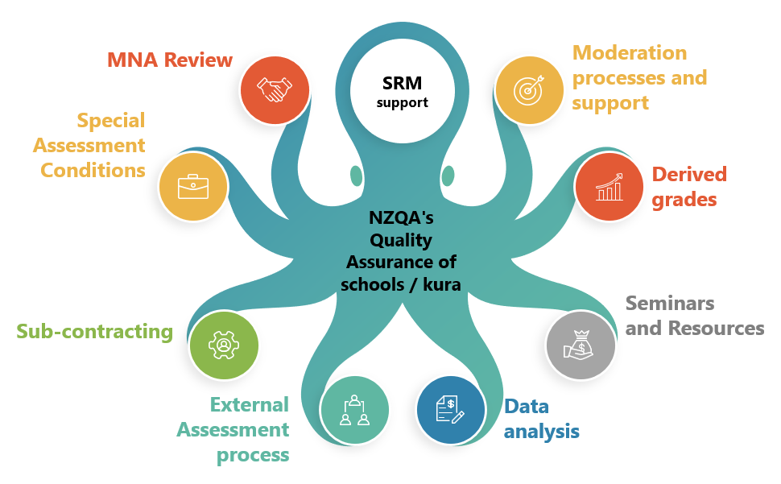

Quality Assurance involves…
- Checking compliance and quality
- Systemic overview and review of systems and processes,
and ongoing improvement
- Internal moderation processes – quality verification
- Evaluation and next steps

Data accuracy

It is essential that candidates’ details, entries, and results data submitted to NZQA are accurate, so that students don’t miss out and their Record of Achievement is correct.
For entries, check:
- Standard number and version
- Assessment method e.g. digital or paper
- Assessment opportunity e.g. opportunity 2 is the second assessment event in the calendar year for that standard.
Data is required on or around the first of each month (starting 1 April). You can submit data more than once a month. 1 September and 1 December are hard deadlines.
Once data is submitted, you must check for errors or warnings and take steps to resolve these.
For any data issues or further support, email schools@nzqa.govt.nz
Common issues to look out for:
- Te reo matatini me te pāngarau | literacy and numeracy dedicated standards – select the correct assessment opportunity. Note that the second assessment opportunity could be the first time a student has attempted a standard. Check that the method is ‘digital’. After the first assessment opportunity, recheck these entries and change if necessary.
- Te Ao Haka standards – select the correct assessment opportunity – TAPA 1, TAPA 2, or kete manarua (TAPA = Tūmahi Aromatawai Pāta).
- External standards that have different assessment methods – check digital vs paper.
- International students – make sure their entries are deliberate, as you will be charged
- Ensure that staff gather evidence for derived grades. Submit these grades to NZQA with the rest of your data as soon as they are available. If you have an SMS (e.g. Kamar / Edge), set up markbooks for DGs.
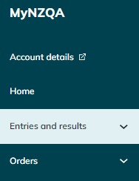
Empower staff to “own their markbooks” – they need to know what their students are planning to attempt and make accurate entries according to school policies. Carefully check entries for students who join classes during the year. Remind staff often and/or buddy them up to check so that you can do a final check, not everything.
Empower students by getting them to login to the MyNZQA portal to check their entries and results. e.g. form time activity to check school portal with MyNZQA portal.
Put regular checks in your calendar Note all the steps in your calendar, and share with staff – include entries, submissions, checks for errors, staff checks, student checks, international student entries.
Discuss: What is your ‘top tip’ for ensuring that entries and results data are accurate?

Managing National Assessment reviews (MNAs)

The Managing National Assessment review confirms the school’s ongoing Consent to Assess. It evaluates the extent to which the school has effective policies and systems that ensure credible internal assessment for national qualifications. The review is a partnership between the school and NZQA.

Management National Assessment Outcomes 2023
Last year SQAL completed 143 Managing National Assessment visits and reports. Most schools and kura are effective or highly effective in the delivery of credible assessment.

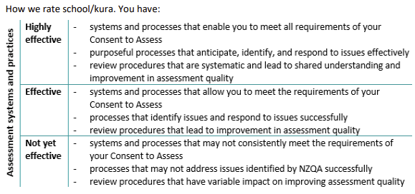

Currently the MNA outcomes for the 514 consented schools and kura are 15.1% Highly Effective, 76.8% Effective, 3.1% Not Effective and 5% newly consented or their consent has been limited or suspended.

Common agreed actions in 2023 MNA reports

- External moderation outcome and process
The monitoring of external moderation follow-up actions to ensure identified issues are effectively resolved.
- Internal moderation quality assurance
Monitoring and documenting the completion of internal moderation steps and sufficient and strategic verification of samples of student work.
- Communications
Ensuring the currency of staff and student information and accessibility.

Discuss:
- Have you recently reviewed your school / kura practice in the above areas?
- How are you going? How do you know?

For school review:
  - How effectively do you ensure the credibility of assessment for national qualifications?
  - Have you followed up the actions and considerations from your last MNA review?

Internal Moderation and the new standards in 2024
Internal moderation supports the credibility of assessment by ensuring that assessment is valid, authentic and grade judgements are verified.
The requirements for internal moderation remain the same in 2024.
You must ensure that:
- all assessment material is critiqued before use.
- you follow the conditions of assessment for each standard.
- judgements are consistent with the requirements of the standard.
- for each standard a sufficient sample of each teacher's grade judgements is verified. The verifier must be a subject specialist with standard-specific knowledge.
- assessment materials are retained for each standard, along with a selection of student work following NZQA guidelines, for the purpose of external moderation.
- all selected standards are submitted for external moderation when they are ready
- all advice from external moderation is actioned before the materials are used again.
For new Level 1 Achievement Standards in 2024, this may mean that each teacher is marking against the standard for the first time. It is important that each teacher is familiar with the current version of the standard.

Discuss:
What will be your challenges for internal moderation for Level 1 in 2024?

How do you manage the monitoring workload?

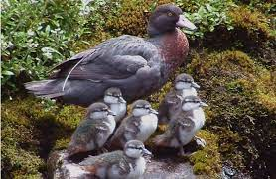

External Moderation 2024

Your moderation plan
For schools assessing Level 1:
  - Priority has been given to Level 1 Achievement Standards. One standard has been selected for each Level 1 subject you have said you plan to assess
  - Some Level 2 and 3 Achievement Standards may be included.

For schools with very little Level 1 assessment:
  - Your plan will focus on Level 3 and 2 Achievement Standards but may cover fewer subject areas than in previous years.
Timing
- You no longer have your own individual moderation month
- You must submit each selected standard once you have completed the assessment process (when internal moderation has been completed and results given to students for that standard)
- Submissions must be made by 20 October 2024 (contact your SRM about any standards that might not be ready by then).
Moderation outcomes
- You will still receive individual moderation reports and be able to submit queries and appeals
- You can NOT change student grades based on external moderator feedback
- You must have a process to ensure that feedback is acted on as needed, and the actions evaluated.

NZQA assessor support will include
- New Learning Area webcasts at the start of the year
- Making the Assessor Practice Tool available (to practice making assessor judgements)
- Offering online workshops and learning modules

- An Annual Subject Report will be published in February 2024 and which will include national moderator feedback..
- Further support - see the full Assessor Support catalogue.

Do now | - Make sure ESL moderation access is accurate for your school / kura  - High Security – can submit moderation (PN)  - Moderation Processor – access, prepare submissions and appeals, query reports (HODs)  - General Security – view access (assistant teachers)  - Check your moderation plan and communicate it to your staff  - Request any changes through your SRM. Request any further changes to your plan if assessment programmes change during the year  - Discuss with your SRM any selected standards that can’t be submitted by 20 October.
Plan for | - Monitoring that material is submitted on time  - Following up moderation feedback through the year, as it will now be staggered  - Monitoring the completion of action plans and their evaluation  - Delegating parts of the process while retaining SLT / PN oversight  - Streamlining parts of the process with centralized processes or documentation.

Useful resources:
- Changes to External Moderation, 20 September 2023
- External moderation for secondary schools and kura

Activity: Find your 2024 moderation plan – here:

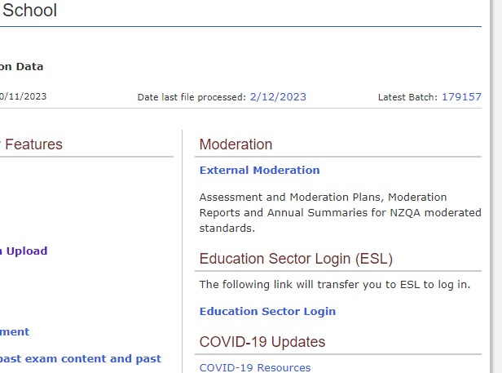

External Assessment Processes
Special Assessment Conditions (SAC)

When making new SAC applications for students attempting NCEA Level 1 standards in 2024, schools can choose either the current Approvals Gateway to submit applications for NZQA approval, or the new Notifications Gateway to inform NZQA of student needs and what SAC is required.

The use of the Notifications Gateway should significantly decrease the current administrative load for schools and kura when submitting SAC applications.

Schools will continue to submit applications for Level 2 and 3 students via the existing Approvals Gateway during the trial period.

What schools need to know
- A trial Notifications Gateway will be available for schools and kura making new SAC applications for students attempting Level 1 standards in 2024.
- The Notifications Gateway will be optional for schools and kura to use. The current Approvals Gateway can still be used for any applications at the school’s or kura discretion – for example if the SENCO is new or inexperienced, or in any cases where a decision by NZQA is preferred.
- All applications for students in Years 12 and 13 must use the current Approvals Gateway in 2024.
- A SAC application or notification is not required for students who are only completing assessments for the dedicated NCEA co-requisite standards in 2024. Schools and kura should provide support for these students as appropriate. However, if a school or kura requires certainty, a SAC application may be submitted.
- During the trial period, NZQA may audit the use of the Notifications Gateway to ensure that submissions are appropriate to the needs of the student.
- During the trial, NZQA reserves the right to restrict access to the Notifications Gateway, if required. This could be done either at a school or kura level, or for certain categories of SAC applications.

Do now | - Decide at senior leadership level about whether the notification gateway will be used for Level 1 students in 2024.  - Consider whether existing school SAC processes need updating to suit the changes
Plan for | - identifying students with learning or other difficulties that impact on fair assessment, and determine what SAC support is appropriate  - discussing the option of SAC with students and their whānau  - gathering evidence of ākonga needs  - using one of the gateways to tell NZQA what SAC students require  - monitoring ākonga progress and trial support as needed  - evaluating the support provided

Access information on the new notifications gateway here.
SAC Online Tool Guide provides guidance on the online application process
Derived Grades

Derived grades (DGs) are evidence-based grades that we may award to students when they can’t attend an examination or external assessment, or their performance is impaired.
Schools need to collect student evidence for the purpose of DGs and submit grades to NZQA before the start of external examinations.
Appendix 1 in this handbook is a list of the new Level 1 standards. Those that require evidence collected for derived grade purposes are identified.
It is important that your markbooks are set up early, so that these grades can be submitted through your monthly datafiles.
Update for 2024: We are discontinuing the derived grade audit visits. The evaluation of school processes for collecting and quality assuring evidence for derived grade purposes will be conducted through school visits and MNA reviews.

Key points for school / kura policies
- Evidence collection for DGs must meet NZQA requirements, including
  - gathering all evidence for DGs before the NCEA external assessment
  - collecting evidence for DGs for submitted standards (Technology and Design Visual Communication and Level 3 Education for Sustainability, and Level 3 Visual Arts), as well as all examined standards.

- Quality assurance procedures must include
  - how each grade will be subject to the quality assurance process
  - how you will record evidence of the quality assurance process – you could use your own system, or you could use or adapt a template, available here
  - how the quality assurance process will be documented and monitored.

Consider:
How do you track the collection and submission of DGs to NZQA?

What needs reviewing and/or improving?

Method of external assessment and Derived Grade availability
2024 Level One Achievement Standards
 | Point in time  Window or date of assessment is defined | Over-time submission  Schools have flexibility to manage assessment over time and meet the prescribed submission date | Multiple assessment events with re-assessment opportunities  Re-assessment opportunity is available
School is required to collect evidence for the purposes of derived grades, derived grades at scale, and adverse events | Yes | No | No
Rationale for availability or unavailability of DG to students | If a student is unable to attempt the assessment in the defined window/date of assessment, then a DG is available. | Schools have the opportunity to manage assessment and therefore a DG is not required. | If a student is unable to attempt the assessment and re-assessment opportunities are available, then a DG is not required.
Examples include | Digital Technologies – 92006  Examination 25 November | Materials Technology – 92014  Assessment window is not restricted. | Te reo matatini me te pāngarau | literacy and numeracy co-requisite standards  32403, 32405, 32406, 32412, 32414
Examples include | Te Ao Haka - 91978, 91979  TAPA Assessment dates:  - 4 June 2024  - 9 September 2024 | Te Ao Haka - 91978, 91979  Kete Manarua  Submission date is 30 October 2024

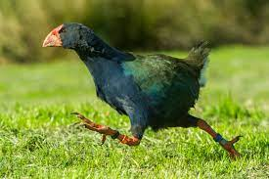
Over-time submission
Schools and kura already have policies and procedures for managing internal assessments and submitted external assessments effectively. The same principles will underpin your approach to the new submitted standards.
Administering submitted external assessments in school
Assessment Specifications vary between standards and subjects and can be found on the NCEA Subject Resources » NZQA on the NZQA website.

Schools must adhere to the published assessment specifications for each standard, including:

- When students may have access to the assessment and/or the assessment resources
- What resources students may have in the assessment
- The extent to which teachers may discuss the assessment with students and/or provide feedback
- Whether students may discuss the assessment with each other while under supervision

We advise you to be familiar with the digital submissions process well in advance of the Term 3 assessment timeframe and determine which staff will be involved in these processes:

- Downloading the assessment
- Managing the assessment resources
- Supervision
- Using the new digital submissions tool
- Using the existing digital submissions system
- Secure digital storage of student work and naming files
- Supporting students to submit the assessment
- Recording attendance and ensuring all work is submitted
- Reviewing uploaded student work and submitting it to NZQA.

Authenticity
Over-time submission assessment specifications – new common phrasing:

The use of chatbots, generative AI, paraphrasing tools, or other tools that can automatically generate content is not permitted and material generated by these tools should not be submitted as part of the candidate’s work.

Teachers must closely supervise the process of evidence collection to ensure that candidates:
- do not copy from another person or source without appropriate acknowledgement
- do not receive guidance, scaffolding, instruction, assistance, or assessment conditions beyond what is specified as permissible in these Assessment Specifications

Where a teacher cannot verify that the assessment submitted is the authentic work of the candidate, they must notify NZQA of a possible Candidate Breach of External Assessment.

Discuss:

Ideas for managing submission at our school / kura

Frequently asked questions
Can teachers share the assessment resources?
No. Teachers may not make extra copies or share the assessment with colleagues.

What advice should teachers give students?
Assessment Specifications vary, so teachers must give instructions to students based on the particular specifications for that standard. This should include, for example, whether students are permitted to access the internet, the use of artificial intelligence tools, whether teachers may give advice, and whether students may access any other resources.

What about authenticity?
NZQA has published a new webpage with helpful information for kura and schools on Artificial Intelligence (AI), and when its use is acceptable in assessment. You can view this page here.

If a breach of assessment rules is suspected that could affect the authenticity of student work, schools must notify NZQA and submit the student work as usual. Once the student work is submitted to NZQA, the school should complete a breach notification form.

What if a student misses an assessment?
There are no derived grades available for submitted standards where the timing is at the school’s discretion. Assessments should be scheduled so that all students can be assessed before the NZQA final submission date. If a student does not have an adequate opportunity to be assessed, they should be marked as Not Submitting.

Should students be provided with special assessment conditions?
Yes, unless they are specifically excluded in the Assessment Specifications for that standard.

See the PN Handbook for tips on uploading student work to NZQA.

Digital external assessments and examinations 2024

The dedicated co-requisite unit standards, most Level 1 exams, some Level 2 and 3 exams, and Scholarship Media Studies will be offered digitally. See the examination timetable for the full list of end-of-year digital exams.

- SRMs will be in touch in February / March about school and kura intended arrangements for the May dedicated co-requisite standards assessments to help with NZQA planning.
- It is important that all entries are made on time, and for the correct assessment opportunity.
- Online training for the digital assessment platform, for schools to manage the dedicated co-requisite standards, will be offered in term 1 week 9, and term 2 week 2.

- NZQA is planning for the large-scale digital external assessments this year. When our internal and external reviews of the performance of the digital assessment platform during the 2023 digital assessments have been completed, you will be advised about any changes of practice and improvements arising from recommendations.
- If a standard is offered digitally, this will be automatically selected when you make an entry in your SMS or Web entries.
- You can de-select the digital option and select paper.
- Personalised papers will be provided for all exams this year, even if students are entered for the digital option.

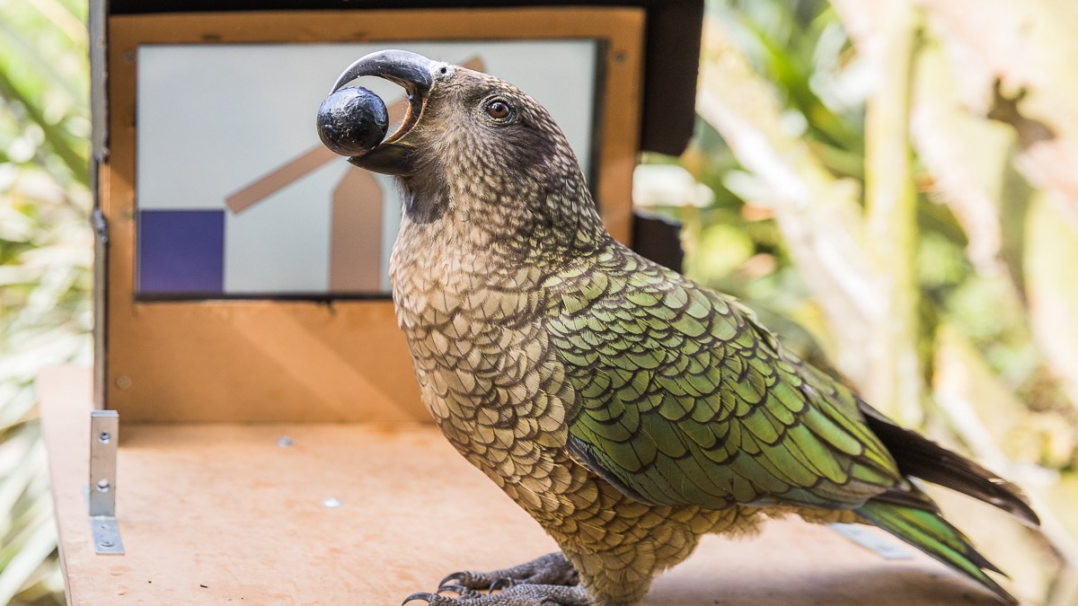
Handy Resources and Links

New and updated processes | NCEA Education | The home for resources, guidance, achievement standards, tools and co-requisite for both Te Marautanga o Aotearoa and The New Zealand Curriculum
Being a Principal’s Nominee | Resources for Principal’s Nominee | LNA Seminar Handbooks and PowerPoints  Principal’s Nominee Handbook  Action items by calendar month
Being a Principal’s Nominee | Key dates calendar | Key dates relating to secondary qualifications, including data deadlines, submissions, and exams
Being a Principal’s Nominee | EmaiLink | Regular update from SRMs to PNs
Being a Principal’s Nominee | The Myths | Clarifying assessment practice issues
NZQA’s Learning Management System | Pūtake | Each teacher should have ESL (Education Sector Login) access. Resources for improving internal assessment practice, and other e-learning courses including Assessment Master. Check in often.
Application information | Derived Grades | For help: derivedgrades@nzqa.govt.nz
Application information | Special Assessment Conditions | For help: sac@nzqa.govt.nz
Application information | Education Sector Login | Roles to assign in your school / kura
Application information | Extension of Consent to Assess | Getting permission to assess standards beyond Base Scope
Application information | NCEA Reviews and Reconsiderations | Available through each student’s learner login
Some other useful links – add your own! | Standards Exclusion List
 | External Moderation | Managing external moderation – including a guide to managing the External Moderation Application.
 | Approved subjects for University Entrance
Learner Login resource | How to create a new learner account | Video resource for students – creating their NZQA learner login (1 minute 39 seconds)

Appendix 1
2024 Level 1 External Assessments – New Zealand Curriculum February 2024

Note these lists are accurate at the start of February 2024. Keep track of any updates to the assessment specifications.

Learning Area | Level 1 subject | DG? | AS 1.3 | Resource material released | Submission or Exam | Method | DG? | AS 1.4 | Resource material released | Submission or Exam | Method
English | English |  | 91926 | T3 Wk1 | S | Response to stimulus | ü | 91927 |  | E | Response to stimulus
NZ Sign Language | NZ Sign Language |  | 92357 | T3 Wk1 | S | Response to stimulus |  | 92358 | T3 Wk1 | S | Response to stimulus
Te Reo Māori | Te Reo Māori | ü | 92094 |  | E | Response to stimulus TAPA |  | 92095 |  | S | Kete manarua
The Arts | Dance |  | 91938 | T3 Wk1 | S | Report |  | 91939 | T3 Wk1 | S | Report
The Arts | Drama |  | 91942 |  | S | Performance |  | 91943 |  | S | Report
The Arts | Visual Arts |  | 91914 |  | S (verified) | Portfolio - due 23 Oct |  | 91915 |  | S (verified) | Portfolio - due 23 Oct
The Arts | Te Ao Haka | ü | 91978 |  | E | 4 June TAPA | ü | 91979 |  | E | 4 June TAPA
The Arts | Te Ao Haka | ü | 91978 |  | E | 9 Sept TAPA | ü | 91979 |  | E | 9 Sept TAPA
The Arts | Te Ao Haka |  | 91978 | 4-Mar | S | Kete Manarua |  | 91979 | 4-Mar | S | Kete Manarua
The Arts | Music |  | 91950 |  | S | Report |  | 91951 |  | S | Portfolio
Health and Physical Education | Physical Education |  | 92018 | T3 Wk1 | S | Portfolio |  | 92019 | T3 Wk1 | S | Report
Health and Physical Education | Health Studies | ü | 92010 |  | E | Answers to questions | ü | 92011 | T3 Wk 1 | S | Report
Learning Languages | Te Reo Māori Kūki ‘Āirani | ü | 92042 |  | E | Response to text | ü | 92043 |  | E | Response to audio
Learning Languages | French | ü | 91966 |  | E | Response to text | ü | 91967 |  | E | Response to audio
Learning Languages | German | ü | 91970 |  | E | Response to text | ü | 91971 |  | E | Response to audio
Learning Languages | Gagana Sāmoa | ü | 92034 |  | E | Response to text | ü | 92035 |  | E | Response to audio
Learning Languages | Japanese | ü | 91958 |  | E | Response to text | ü | 91959 |  | E | Response to audio
Learning Languages | Korean | ü | 91962 |  | E | Response to text | ü | 91963 |  | E | Response to audio
Learning Languages | Lea Faka-Tonga | ü | 92038 |  | E | Response to text | ü | 92039 |  | E | Response to audio
Learning Languages | Chinese (Mandarin) | ü | 91954 |  | E | Response to text | ü | 91955 |  | E | Response to audio
Learning Languages | Spanish | ü | 91974 |  | E | Response to text | ü | 91975 |  | E | Response to audio
Learning Languages | Gagana Tokelau | ü | 92349 |  | E | Response to text | ü | 92350 |  | E | Response to audio
Learning Languages | Vagahau Niue | ü | 92253 |  | E | Response to text | ü | 92354 |  | E | Response to audio
Mathematics and Statistics | Mathematics and Statistics |  | 91946 | T3 Wk1 | S | Report | ü | 91947 |  | E | Printed paper - Answers to problems
Science | Science | ü | 91922 |  | E | Response to stimulus |  | 91923 | T3 Wk1 | S | Report
Science | Agricultural and Horticultural Science | ü | 91930 |  | E | Response to stimulus |  | 91931 | T3 Wk1 | S | Report
Science | Chemistry and Biology |  | 92022 | T3 Wk1 | S | Report | ü | 92023 |  | E | Answer to question
Science | Physics, Earth and Space Science |  | 92046 | T3 Wk1 | S | Report | ü | 92047 |  | E | Printed paper - Answers to problems
Social Sciences | Religious Studies | ü | 91918 |  | E | Answers to questions |  | 91919 | T3 Wk1 | S | Response to stimulus
Social Sciences | Social Studies | ü | 92050 |  | E | Response to stimulus |  | 92051 | T3 Wk1 | S | Report
Social Sciences | History | ü | 92026 | 21-Oct | E | Response to stimulus |  | 92027 | T3 Wk1 | S | Response to stimulus
Social Sciences | Geography |  | 91934 | T3 Wk1 | S | Report | ü | 91935 | T3 Wk1 | E | Response to stimulus
Social Sciences | Commerce | ü | 92030 |  | E | Response to stimulus |  | 92031 | T3 Wk1 | S | Report related to stimulus
Technology | Materials and Processing Technology |  | 92014 | T3 Wk1 | S | Report |  | 92015 | T3 Wk1 | S | Report
Technology | Digital Technologies | ü | 92006 |  | E | Response to resource |  | 92007 | T3 Wk1 | S | Report
Technology | Design and Visual Communication |  | 92002 | T3 Wk1 | S | Portfolio |  | 92003 | T3 Wk1 | S | Portfolio

KM = Kete Manarua, TAPA = Tūmahi Aromatawai Pā tahi

2024 Level 1 Aromatawai ā-Waho – Te Marautanga o Aotearoa
KM = Kete Manarua, TAPA = Tūmahi Aromatawai Pā tahi

Learning Area | Level 1 subject | DG? | 1.3 | Opportunity | DG? | 1.4 | Opportunity
Te Reo Rangatira | Te Reo Rangatira | ü | 92075 | 16 Sept TAPA | ü | 92076 | 17 Sept TAPA
Ngā Toi | Ngā Mahi a te Rēhia | ü | 92063 | 30 May TAPA |  | 92064 | 30 Oct KM
Ngā Toi | Toi Ataata | ü | 92085 | 30 May TAPA |  | 92086 | 30 Oct KM
Ngā Toi | Toi Puoro | ü | 92090 | 31 May TAPA |  | 92091 | 30 Oct KM
Tikanga ā-Iwi | Tikanga ā-Iwi |  | 92080 | 30 Oct KM |  | 92081 | 30 Oct KM
Hangarau | Hangarau |  | 92054 | 30 Oct KM |  | 92055 | 30 Oct KM
Hauora | Hauora |  | 92058 | 30 Oct KM | ü | 92059 | 5 June TAPA
Pāngarau | Pāngarau |  | 92067 | 30 Oct KM |  | 92068 | 30 Oct KM
Pūtaiao | Pūtaiao |  | 92071 | 30 Oct KM |  | 92072 | 30 Oct KM

Te reo matatini me te pāngarau | literacy and numeracy – dedicated co-requisite standards
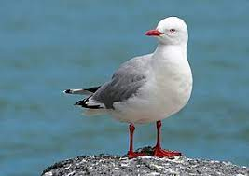
Learning Area | Dedicated standard | Number | Opportunity 1 | Opportunity 2 | Opportunity 3
Te reo matatini me te pāngarau | Te Reo Matatini | 32413 | 10 – 21 June | 9 – 20 Sept | 30 Oct Kete Manarua
Te reo matatini me te pāngarau | Te Reo Matatini | 32415 | 10 – 21 June | 9 – 20 Sept | 30 Oct Kete Manarua
Te reo matatini me te pāngarau | Pāngarau | 32412 | 10 – 21 June | 9 – 20 Sept | 30 Oct Kete Manarua
Literacy and numeracy | Literacy Reading | 32403 | 20 – 31 May | 9 – 20 Sept
Literacy and numeracy | Literacy Writing | 32405 | 20 – 31 May | 9 – 20 Sept
Literacy and numeracy | Numeracy | 32406 | 20 – 31 May | 9 – 20 Sept

A derived grade is not available for any of the dedicated co-requisite standards.
Appendix 2 - Matauranga Māori EN2 in Level 1 standards
Some internally assessed NZC achievement standards require specific inclusion of matauranga Māori in student evidence. Where relevant, it is mentioned in explanatory note 2 of a standard.

Learning Area | Level 1 subject | 1.1 | matauranga Māori EN2? | 1.2 | matauranga Māori EN2? | 1.3 | matauranga Māori EN2? | 1.4 | matauranga Māori EN2?
English | English | 91924 | N | 91925 | N | 91926 | N | 91927 | N
NZ Sign Language | NZ Sign Language | 92355 | N | 92356 | N | 92357 | N | 92358 | N
Te Reo Māori | Te Reo Māori | 92092 | Y | 92093 | Y | 92094 | Y | 92095 | Y
The Arts | Dance | 91936 | N | 91937 | N | 91938 | N | 91939 | N
The Arts | Drama | 91940 | Y | 91941 | Y | 91942 | N | 91943 | Y
The Arts | Visual Arts | 91912 | Y | 91913 | N | 91914 | N | 91915 | N
The Arts | Te Ao Haka | 91976 | Y | 91977 | Y | 91978 | Y | 91979 | Y
The Arts | Music | 91948 | N | 91949 | N | 91950 | Y | 91951 | N
Health and Physical Education | Physical Education | 92016 | N | 92017 | Y | 92018 | N | 92019 | N
Health and Physical Education | Health Studies | 92008 | N | 92009 | N | 92010 | N | 92011 | N
Learning Languages | Te Reo Māori Kūki ‘Āirani | 92040 | N | 92041 | N | 92042 | N | 92043 | N
Learning Languages | French | 91964 | N | 91965 | N | 91966 | N | 91967 | N
Learning Languages | German | 91968 | N | 91969 | N | 91970 | N | 91971 | N
Learning Languages | Gagana Sāmoa | 92032 | N | 92033 | N | 92034 | N | 92035 | N
Learning Languages | Japanese | 91956 | N | 91957 | N | 91958 | N | 91959 | N
Learning Languages | Korean | 91960 | N | 91961 | N | 91962 | N | 91963 | N
Learning Languages | Lea Faka-Tonga | 92036 | N | 92037 | N | 92038 | N | 92039 | N
Learning Languages | Chinese (Mandarin) | 91952 | N | 91953 | N | 91954 | N | 91955 | N
Learning Languages | Spanish | 91972 | N | 91973 | N | 91974 | N | 91975 | N
Learning Languages | Gagana Tokelau | 92347 | N | 91248 | N | 92349 | N | 91250 | N
Learning Languages | Vagahau Niue | 92251 | N | 92352 | N | 92253 | N | 92354 | N
Mathematics and Statistics | Mathematics and Statistics | 91944 | N | 91945 | N | 91946 | N | 91947 | N
Science | Science | 91920 | Y | 91921 | N | 91922 | N | 91923 | N
Science | Agricultural and Horticultural Science | 91928 | Y | 91329 | N | 91930 | Y | 91931 | Y
Science | Chemistry and Biology | 92020 | N | 92021 | N | 92022 | N | 92023 | N
Science | Physics, Earth and Space Science | 92044 | N | 92045 | N | 92046 | N | 92047 | N
Social Sciences | Religious Studies | 91916 | N | 91917 | N | 91918 | N | 91919 | N
Social Sciences | Social Studies | 92048 | N | 92049 | N | 92050 | N | 92051 | N
Social Sciences | History | 92024 | N | 92025 | N | 92026 | N | 92027 | N
Social Sciences | Geography | 91932 | N | 91933 | N | 91934 | N | 91935 | N
Social Sciences | Commerce | 92028 | Y | 92029 | N | 92030 | N | 92031 | Y
Technology | Materials and Processing Technology | 92012 | N | 92013 | N | 92014 | Y | 92015 | N
Technology | Digital Technologies | 92004 | N | 92005 | N | 92006 | N | 92007 | Y
Technology | Design and Visual Communication | 92000 | Y | 92001 | N | 92002 | N | 92003 | N

Evaluation

2024 LNA Seminar EVALUATION
