.

Leading National Assessment
Seminar 2025
18 February – 7 March 2025
Kaitakawaenga ki te Tumuaki me ngā Pouārahi |
Principals’ Nominees and Senior Leaders



Pukapuka Aratohu | Handbook
Wāhanga Tohu Mātauranga | School Quality Assurance and Support

Contents
NCEA in 2025 4
2024 Level 1 NCEA – the data 8
Co-requisite requirement 10
Strengthening Credible Assessment – 18
Authenticity and Generative Artificial Intelligence (GenAI) 18
Strengthening Quality Assurance 21
Managing National Assessment reviews – 2024 feedback 22
Strengthening Internal Moderation 23
External moderation in 2025 31
Quality Data – New Process for Subcontracting Arrangements 32
Quality Data – your SMS data submission files 34
Principal’s Nominee: Functions, Skills and Attributes 38
Strengthening external assessment 41
Derived grades 41
Working with your Exam Centre Manager during the year 42
A year in the life… Managing your NCEA assessment calendar 45
Strengthening Communications 46
Reminders for new and seasoned Principals’ Nominees 49
Appendices 49
Memorandum of Understanding – draft template 51
2025 NZC NCEA Internally Assessed Achievement Standards – Review and Maintenance Programme updates 53
2025 External assessments 57
School Quality Assurance and Support – online workshops for schools 2025 68

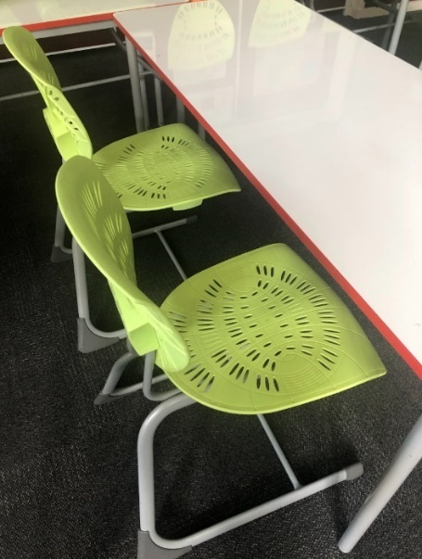

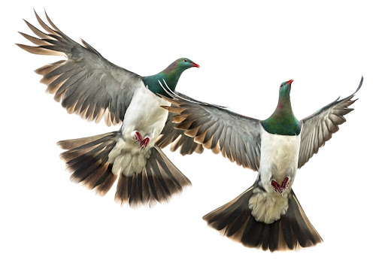

“Ko te manu ka kai i te miro, nōna te ngahere.
Ko te manu ka kai i te mātauranga, nōna te ao.
The bird that partakes of the berry, theirs is the forest.
The bird that partakes of knowledge, theirs is the world.”

Te Kere Ngataierua, Te Āti Haunui-a-Pāpārangi

NCEA in 2025

What did you learn from 2024?

e.g. Submitted externals, CAA and TAPā administration, making entries, results, less assessment, more learning, work-ons, staff capability, resourcing….

What is on your agenda for 2025?

e.g. assessment timing, Level 1 programmes and assessment, Co-requisite strategy, teacher capability, GenAI….

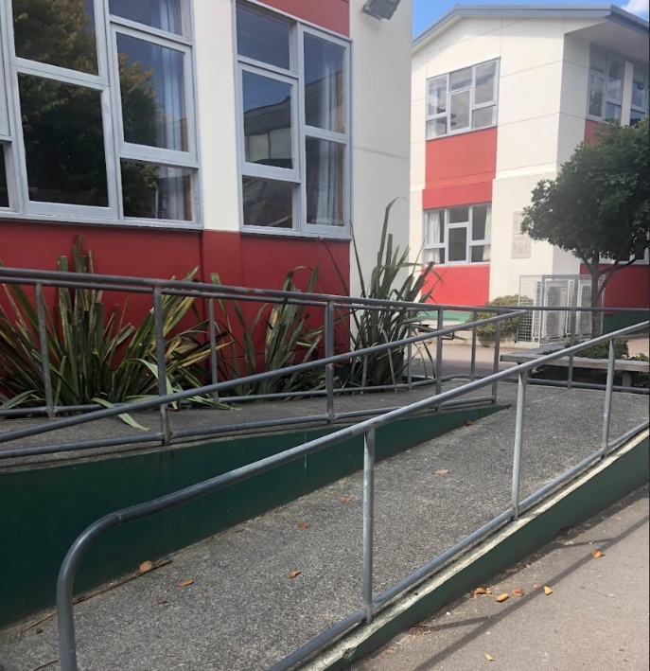

2025 – Changes for all schools and levels, not just Level 1

Revised Achievement Standards and supporting materials for assessment
A number of Achievement Standards and supporting materials, across all three levels, have been updated for 2025 following the Ministry of Education’s Review and Maintenance Programme (RAMP) of the New Zealand Curriculum NCEA subjects.

Refer to the Appendices – revised Internal Assessment, and all External Assessment

Most of the updates have been made to improve clarity and interpretation. Some are due to the removal of submitted reports as a method of external assessment in Level 1. Some of the standards for which there were submitted reports in 2024 will now be assessed by examination, while others will now be assessed by submitted portfolio. See the Appendix for full details, including changes in internal / external standards in Level 1 Social Studies and Level 1 English.

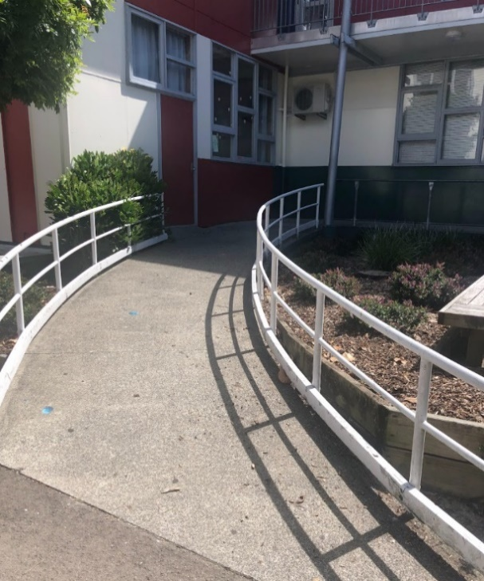
The Ministry of Education has responsibility for reviewing and maintaining those achievement standards and their supporting material. The MOE, NZQA and subject associations contribute to whether standards are prioritised for review, and which materials need to be updated.

There will be no further changes to any Achievement Standards for this year. Any further RAMP changes will be for implementation in 2026 and will be signalled at the start of Term 4 2025.

Supporting material includes:
- Unpacking the Standard,
- Conditions of Assessment,
- Internal Assessment Activities and their assessment schedules,
- Sample Course Outlines,
- Subject Learning Outcomes,
- External Assessment Specifications, and
- Sample assessment items for changed externally assessed standards.
Activity

Take a moment to find each of the above for your favourite subject –

What can you find here for specific standards? https://www2.nzqa.govt.nz/ncea/subjects/select-subject/
What can you find here for specific standards? https://ncea.education.govt.nz/
What can you find here for specific standards? https://lms.nzqa.govt.nz/local/login/index.php

Question
How do your teachers know where to look for subject resources?
How do you know if they’re looking?

How effectively do your teachers use these resources?

- NZQA Subject Resources for all achievement and unit standards, including exemplars and clarifications and buttons that link to Pūtake. National Moderators’ Reports for 2024 assessment will be published by the end of March
- MOE’s NCEA platform for all curriculum related developments, teaching and learning resources, including sample tasks and Conditions of Assessment
- TKI is moving and the replacement site Tāhūrangi is not yet fully developed. The MOE has Curriculum Advisors – Senior Secondary who can support teachers with task design and Teaching and Learning programmes in their specific subject areas.
- Co-requisite resources are located on both sites. The MOE has a focus on resources to support teaching, whilst resources to support assessing can be found on the NZQA site.

Consider

What are the implications of the RAMP updates:
- For you and your senior leadership team?
- For your curriculum leaders / Heads of Department / Teachers in Charge?
- For your subject teachers?
- For your students?

Are there any school systems or processes you need to review because of the updates?

Exemplars for Achievement Standards.
Most external standards have expected student responses or exemplars available now.
Level 1, 2, 3 internal standards have guidance available on expected responses in assessment schedules.

Reminder of the Excellence – a competence to mastery model discussion paper. Always rely on standard and achievement criteria for making assessment grade decisions – not your expectations of grade distribution.
Other updates affecting subjects in 2025

Removal of Supported Learning standards from NCEA
- The Supported Learning unit standards were republished in June 2024 to clarify that the unit standards are intended for students with learning and intellectual disabilities. They are not intended to be used for the award of NCEA.
- From 2025, credits gained from achieving Supported Learning unit standards will no longer be eligible to contribute to the award of a NCEA.
- This exclusion applies to all standards in the Community and Work Skills - Supported Learning - Personal, Community and Work Skills Domain, currently 29299-29310, 32927 and 32929.
- There are New Zealand Certificates (that don’t contribute to NCEA) that schools could consider offering.

New New Zealand Scholarship subjects in 2025
- Scholarship Digital Technologies – exam.
- Scholarship Psychology – exam.

Scholarship exams 2025
- Further New Zealand Scholarship subjects will be available to be assessed by digital exam this year. The list of subjects will be confirmed soon.

Te Reo Māori 92094
- Please note that although Te Reo Māori 92094 is scheduled for assessment on 4 November (the first day of exams), it will be a school-managed assessment, however schools can work with their Exam Centre Managers for support.



2024 Level 1 NCEA – the data
In 2024, there were 70,250 Year 11 students enrolled at secondary schools for one day or more. Of these, 45,038 (64%) participated in a full programme of assessment leading towards a NCEA Level 1 qualification. We have defined ‘participating in a full programme’ to mean a student has been entered for at least 80 credits of assessment, inclusive of the Co-requisite credits.

The table below shows participation and attainment for all Year 11 students enrolled at secondary schools in 2024 and in 2023
 | 2023 | 2024
Year 11 students participating in a full programme of assessment leading  to a NCEA Level 1 | 75% | 64%
Year 11 attainment of NCEA Level 1 (out of all Year 11 students enrolled  at senior secondary) | 62% | 45%
Year 11 attainment of NCEA Level 1 (out of those students participating in  a full programme of assessment leading to a NCEA Level 1) | 82% | 70%

The chart below shows the numbers of Year 11 students enrolled in 2023 (blue) and 2024 (red), and the number meeting the NCEA Co-requisite requirement.
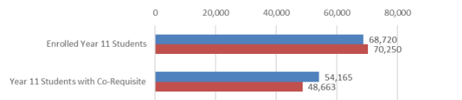

In 2024, 155 schools did not offer a full programme of assessment leading to a NCEA Level 1 to their Year 11 students.

The table below shows the five regions with the highest proportion of schools not offering a full NCEA Level 1
Region | Number of schools not offering a full NCEA Level 1 assessment programme to their Year 11 students
Auckland | 64 of 130 (49%)
Southland | 7 of 16 (44%)
Wellington | 17 of 55 (31%)
Manawatū-Whanganui | 9 of 36 (25%)
Hawkes Bay | 7 of 30 (23%)

The number of schools by School Equity Index Group not offering a full NCEA Level 1 to their students:
School Equity Index Group | Number of schools not offering a full NCEA Level 1 assessment programme to their Year 11 students
Fewer socio-economic barriers to achievement | 40 of 83 (48%)
Moderate socio-economic barriers to achievement | 34 of 221 (15%)
More socio-economic barriers to achievement | 32 of 192 (17%)
Unassigned (schools without an EQI number, such as private schools and Te Kura) | 49 of 58 (84%)

Further notes about 2024 participation in NCEA Level 1
- There are four achievement standards in each new Level 1 subject. On average, across all New Zealand Curriculum (NZC) and Te Marautanga o Aotearoa (TMOA) derived subjects at Level 1, 33% of students had entries for all four standards in a subject.
- For Level 1, 27% of achieved results came from externally assessed achievement standards, 50% from internally assessed achievement standards, and 23% from unit standards.
- In 2024, Year 11 students who were fully participating in NCEA Level 1 were entered into an average of 101 credits (excluding the dedicated Co-requisite standards), down from 113 credits in 2023. This reduction, along with fewer, larger standards, might have had a minor impact on attainment.

The ERO review

“The Ministry of Education will consider ERO’s report to understand its impact on NCEA Level 1 and the future implementation of Levels 2 and 3. We recognise the challenges with NCEA Level 1 changes and are committed to improving the rollout of Levels 2 and 3….

Many of ERO’s recommended “quick changes" have already been implemented by the Ministry. These include:
- removing submitted reports as a method of external assessment in NCEA Level 1 from 2025
- extending the transition period for the implementation of the new NCEA Co-requisite standards - originally scheduled to end in 2025 - by another two years up to the end of 2027. The extended transition will give schools and kura extra time to adjust to the new requirements and strengthen the teaching and learning of te reo matatini, pāngarau, literacy and numeracy.
- providing schools supplementary funding to help offset the costs of administering the NCEA Co-requisite assessments (see page 13 for more detail).
- offering targeted literacy and numeracy support that will initially benefit around 10,000 secondary students
- reviewing and updating Achievement Standards and supporting materials of New Zealand Curriculum NCEA subjects across all three levels.”

https://ncea.education.govt.nz/whats-new/ministry-consider-ero-review-ncea-level-1 26/11/2024
Discuss

How did you approach Level 1 in 2024?
How did it go?
How will you approach Level 1 in 2025?

NZQA has invited schools to complete a survey this term – see EmaiLink #1. We have extended the deadline for schools to 7 March.
The survey includes questions about NCEA Level 1 participation.
The Ministry of Education is working with NZQA and the Minister of Education’s NCEA Professional Advisory Group on further possible changes to NCEA.

Co-requisite requirement
Te Reo Matatini me Te Pāngarau | Literacy and Numeracy
The purpose of the NCEA Co-requisite is to ensure that all students who attain a NCEA have the foundational Te Reo Matatini or Literacy and Pāngarau or Numeracy skills to succeed in future pathways.
All students need to achieve the 20-credit Co-requisite to be awarded any level of NCEA. The Co-requisite is a one-off requirement.

The transition period for the implementation of the NCEA Co-requisite, originally scheduled to end in 2025, has been extended for another two years up to the end of the 2027 academic year. This is intended to give schools, kura, and all NCEA providers extra time to adjust to the new requirements and strengthen the teaching and learning of te reo matatini, pāngarau, literacy and numeracy.

A reminder to check whether standards are eligible, and to check students’ eligibility to use those standards: Eligibility is determined based on individual students’ enrolment status recorded with the Ministry of Education.

Literacy and numeracy assessment standards.

Options for completing the Co-requisite in 2025, 2026, 2027

Co-requisite transition arrangements 2025 - 2029
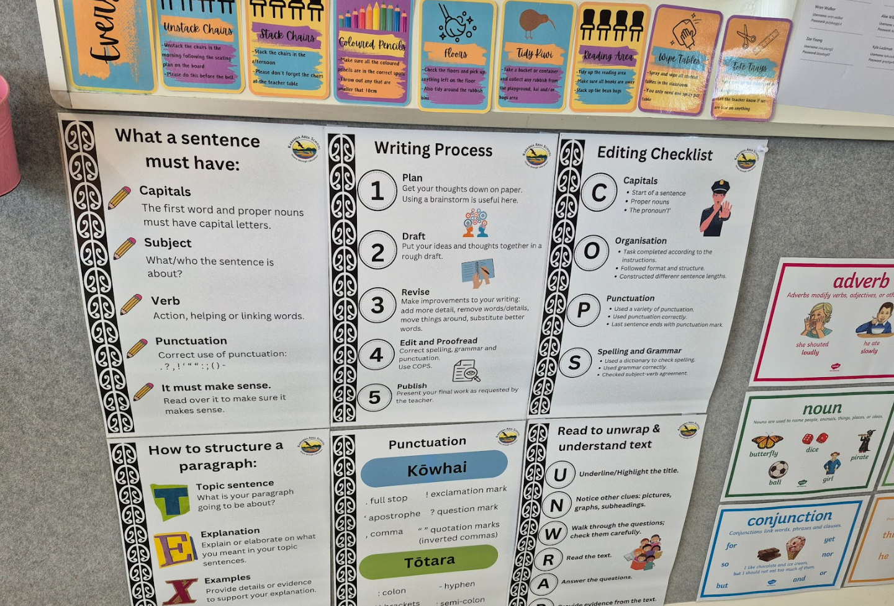

Ministry of Education Core Generic standards eligibility restrictions clarification
The standards with usage restrictions include the 266** series of standards.
These standards may only be used to meet the Co-requisite requirement:
- with students who are enrolled full-time with tertiary education organisations
- or students enrolled with alternative education providers, activity centres, specialist schools, teen-parent units, health schools, and youth justice facilities,
- or students living in Niue, Tokelau, or the Cook Islands in the current academic year.
Students in mainstream NZ schooling can only gain the Co-requisite through the dedicated standards (324**s) or from the approved achievement standard list.
Students should not enrol with another provider for the purpose of accessing the 266** standards.
Please refer to the Ministry of Education’s eligibility criteria for detail about students who are enrolled in an alternative eligible setting and then return to school to complete the 266* series in the same academic year.
Eligibility for standards with restricted usage requirements is based on ENROL data. Schools need to ensure their ENROL data is accurate to ensure eligibility. Schools should contact the Ministry of Education to confirm eligibility for individual students.

2025 Assessment dates for Te Reo Matatini me Te Pāngarau | Literacy and Numeracy

A few NCEA Co-requisite reminders
Remember – the overall credit requirement for a qualification is 80 credits.

Remember – where additional standards are used to meet the Co-requisite, the associated credits can be used in calculations for course endorsement and certificate endorsement, but not towards the 60 credits (i.e. they cannot be double-counted).

Remember – The 266XXX series of unit standards can only be used to complete the Co-requisite by students who meet the eligibility criteria. If the student is only or mostly enrolled at a school or kura, they are likely ineligible. Engaging in short courses at other training organisations will not make students eligible to use these standards to complete the Co-requisite.

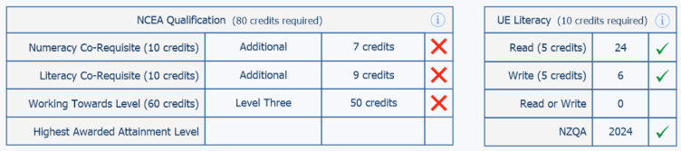
Remember – not all University Entrance Literacy standards count for Co-requisite Literacy.
In this scenario, a screenshot from a SMS, the student has completed the UE Literacy requirements, but not the Level 3 requirements. The student needs at least 10 more Level 3 credits and Co-requisite Literacy and Numeracy to complete the University Entrance award. The Level 3 credits must include at least 14 credits in each of 3 UE approved subjects.

Co-requisite Literacy Writing, Literacy Reading and Numeracy assessment 2025
This year we will provide a different assessment each week for the Co-requisite Literacy Writing, Literacy Reading, and Numeracy assessments.
- Students may only attempt ONE assessment within the two-week period.
- Assessment One must not be used as a teaching tool for the second week's assessment.

Question

Does everyone know how the Co-requisite works?
Deans, whānau teachers, students, careers advisor, teacher aides…?

Co-requisite administration payment
Last year, the Ministry of Education announced that schools will receive a co-requisite payment to help offset the costs of administering the dedicated Co-requisite standards’ assessments in 2024.
NZQA will distribute this payment alongside the usual administration payment. Schools that reported results for dedicated Co-requisite standards will each receive a base payment of $200, plus $5 per candidate for each assessed result. When the payment is made, NZQA will email Principals’ Nominees a breakdown of how it was calculated.

Please note the following criteria apply:
- The payment will only be made for students assessed against the specific Literacy (US32403 and US32405), Te Reo Matatini (US32413 and US32415), Numeracy (US32406) and Te Pāngarau (US32412) standards in 2024 (not for the list of additional standards).
- The payment will be calculated based on the number of standards where there were assessed results, rather than the number of entries to a maximum of $15 per student.
- If a student participated in multiple assessment events for a standard, their school would receive a single payment for the student being assessed against that standard; and
- Absent and Standard Not Assessed outcomes are not included as an assessed result.
Question
What happens with the administration payment in your school / kura?

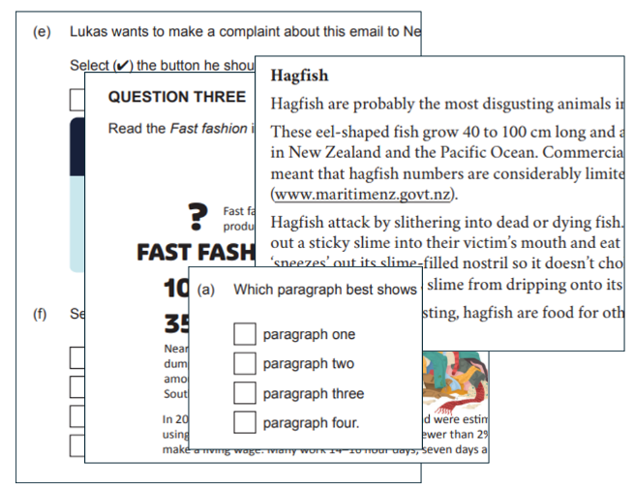
New Process: Common Assessment Activity (CAA)
& Tumahi Aromatawai Pātahi (TAPā) Quality Assurance 2025

Your School Relationship Manager (SRM) may request a visit with you during the Co-requisite assessment window in May or September this year to quality assure the delivery of the assessments.

The school’s processes and practices related to CAAs and TAPā will be evaluated to ensure they provide students with credible assessment opportunities. This includes determining students’ readiness to participate, making timely entries and managing the delivery of the assessments.

- Review information will be sent to you prior to the visit. The template we will use aligns with the Literacy and Numeracy Administrative and Submission Instructions.
- Visits may not necessarily be on the day a standard is being assessed and should take about two hours. Where possible, your SRM may ask to meet with a supervisor and some students.
- After the visit, the school will receive a brief written report summarising our findings.

In preparation for a possible visit, you may wish to do some self-review using the template on the following pages.

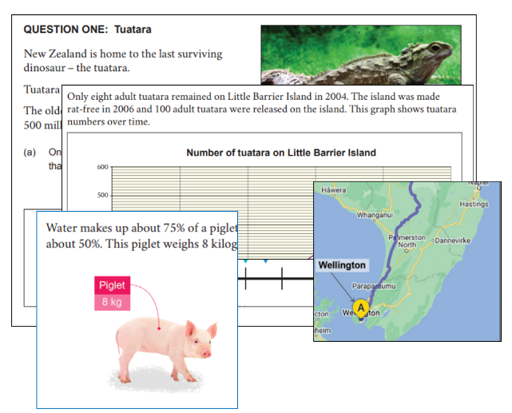
CAA self-review template
The school has processes in place to: | Y/N
Evaluate student readiness to participate in the assessment
Check and submit students’ entries into the standard(s) on time
Make late entries for students
Ensure students receive information about assessment conditions
Ensure the correct external assessment conditions in the assessment specifications are met
Ensure all supervisors are familiar with accessing and using Assessment Master and have tested their logins
Ensure all teachers/supervisors have read and understand assessment specifications and instructions/guides
Ensure the school technician is available to assist
Securely print and store PDFs for SAC students and/or if required where Assessment Master is unavailable
Ensure login credentials are kept secure

The school has processes in place to: | Y/N
Ensure students know their NSNs
Check that students have created their MyNZQA accounts and know how to login
Give students the opportunity to complete practice digital assessment or PDF paper assessments

Prior to the assessment the school has organised: | Y/N
Suitable rooms are used where students are spaced appropriately
Spare devices and headphones are made available
That material on walls is covered / removed as appropriate
Headphones are compatible with devices used
Reliable Wi-Fi is available in assessment spaces
Digital exams device checks
Power sources are accessible

Discuss

What works well in your context?

Next steps for your school / kura:

Term One:

Term Two:

Term Three:

Term Four:

The school administers the CAA / TAPā appropriately by: |  | Y/N
Having enough supervision available
Providing the appropriate SAC conditions for students
Ensuring provision is made for sufficient time as needed by students
Reading the pre-assessment instructions
Providing students with printed copies of the assessment if required
Instructing and assisting students to follow login processes and provide students with the 4-digit access code
Checking that students have submitted their responses i.e. their status is ‘Complete’
Closing the CAA at the end of the assessment session
Submission and follow-up |  | Y/N
Possible breach of assessment rules reports completed (if needed)
PDF papers scanned and uploaded using naming conventions (if needed)
Scanned paper register completed (if needed)
PDFs are destroyed, uploaded files deleted or kept secure (if needed)
Submit the results confirmation process form if required

Strengthening Credible Assessment –

Authenticity and Generative Artificial Intelligence (GenAI)
Level 1 Submitted Report externals have gone
Due to the administrative burden of submitted reports and concerns over authenticity, including the rapid advancement in AI tools, the Ministry of Education decided to discontinue their use as a method of external assessment in NCEA Level 1 from 2025. The change in methods of assessment is intended to support schools and teachers in implementing NCEA Level 1 and address specific concerns over authenticity.
https://ncea.education.govt.nz/understanding-how-ncea-requirements-are-changing#submitted-reports-to-be-discontinued-as-an-external-assessment-method-from-2025

Authenticity

Schools with consent to assess standards are required to have an authenticity policy to support assessment practice. This policy must include the acceptable use of AI. School policy should help students, teachers and the school community understand the parameters for GenAI use in learning and assessment.

Assessment is authentic when it affirms the skills, knowledge and competencies acquired by ākonga, and reflects real world contexts.

Things to be aware of:
- Valid assessment evidence must be the student’s own work. Similarly to plagiarism or over-scaffolding, if GenAI is used to produce evidence that is assessed as the student’s work, then the assessment is invalid.
- The possible uses of GenAI in assessment contexts are therefore more limited than in teaching and learning contexts.
- For NCEA internal assessments, teachers must be aware of any specific requirements of the Achievement Standard being assessed and its Conditions of Assessment. See also Guidance on the acceptable use of Artificial Intelligence.

Generative AI in NCEA
Key Messages:

- Schools must have a policy on the acceptable use of GenAI. This policy should guide teachers’ and students’ NCEA assessment practice.
- The principle of authenticity means that students are required to demonstrate their own knowledge, understanding, and skills in NCEA assessment events. Any evidence submitted for assessment must be their own work.
- Another way of thinking about a student’s ‘own work’ is that it presents evidence of the knowledge and skills being assessed against the standard that the student has independently demonstrated and that they could repeat in a different context.
- The use of GenAI is not permitted in NCEA external assessment.

Questions to consider when writing assessment policy to include AI

- How do you promote academic integrity?
- What is academic integrity?
- How does the use of GenAI relate to academic integrity?
- What are the responsibilities for ensuring academic integrity for students? for teachers? for whānau?
- Do your school’s assessment communications outline the responsibilities of each group, and have a clear process to follow when these may not have been met?
- How does your school policy outline your preferred approach to referencing source material, including referencing GenAI?
- Do students and staff understand how to reference GenAI – with the platform used, the date, the prompt and the response?
- How does your school policy warn about bias and inaccurate information being generated by GenAI?

Breaches of assessment rules
Referring to the breaches of external assessment rules may help you determine your school policy, when your school assessment rules have been breached, and how you respond - Breaches of external assessment rules.

The biggest sub-category of reported breaches for 2024 external assessment came from inauthentic material within submitted external reports, specifically the use of Gen AI.

As examples, the following incidents may raise questions about the credibility of a student’s result in an assessment. The list does not cover every situation.

- A teacher notes that student work may have been generated using a Gen AI tool or copied from the internet / exemplar / another source or another student
- A teacher notices a sudden increase in text in a short period of time, indicating unauthorized material or Gen AI may have been used
- A teacher considers that there may have been inappropriate assistance from another person
- A school identifies that a teacher may have provided excessive feedback
- A teacher notes that there may have been inappropriate collaboration between students that may affect the credibility of the results.

Updated resources on the use of Generative AI – MOE and NZQA
- Guidance on the acceptable use of Artificial Intelligence - NZQA
- Generative AI - Ministry of Education
How do you know evidence is authentic?
Although we no longer have submitted reports, we can apply what we learnt from the experience to internal assessment.

Remember a template like this last year? Would it help to improve the robustness of assessment conditions at your school?

Pre-assessment blank template for subject use – adapt to suit.
Subject and standard
Teacher in charge
Number of students
Task given out date:

Milestone dates:

Due date:
Plans for absent students

Conditions of assessment

Teacher guidance?
Teacher feedback?
Security of resources / task?
Security of work in progress?

Authenticity risks & mitigations

Use of generative AI?

Discuss
- What did you learn from the 2024 submitted reports that could apply to internal assessment and/or DG exams and/or external assessment in your school?

- How alive and well is academic integrity in your student body? Across your staff? How do you know?

- How confident are you about the way each subject area manages authenticity? What is that level of confidence based on?

- How do you document Breaches of Authenticity and monitor them to ensure consistent practice across all learning areas?

Strengthening Quality Assurance
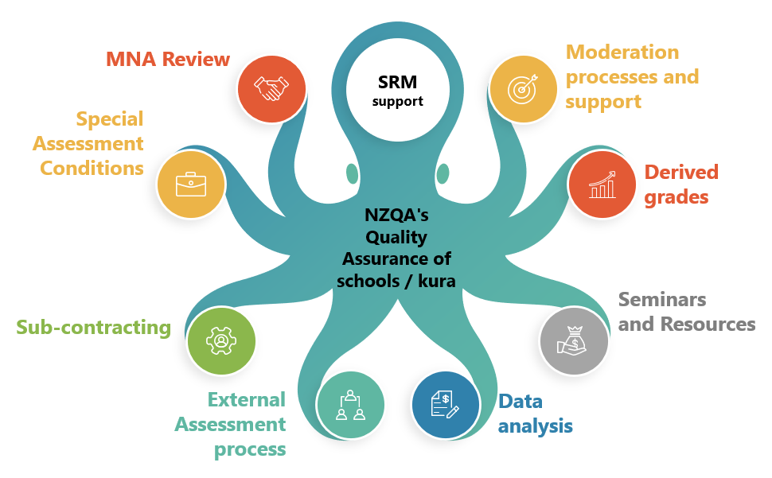

Everything in moderation, except moderation!

How will you strengthen moderation this year?
How will you strengthen moderation this year?

Managing National Assessment reviews – 2024 feedback

Managing National Assessment (MNA) reviews are a partnership between schools and NZQA. Reviews look for evidence to answer the question:

“How effectively does your school
ensure the credibility of assessment for national qualifications?”

Sections of the report and related agreed actions in 2024 MNA reports

External and Internal Review | Leadership, Ownership and Capability  Responses to External Moderation
Credible Assessment Practice | Assessment Processes and Procedures  Communications currency and accessibility  Derived grades Quality Assurance  Data Management and Use  Equity  External Assessment
Internal Moderation | Internal Moderation Processes  Monitoring Internal Moderation

Agreed actions in 2023 and 2024 MNA reports
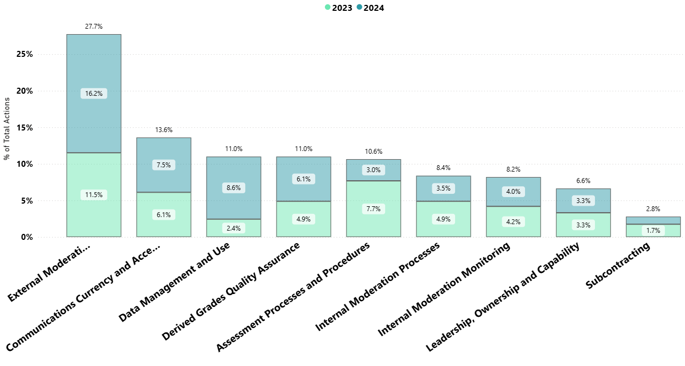

Consider
Which of the above areas are you confident that your school or kura delivers effectively?

Strengthening Internal Moderation
Activity

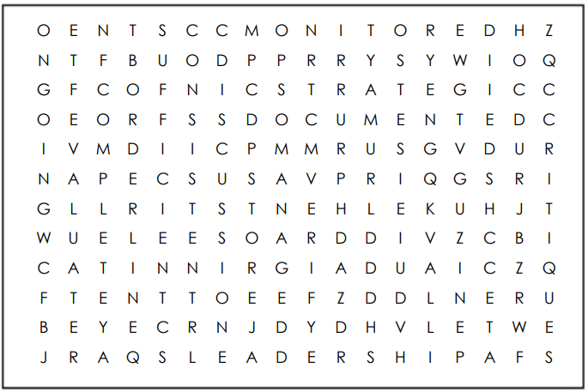

The credibility of NCEA relies on effective quality assurance in your school / kura. Find 17 terms.

Consider
Why should you strengthen internal moderation?

Schools must undertake quality assurance to ensure that:
- all assessment material is critiqued and re-contextualised / modified as necessary, before use
- assessor judgements are consistent with the standard
- for each standard, a sufficient sample of each teacher's grade judgements is verified
- for each standard, assessment materials are retained, along with a selection of student work following NZQA guidelines, for the purpose of external moderation
- all advice from external moderation is actioned before the materials are used again.

NZQA (through your School Relationship Manager) undertakes to:
- review the internal moderation processes and follow up external moderation of every school with Consent to Assess NCEA every year, and
- to provide support and guidance when a school’s internal quality assurance processes fall short of NZQA’s requirement
Review and improve systems and processes
A ‘high trust’ model does not meet NZQA’s requirements.
Everything must be able to be checked and completed before results are reported.

Review Step 1. Quality Assure the Critiquing Process
Is the critiquing process robust across all your subject/learning areas?
Hints that a subject area’s critiquing is not robust enough are apparent when NZQA external moderators’ reports advise your teachers to check one or more of the following:
- standard
- exemplars
- Pūtake - APT tool and other NZQA assessor support tools,
(Make sure teachers have ESL access to Pūtake!)
- clarifications
- National Moderator’s report.
- How often do you meet with learning leaders to discuss whether their documentation matches practice in their department?
Can you share ownership with HODs/HOLAs for this?

Review Step 2: Quality Assure the Verification Process
How to strengthen verification:
- select a verifier who is a subject expert with recent, successful experience with the standard
- go outside the school, even if you have enough staff to do it in-house
- share the critiquing materials with the verifier
- revisit external moderation feedback before assessing the standard again, and tell the verifier what you wanted to improve
- share relevant moderator feedback with the verifier
- other ideas:

Activity:
We have highlighted the parts of the internal moderation cover sheet that are too often left blank or rushed through.

- Do you know why each is important? How do you check if your staff know?
- Are they completed thoroughly in your school? How would you know if they weren’t?
- What actions could you implement to ensure that documentation is consistent with actual practice?

INTERNAL MODERATION COVER SHEET

Aspects of critiquing and verification that are sometimes overlooked
NZQA Assessment Rules require that schools must establish an internal moderation process that meets NZQA's requirements and which is applied each year, for each teacher, to every internally assessed standard being assessed, to ensure that judgements are consistent with the Assessment Standard.
Faculty/Department: __________ Teacher in Charge of Assessment: __________________
Assessors: _______________________ __________________________ _____________________________

Section A: Complete information on the assessment before any teaching
Course Title: |  |  |  |  |  | Standard Number: |  | Version:
Standard Title:
Credits: |  | NZQF Level: |  |  | The school has consent to assess this standard |  |  |  |  | Yes |  | No
Source of Materials: Commercial / Own / MOE / NZQA / Subject Association / Other (specify):
Section B: Critique all assessment materials before any assessing
The critiquing process is to ensure that the assessment materials meet the requirements specified in the standard and provide the opportunity for students to present authentic evidence at all grades.
Before use the assessment materials have been checked against:
The current moderator report and clarification of the standard document |  |  |  |  |  |  |  |  |  |  | Yes |  | No
The conditions of assessment |  |  |  |  |  |  |  |  |  |  | Yes |  | No
Any external moderation feedback |  |  |  |  |  |  |  |  |  |  | Yes |  | No
The standard is unchanged, and the task has been previously critiqued, |  |  |  |  |  |  |  |  |  |  | Yes |  | No
If yes, no further critiquing required.
The assessment is consistent with the explanatory notes/learning/context/curriculum level |  |  |  |  |  |  |  |  |  |  | Yes |  | No
The assessment allows students to achieve all requirements and grades of the standard |  |  |  |  |  |  |  |  |  |  | Yes |  | No
Assessment schedule is consistent with the standard and clarifications documents |  |  |  |  |  |  |  |  |  |  | Yes |  | No
Instructions are consistent with the standard explanatory notes/range statements |  |  |  |  |  |  |  |  |  |  | Yes |  | No
Judgement/sufficiency statements clearly describe performance levels for each grade, e.g. quality & length |  |  |  |  |  |  |  |  |  |  | Yes |  | No
Evidence statements allow for a range of acceptable answers with specific examples for each grade (A/M/E) |  |  |  |  |  |  |  |  |  |  | Yes |  | No
Student instructions are clear, and language is appropriate |  |  |  |  |  |  |  |  |  |  | Yes |  | No
Registered standard number, version, title, level and credits are given. |  |  |  |  |  |  |  |  |  |  | Yes |  | No
Critiquer Name: |  |  |  | School: |  |  |  |  | Date:
Section C: Verify sufficient teacher judgements before reporting results PTO
The verification process is to ensure that any teacher judgements are consistent with the standard before they are reported to NZQA.
Verifier Name: |  |  | School: |  |  |  | Position: |  | Date:
Evidence of verification is available overleaf, attached or at location (specify):
I have sighted evidence of the critiquing and verification processes completed for this standard.
Signed: Position: |  |  |  |  |  |  |  |  | Date:
Section D: Retain samples and review assessment materials after results are reported
Results loaded into student management system: |  |  |  |  |  |  |  |  | Date:
Assessment materials and student work are stored to meet NZQA requirements |  |  |  |  |  |  |  |  |  |  | Yes |  | No
Location or file path:
Where required NZQA selection requirements have been used to select work for external moderation and material submitted |  |  |  |  |  |  |  |  |  |  | Yes |  | No
Assessment materials have been reviewed in response to feedback |  |  |  |  |  |  |  |  |  |  | Yes |  | No
New benchmark samples have been annotated and/or existing examples of grade boundary decisions have been updated |  |  |  |  |  |  |  |  |  |  | Yes |  | No

SECTION C: VERIFICATION OF EVIDENCE USING STRATEGIC SELECTION
Strategic selection of samples of work is based on the experience of the assessor(s), external moderation history, and the previous use of the task. The sample size can be sufficient, purposeful (at grade boundaries) or minimal. Each teacher’s marking must be verified each year, for each standard assessed.
Student’s Name | Marker’s  Grade | Reason selected for verification | Verifier’s  Grade | Summary of discussion comments (or location of these comments) | Final Grade
 |  |  |  | 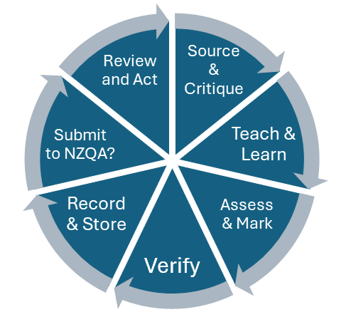
Briefly justify the total number of pieces in this sample:
Complete all columns. Add extra rows as required. Where appropriate, it is good practice to indicate a grade’s proximity to a boundary.
https://www2.nzqa.govt.nz/ncea/ncea-for-teachers-and-schools/managing-national-assessment-in-schools/moderation/internal-moderation/
When you’ve finished this sheet, check if the standard needs to go to External Moderation. If so, do it now!

Use External Moderation feedback to strengthen Internal Moderation
Activity
Which of these issues are identified in the External Moderation report excerpts A, B and C below?
- Poor reading/understanding of the standard
- Incomplete or inadequate critiquing
- Problems with a verifier
- Other (e.g. Materials or curriculum level)

What advice you would give the assessors in your follow up?
Are you familiar with the meaning of the consistency statements?
-----------------------------------------------------------------------------------------------------------------------------
A. The evidence accepted for all levels of achievement needed strengthening in all instances. Convincing biological knowledge is required to develop an informed response (position and action) by proposing (at Achieved), explaining (at Merit), and justifying (at Excellence), why the personal position and the proposed personal/societal action(s) have been taken. This should be based on the integrated biological knowledge, rather than just on researched ideas. The personal response needs to flow logically from the integrated biological knowledge used, at level 8 of the curriculum. The Making Assessor Judgements workshop for this standard provides further guidance about the quality of evidence required. It can be accessed via the Biology subject page of the NZQA website.

NB: 6 grades in a range from N to E all went to N. Outcome NYC.
Issue/s:
Follow up advice:

--------------------------------------------------------------------------------------------------------------------------------
B. Overall, assessor decisions for the sample of work provided are not consistent with the standard. Of particular concern is that a number of students have selected pieces which are not suitable for assessment at this level. Further advice and guidance around which pieces of music are suitable for assessment could help improve student achievement. A review of this standard's exemplars, available on the NZQA website, may help the assessor to better align their grade decisions with the national expectations.

NB: Grades 3 E-M. 2 M-N. Outcome NC.

Issue/s:
Follow up advice:

C. Overall, assessor decisions for the sample of work provided are not yet consistent with the standard. Additional evidence is expected to explain or justify the oxidation and reduction reactions. For achievement with Merit, the standard requires learners to identify oxidation and reduction using the change in oxidation numbers or the correct number of electrons lost or gained. For achievement with Excellence, the standard requires learners to justify oxidation and reduction using changes in oxidation number or electron transfer. The clarification document and exemplars for Merit and Excellence for this standard provide further guidance and these can be found on the Chemistry subject page on the NZQA website.

Assessment Schedule
Overall, do evidence and judgement statements provide sufficient guidance to assessors?
No
Issues Identified:
For Merit, oxidation and reduction need to be explained in terms of the change in oxidation number, or the correct number of electrons lost or gained. Justifying oxidation and reduction using change in oxidation number or electron transfer from 1 species to another is required for Excellence.
Recommendations:
The judgement for Merit in the assessment schedule needs to be modified to include a statement that oxidation and reduction are explained in terms of change in oxidation number, or the correct number of electrons lost or gained

NB: Grades 2 E-A, 1 E-M; 1 M-A, 2 N-N. Outcome NYC.

Issue/s:
Follow up advice:

Internal moderation evaluation and next steps

To improve external moderation outcomes, improve internal moderation processes.

Use external moderation feedback to check where internal moderation processes could have been improved. If critiquing steps were ticked that were not actually carried out, then include this in an action plan.

Submit a Query Only 3 percent of all External Moderation reports have been queried since the facility was introduced 5 years ago! Yet teachers often express disagreement with the Moderator’s decisions. Using the Query facility can help teachers gain greater clarity and improve future outcomes. Make sure you and your HODs/HOLAs have got access to the External Moderation App guide and they know how to submit a query.

Out-of-cycle moderation NZQA may require additional moderation from a school for repeatedly failing to follow NZQA’s moderation requirements, including addressing ongoing issues in subject areas.

In Schedule 4 of the NZQA Rules:
6. Schools or TEOs to address issues that are identified in the report
- Before the School or TEO next assesses against the standard they must address issues that are identified in the External Moderation results report, including (without limitation) where there is any use of invalid tasks or lack of agreement by the moderator with assessor judgements and issues related to academic integrity
- If the issues referred to in clause 6.1 are not adequately addressed, NZQA may require additional out-of-cycle external moderation and/or impose limitations on reporting results for internally assessed standards. This may include, but is not limited to, measures such as requiring additional external moderation to confirm assessor grade judgements prior to the reporting of results or taking steps to remove the relevant standard from a School’s or TEO’s Consent to Assess.

Use consistent, monitored ways to follow up External Moderation feedback You may like to use or adapt the templates on the Principal's Nominee resources page, to assist with your review at a standard level, subject or department level, and whole-school level.

External Moderation in 2024

What happened to your external moderation in 2024?

- Benchmarking: As new Level 1 Achievement Standards were assessed and moderated in 2024, NZQA had to hold submissions until benchmarking was completed and moderators trained on grade boundaries. Benchmarking could not proceed until suitable samples had been obtained.

- Check moderating by another moderator for a significant number of samples to ensure consistency in moderation reports. For some systems, this involved three months of compulsory checking.

- Standards with Explanatory Note 2 (EN2) requiring Mātauranga Māori underwent additional checks.

- Check moderator comments / Mātauranga Māori check moderator comments adjusted, and report returned to schools.
A note about timing:

- We supported schools to submit moderation on time by sending monthly reminders if results had been reported but moderation not yet submitted. Moderation submissions peaked around October which delayed the completion of all processes.
- In some instances, NZQA had to hold moderation as further clarifications were needed on the standard requirements. This meant that NZQA had to work with the Ministry of Education and subject associations.

The National Moderator reports soon to be published will focus on Level 1 standards. They discuss the moderation outcomes for both internals in a subject for schools. Schools who had feedback on one standard can view moderator comments for the other standard in these reports, found through subject pages.
Activity
Find your 2025 moderation plan in your login, in the old portal.

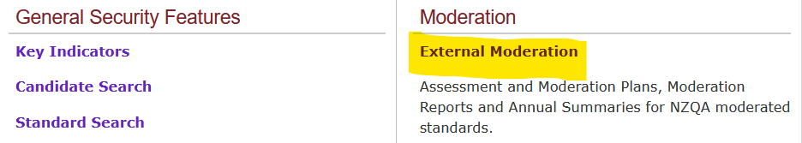

External moderation in 2025
The selection of materials in 2025:

- The focus of moderation is again L1 standards. One standard per subject per school will be selected for moderation. However, it will be the other internal as opposed to the one moderated last year.
- Some Level 2 & 3 standards will be selected to ensure national and school coverage.
- The samples submitted should be from 2025 assessment.
- Your School Relationship Manager can change selected standards in consultation with you.
- Schools are required to submit moderation materials as soon as internal moderation has been completed and results returned to students. The final due date is 20 October 2025. Schools should inform their SRM if this deadline cannot be met because of when a standard is assessed. This will help us get the external moderation back to you in a timely manner.

What will happen to your external moderation in 2025:

- Benchmarking will only be done for standards that have significantly changed. Moderator training will be required for these standards only.

- Moderation completion per subject and standard will be prioritised in order of submission.

- Check Moderation: will be initially extensive for changed standards only. All other standards will be randomly check moderated as usual to ensure timely completion of moderation reports.

- Additional checks for Standards with EN2 Mātauranga Māori content will continue to be check moderated by Mātauranga Māori experts, and we are putting systems in place to speed the process up.

- Additional moderators will clear peak submissions and late submissions in 2025.

Reminders:
- Queries and appeals must be submitted within the deadline - 20 working days.
- Check your 2025 moderation plan and communicate it to your staff.
      - Request any changes to your plan now if you do not plan to assess a selected standard or if assessment programmes change during the year.
      - Discuss with your SRM any selected standards that can’t be submitted by 20 October.

To assist you to monitor the submission of external moderation, from Term 2 onwards we will send you reminders if you have reported results but not submitted required standards.

Additional moderation process
In a new process for 2025, extra moderation support will be provided for selected schools that have been identified through external moderation outcomes. By the end of March, additional standards will be added to moderation plans, selected from standards assessed in 2024 and using student work from 2024. This should be submitted as soon as possible as it aims to provide feedback to help schools with assessing the standard in 2025. Schools will be contacted if they have standards added.

Quality Data – New Process for Subcontracting Arrangements

If a school wants to increase the range of courses or standards that it can offer to learners, it might want to engage sub-contractors to do this. The type of subcontracting arrangement depends on the consent status of the two providers (the school and the external provider).

Types of subcontracting arrangements with an external provider:

- Third Party Consented Memoranda of Understanding (MOUs)
- The external provider holds consent to assess the standards
- The external provider holds responsibility for the quality assurance of assessment
- A memorandum of understanding must be in place for all external providers used

- Third Party Unconsented Agreements
- The external provider does not hold consent to assess the standards, but the school/kura does
- The school/kura retains responsibility for the quality assurance of assessment. An application must be made to NZQA, and be approved, prior to assessing

To minimise the risk to students, the providers and the qualification, it is important that the correct process is followed for all arrangements.

To ensure that all results are from consented providers and students therefore receive their grades, all subcontracting arrangements must be submitted to NZQA from now on.
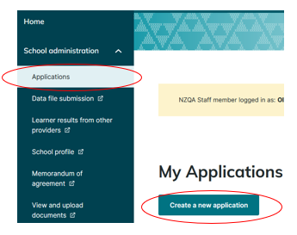

Every MOU and applications to use an unconsented third party must be made in the Applications section of the new portal.

An MOU which does not include required information (below) will be rejected. Please check before uploading.

Third Party Consented MoUs – must be reviewed and uploaded every year

Where an applicant for consent to assess against standards, or a holder of a consent, proposes to use a sub-contractor which itself is the holder of a consent to assess against those standards, the applicant or holder must supply to NZQA the following information prior to using the sub-contractor:
- a copy of the sub-contracting agreement which must outline the responsibilities and obligations of the parties
- the duration of the arrangement
- the reasons for the arrangement
- confirmation that any advertising and other information provided to prospective learners clearly shows that the study or training involved is provided under a sub-contracting arrangement.
From this year you will be required to upload your MoUs in the NZQA portal. More information will be provided in due course.

Third Party Unconsented Agreements – must be reviewed and uploaded every 3 years

- Where an applicant for a consent to assess against standards, or a holder of a consent, proposes to use a sub-contractor which does not itself hold a consent to assess against those standards, the applicant or holder must apply to NZQA to engage the sub-contractor.
- NZQA will only grant approval to an application under rule 8.2 where it is satisfied that:
- the holder remains responsible for the sub-contractor meeting all the holder’s obligations in relation to the consent; and
- the sub-contractor will meet all relevant obligations in the Act and in rules made under section 452 of the Act in relation to the consent; and
- there is an agreement between the holder and the sub-contractor that includes provisions to ensure that NZQA can exercise its quality assurance and enforcement powers and functions in respect of the acts or omissions of the sub-contractor relating to the consent; and
- the information and advertising for the study or training clearly states that it is provided through a sub-contracting arrangement; and
- all learner enrolments are through the holder, and the holder maintains all student enrolment and academic information; and
- the holder will report credits for the learners and pay the relevant credit reporting fee.

Note: Every unconsented sub-contract must be approved by NZQA before any assessment occurs. Contact your SRM if you need assistance.

Question

How do you keep track of subcontracting arrangements?

How do you assure yourselves that these arrangements meet NZQA’s requirements?

Who will upload the MOUs for your school / kura? High Security users only.

Quality Data – your SMS data submission files
Accurate data means less work for you, better tracking of student progress, and staff accountability.
- Check your April file and September file carefully to avoid problems later
- It takes NZQA longer to process files when we’re busy – avoid delays by checking for common errors first

In 2024, over 7500 data files were submitted to NZQA for processing.
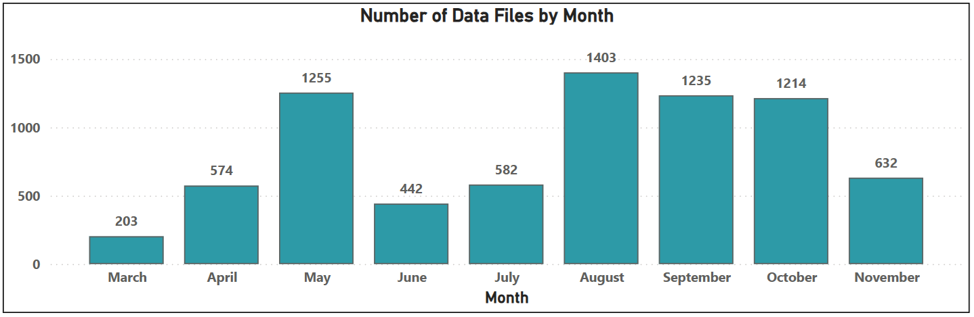Notice the peaks for the first file of the year, and the external assessment due date file.

Within these files, there were over 4.3 million errors or warnings created!
To reduce your workload related errors and warnings, you need an understanding of both the assessment requirements and your SMS processes.

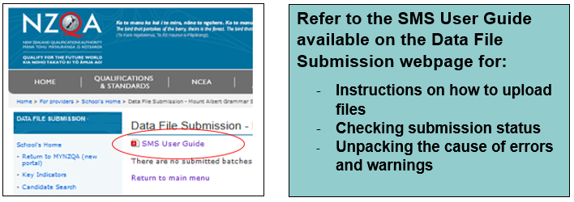
Refer to the SMS User Guide available in the Data File
Submission link in your login for:
- instructions for uploading files
- checking submission status
- unpacking the reasons for errors and warnings

Data files progress through a sequence of stages
depending on the quality of the data. The status is
visible in the batch summary screen under the ‘Current
Status’ heading.
Most files require some form of follow up by the school. Files containing severe issues will not be processed and will be cancelled by NZQA.

Errors tell you that there is a critical data issue with a record in the file. The record(s) will not be added to or updated in the NZQA database. For this to occur, the error must be corrected.

Warnings tell you about minor data issues. A warning will still allow the record(s) to be added or updated in the NZQA database, but unless corrected, the warning message will persist.

Discuss:
What do you do to prepare a data file for submission?
What helps you to keep your data file clean?

Activity
Match the common errors and warnings from 2024
Issue |  | Resolution
1. Error - Assessment method is either missing or invalid for this standard |  | A: An entry will not be created as the standard or version has expired. Check the data file report to identify the standard then update or remove as needed.
2. Error - No assessment opportunity received |  | B: When a student has achieved a standard but is entered in a subsequent opportunity. No entry will be made in the subsequent opportunity.
3. Warning - Invalid assessment method for standards |  | C: A student has been entered twice for a standard. This usually occurs when the school submits entries for the same standard but different result date or assessing provider. Ensure this is reported correctly.
4. Error - Invalid assessment opportunity supplied as standard has already been achieved in this academic year |  | D: You must select a correct assessment method for every standard with multiple assessment method options (e.g. 91337 is available as a digital submission - DS or paper portfolio - PE). Any entry with this error will not be created. This means that students will not be able to access digital exams for these standards.
5. Warning - Duplicate standard for student |  | E: Some external standards can be attempted multiple times in one academic year (e.g. CAAs). You must indicate which opportunity the entry relates to. Entries with this error will not be created and therefore, students will not be able to access digital exams for these standards.
6. Error - Attempted to withdraw external entry with result |  | F: This usually occurs when special characters are reported in the students’ name or address. Entries for the student will not be created. Remove special characters from the file (e.g. macrons, punctuation and symbols)
7. Error - Internal standard has expired |  | G: A result will not be recorded. Contact the external provider if required and enter the correct provider number and location
8. Warning - Invalid gender code |  | H: Select an Iwi code from the list supplied by your School Management System
9. Warning - No iwi supplied for Māori learner |  | I: An assessment method is missing or is not allowed for a standard. This relates to standards with only one assessment method available. Entry is created but forced into the available assessment method
10. Error - Invalid other provider |  | J: Ensure you enter the correct leaver reason code and date of withdrawal
11. Error - Missing Leaver code/date |  | K: The only gender codes accepted are F and M
12. Error - Value is not ASCII |  | L: Entry will not be withdrawn

Some brief reminders from our Data team
Fees for international students

Fees | GST exclusive | GST inclusive
International student entry to NCEA standards | $333.30 per year | $383.30 per year
International student entry to NZ Scholarship subjects | $88.87 per subject | $102.20 per subject

Since 2020, schools have been responsible for paying the NZQA fee for their international students and are invoiced annually after 1 September. As for all students, all assessment results must be reported to NZQA. For international students a fee must be paid for reporting internal assessment results and/or making entries in NCEA externals and/or New Zealand Scholarship.

NZQA does not adjust invoices to accommodate school data errors so schools must have in place a system to ensure data submitted to NZQA is accurate and to pay the fee. Agreeing assessment intentions with international students when they join your school helps your staff ensure assessment data is accurate. Within your Provider Login, the Billing report in High Security Features and the Foreign Fee Payers link in Key Indicators help you check the accuracy of data reported to NZQA for international students.

Student name changes

If a student changes their name, a formal name change must be requested via your SRM. NZQA need evidence of a legal change of name – with a passport, birth certificate, or legal confirmation of name change document. If you submit a preferred name to NZQA, this will appear in student’s learner logins, and examination admission slip, but not on Records of Achievement or Qualifications. Check with your SRM or schools@nzqa.govt.nz (the Data team) regarding particular situations.

Data processes for students who leave secondary education or transfer to another school

Make sure you and / or your data manager are familiar with these processes. If a student is leaving secondary education, do not withdraw their enrolment or they will lose all their entries and results for the year. If a student is transferring to your school, you need to enter all their entries and results from their previous school into your SMS, using the other school’s provider code. If a student is transferring from your school to another school, make sure you send the new PN all the student’s entries and results – they can’t access them otherwise.

Make sure the standards file in your Student Management System (SMS) is up to date.

Get teachers to check the versions of any standards that were put in markbooks early this year, to ensure that they have added the most recent versions.

Every request for the NZQA Data team to change a result needs to be approved by your School Relationship Manager first.

Quality Data – Learner Login reports

NZQA has improved the Learner Login reports. They have been changed to simply indicate if a student has a registered account or not. Previous reports captured access to the old portal and not the new portal so could be incorrect.
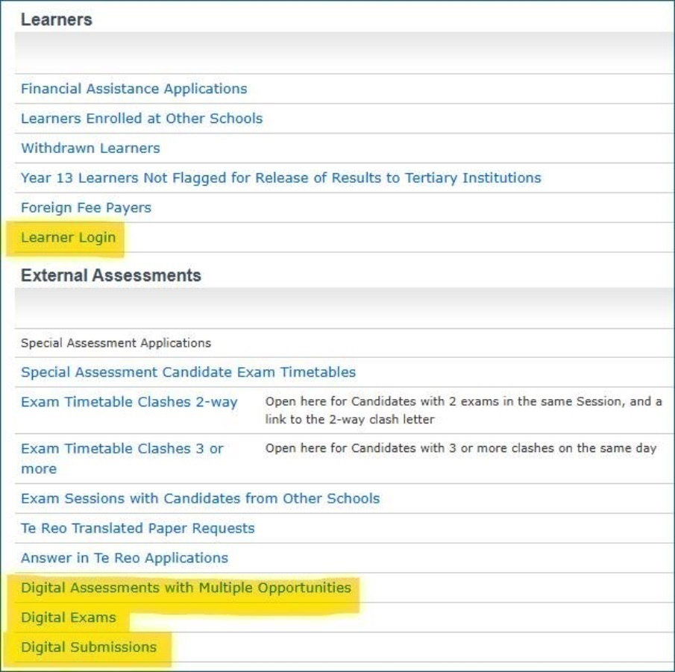

You will now see a list of candidates and if they have a registered learner account - Yes or No.

There are five reports that have been changed (one in Reports and four in Key Indicators):
- Candidate Account Register – previously called Candidates’ Last Login
- Learner Login
- Digital Assessments with Multiple Opportunities
- Digital Exams
- Digital Submissions

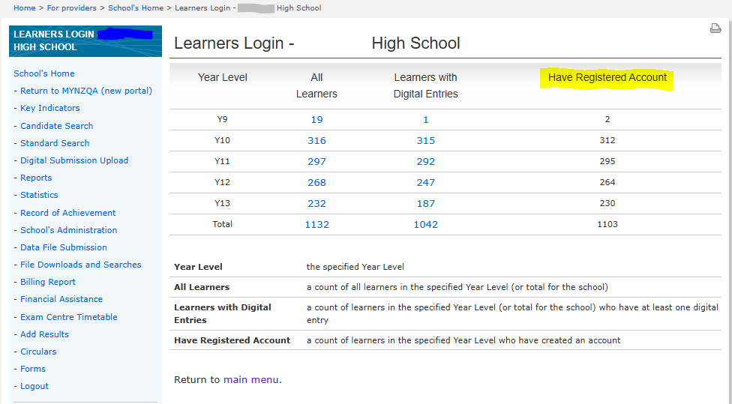

Principal’s Nominee: Functions, Skills and Attributes
To ensure the integrity of New Zealand qualifications, each school is accountable for three aspects of assessment. The Principal’s Nominee, acting as an individual or as part of a team, ensures that each aspect is carried out.

Assessment aspect | Role functions | Skills and attributes
Leadership | Leading by enabling and empowering curriculum leaders and teachers to provide quality assessment of students for New Zealand qualifications. | Respected  Assessment knowledge holder  Permission giver  Influencer  Communicator  Change leader
Quality assurance | Monitoring and reviewing that effective practice of quality assessment for New Zealand Qualifications meets student needs. | Regulatory  Analytical  Evaluative  Assessment expertise
Administration | Checking that the administrative functions needed to assess for New Zealand Qualifications are accurately managed to meet agreed timelines. | Attention to detail  Accuracy  Compliance and Control  Functional Knowledge

Rules and requirements:
- NZQA Assessment Rules for Schools, TEOs assessing against Achievement Standards and NCEA Co-requisite Standards, and Candidates 2025
- Requirements for Consent to Assess (CAAS)
Discuss:

How are Leadership, Quality Assurance, and Administration of assessment covered within your school?

Accountabilities
Activity:
Annotate the PN Accountabilities table with the codes of your people.

Indicate which ones you might need to discuss further with your colleagues at school.

Is there anything you think should be added? Ticked differently?

SCHOOL ASSESSMENT ACCOUNTABILITIES | ASSESSMENT LEADERSHIP | QUALITY ASSURANCE | ADMINISTRATION / MANAGEMENT
identifying issues and risks to credible qualifications and assessment integrity |  | 
enacting responses to self-review findings to ensure credible qualifications and assessment integrity
maintaining, monitoring and documenting the Quality Assurance of internal moderation practices within the school to ensure the validity and credibility of assessment for qualifications
ensuring the school engages in and complies with the external moderation process, monitoring that issues identified by the external moderation process are addressed, and evaluating the effectiveness of internal moderation
providing guidance about the appropriateness of assessment programmes for the school’s curriculum, courses and pathways.
ensuring the integrity of assessment data submitted to NZQA, including student eligibility, reported results and student entries for external assessment; ensuring that assessment data including student information is sent to NZQA to meet published deadlines
developing and managing the school’s processes for monitoring authenticity and responding to breaches of the Assessment Rules and to appeals of assessment decisions
considering and making applications to NZQA on behalf of students for special assessment conditions
quality assuring evidence for derived grades and managing applications to NZQA on behalf of students
holding current and appropriate subcontracts with external providers
maintaining the school’s assessment policy and procedures to reflect current NZQA requirements and communicating these to staff, students, and families
ensuring the smooth running of external assessment conducted during the year (on going or point in time), including administering non end of year digital external assessments

ensuring that all NZQA requirements and timelines for external assessments are met, including the smooth running of end of year exams, in conjunction with the ECM, ensuring the availability of suitable staff, accommodation, and equipment for the conduct of external assessments, and the provision of special assessment conditions
monitoring and tracking student progress
leading professional learning to build assessment-capable teachers
responding to NZQA communications and requests for information, communicating with school staff about assessment matters, including navigating the NZQA website and sharing NZQA communications
facilitating NZQA visits and reviews
ensuring that student fees (for international students) are paid in full to NZQA to meet published deadlines
ensuring succession planning for ECM and PN roles
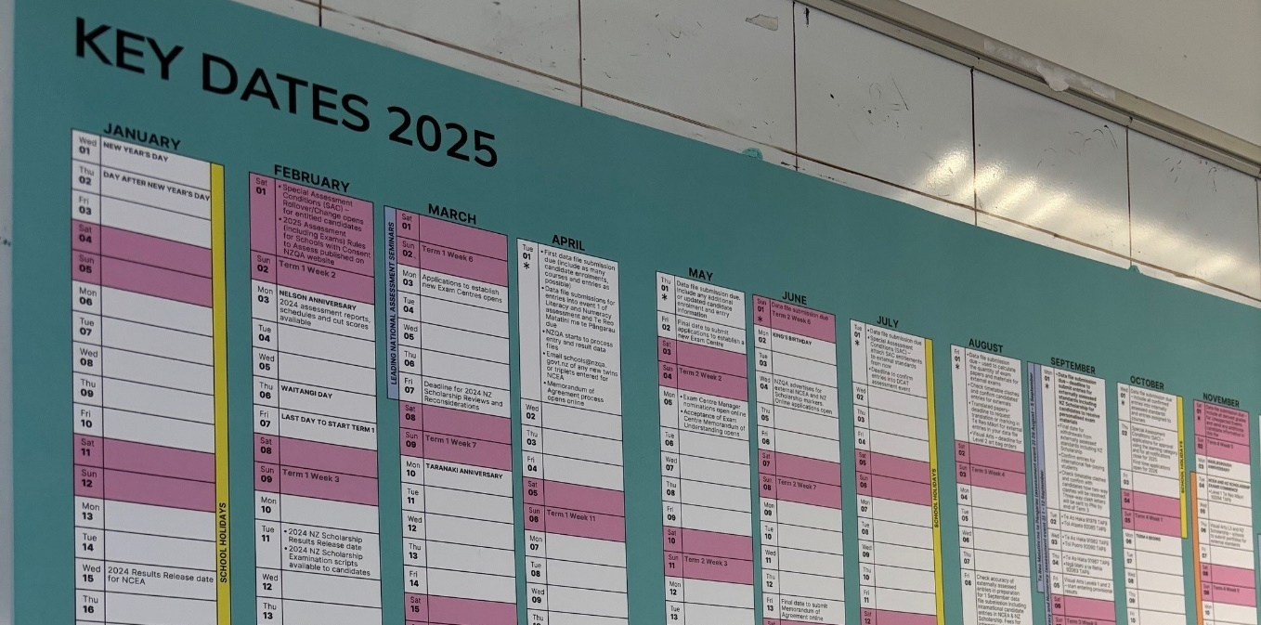
Consider joining the Aotearoa New Zealand Principal’s Nominee Network – email anzpnn@gmail.com

Strengthening external assessment

Derived grades
There is a new derived grade (DG) application submission tool. It will be introduced once final testing is completed, hopefully by the end of Term 1. We believe that the tool will make it easier and quicker to submit applications. It is designed to be an intuitive tool, but there will be support materials provided.

One of the new features is that it will pull the practice exam grades that you submit to NZQA through the monthly file submission from our database into the application. You will not have to enter these grades manually if they have already been submitted.

You must submit practice exam grades to NZQA so that grades can be awarded when students can’t attend an exam, or their performance is impaired.

Common reasons why students apply for derived grades:
- a temporary acute illness or injury
- a significantly disturbing or distressing experience
- a sudden and significant change to a chronic illness that happens no more than 1 week before the student’s first affected assessment
- national representation in a sport, academic, or cultural event.

Consider

Why is it important to submit all potential DGs to NZQA?
What are the barriers to this happening in your school?

Each application is evaluated by NZQA based on the evidence provided. The process must be robust to ensure that student results are credible. We decline about 2% of the approximately 3,000 applications we receive each year.

Reasons why we might decline derived grade applications:

- Exam(s) sat outside dates covered by medical evidence.
- Medical evidence does not support the application – no impairment.
- Medical evidence obtained well past the exam date – over a fortnight.
- Students not checking their entries – students must check their admission slips to ensure the entries are accurate; their last opportunity is to put their hand up at the beginning of the exam. Checking mark books for accuracy before 1 September is essential.
- Family events such as overseas weddings.
- Limited disruption to an exam – fire alarms are common occurrences, as is outside noise.
- Issues with technology that have been resolved. A loss of connectivity doesn’t necessarily mean work isn’t saved. Quite often the work is saved and available for marking once connectivity is restored.
- National representation application that is not for representing New Zealand (or another country). Clubs, churches, regional, local and self-selection will be declined.
- Loss of preparation time before an exam.

Working with your Exam Centre Manager during the year
Your responsibilities as PN, from PN Skills and Attributes include:
ensuring that all NZQA requirements and timelines for external exams are met, including the smooth running of end of year exams, in conjunction with the ECM, ensuring the availability of suitable staff, accommodation, and equipment for the conduct of external exams, and the provision of special assessment conditions.

Your role with the ECM through the year

Review

What went well during the 2024 EOY NCEA Exams?
What were the pressure points?
What could you do to strengthen external exam practice in your school/kura?

Roles and responsibilities of the PN and ECM
A strong working relationship between the Principal’s Nominee (PN) and Exam Centre Manager (ECM) helps to ensure that exams run smoothly. More information about these roles can be found on the NZQA website, under Examination Centre Management.

Principal’s Nominee / SENCO | Exam Centre Manager
Pre-Exam Planning
Applies or confirms intention to be an Exam Centre for the current year.
Nominates & provides agreed resources to ECM  - sends ECM Nomination to NZQA  - sets up ECM with a laptop  - provides access to required areas of the school and to photocopier/printer. | Signs contract with NZQA and schedules an initial planning session with PN & SENCO to go over exam requirements.
Managing Entries  - checks and uploads data files with all exam entries  - enters SAC candidates. | Planning for Entries  - uses entries to populate Planner  - communicates room and reader/writer requirements to the PN.
Confirm the requirements for each candidate with SAC for each exam. | Plans for candidates with SAC.
Plans for 2-way and 3-way exam clashes, liaising with SRM for 3-way clashes. | Uses the NZQA approved clash plans to arrange supervision and support for students.
PN and ECM compare entries to ensure accuracy.
Exam Assistants  - provides ECM with a list of Exam Assistants for SAC candidates  - conducts EA training where needed  - supplies the ECM with a list of all EAs. | Supervisors and Exam Assistants  - recruits supervisors  - conducts training for supervisors and digital training for EAs.
Arranges storage and sorting spaces for exam papers to align with NZQA storage requirements. | Receives, checks, and sorts exam papers and packages papers for SAC students.
Rooms & Equipment Planning  - ensures rooms are properly resourced for exam conditions, including SAC needs  - arranges laptops for each digital exam room  - organises and tests equipment for subjects with audio or recording components  - plans for digital connectivity and IT support. | Room Allocation & Candidate Planning  - allocates candidates to rooms  - assigns reader/writers according to PN/SENCO information.
- ensures students and staff are briefed and prepared for exams and introduces ECM to students.
PN and ECM establish communication methods and determine strategies for various scenarios.
During Exams
Preparing Exam Rooms  - arranges rooms for exam conditions  - checks that required equipment is ready  - provides staff to clear calculator memories if required for an exam  - arranges recording equipment for New Zealand Scholarship, language, performance exams. | Setting Up Exam Rooms Before Every Session  - conducts exam room inspections and designated toilet checks  - lays out required exam papers as per seating plan  - downloads AV files and tests before students are admitted to exam room
Prepares and posts exam related signage. | Posts student room allocations for each session.
Prints exam papers for late entries if needed, and updates ECM with the late entries roll. | In coordination with PN, manages late entries and walk ins.
Arranges procedures for candidates arriving without their admission slip. | Completes attendance rolls and supervises students inside the exam room and the dashboard for digital exams.
Briefs office staff on courier collection protocols. | Sorts and packs exam papers after each session for courier collection.
Uploads students’ digital files (for performance or language subjects). | Transfers digital recordings of student work and saves to a location specified by PN.
Save copies of student responses completed under computer use SAC provisions. | Informs computer use students to print any work to be marked.
Responsible for students if they are evacuated from the exam room in emergency scenarios. | Responsible for evacuation of students from exam room into the care of the PN, then ensuring live exam papers are secured.
Apprises and works with ECM to resolve issues during exam period and assists students with derived grade applications to NZQA where appropriate. | Completes reports of situations arising using appropriate forms and packs these with exam papers for collection, as well as apprising PN.
Meets students coming to sit exams from a different school. Makes ECM aware of these entries. | With advice from PN, plans for and records attendance of students from another school.
Ensure support is provided to ECM during sessions for, but not limited to:  - possible Breaches  - walk in students  - medical or other emergencies  - to relieve for a break if ECM is the sole supervisor in an exam room. | Contacts PN using previously agreed communication method.
After Exams
Answers queries from NZQA in relation to:  - derived grade applications  - missing or incorrectly loaded digital submissions  - possible Breaches. | Answers queries from NZQA in relation to:  - student attendance information  - missing booklets/responses  - possible Beaches  - derived grades  - incident reporting.



A year in the life… Managing your NCEA assessment calendar
Consider

What are your tips for managing NZQA and school assessment deadlines and timeframes?

What challenges do you and/or your staff and students face with managing deadlines and timeframes?

What, if anything, will you do differently this year?

Calendar notes – plan for these early:
- Co-requisite CAA and TAPā assessment event 1 entries are due in your 1 April data file.
- Co-requisite CAA and TAPā assessment event 2 entries are due by 18 August.
- External moderation must be submitted for each requested standard as soon as the internal assessment process is complete.
- Grades from school practice exams for use as potential derived grades should be reported to NZQA before external exams begin.

We have developed an editable template based on the NZQA Key Dates Year Planner. To use, click on the blue “USE TEMPLATE” button. This will save a copy to your Google drive to then personalise for your use.
It does not have all the Key Dates in it. You should always refer to the key dates for secondary assessment published on the NZQA website.

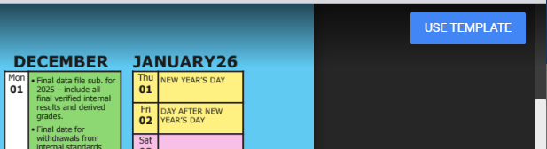

A year planner that blends the NZQA key dates with your school/kura key dates may help you make date decisions during the year, ensure staff are well informed, and keep to deadlines.

Suggestions for personalising the calendar to suit your school / kura:
- delete information not relevant to you e.g. assessments you’re not involved with or anniversary days that are not applicable.
- add significant school-wide events, such as
  - sports - tournament weeks, athletics and/or swimming sports days, major games
  - arts and events - school production, camps, open evenings, prize giving ceremonies
  - assessment - specific Co-requisite assessment dates, school derived grade exams
  - staff commitments - parent-teacher interviews, open evenings, reports.
- change or add colour coding to highlight different patterns e.g. reporting cycles.

Strengthening Communications

It is important that you have comprehensive assessment policies and procedures documented clearly for staff and students, and that these are up-to-date. Communication about assessment also needs to be fit-for-purpose.
Consider / Discuss

Who else in the school is familiar with your handbooks / intranet / website information?

How and where do your staff and students find out what to do?

Share your best practice.

Self-review tool for school assessment documentation
This list identifies information that could be included in school documentation.

 | Staff | Student | NZQA links to support | Templates
Communication
Legislation and Rules |  |  | NZQA Rules
BOT assessment Policy
NCEA Certificates |  |  | Guide to NCEA  NCEA Levels and Certificates
Certificate & Course endorsement |  |  | NCEA endorsements
Course outlines
University Entrance  - Approved Subjects |  |  | University Entrance  Approved Subjects
Vocational pathways |  |  | Vocational Pathways
NZ Scholarship |  |  | NZ Scholarship
Subcontracting arrangements and MOUs |  |  | Subcontracting
New Zealand Certificates |  |  | NZ Certificates
Assessment processes
Appeals  (process and form) |  |  |  | Student Appeal Application
Authenticity (including use of GenAI |  |  | Myth
Breaches of the Rules
Derived grade - assessment tasks used, quality assurance |  |  | Derived grades | Recording DG quality assurance
Further Assessment Opportunity & Resubmission |  |  | Assessment Opportunities  Myths
Guidelines for gathering evidence of achievement |  |  | Gathering evidence of achievement
Missed and late Assessments  (process and form) |  |  | Missed and late assessment | Student Extension Request
Privacy of student results and work
Reporting Not Achieved
Special Assessment Conditions |  |  | L1 Notification process
Standards-based assessment |  |  | About standards
Moderation
Internal Moderation
Expectations for:  - Critiquing  - Verification  - Storage of material  - Evidence |  |  | Internal Moderation | Internal moderation cover sheet
Monitoring internal moderation completion and effectiveness
External Moderation
External Moderation process |  |  | Using the External Moderation Application
External moderation responses and follow up |  |  | External Moderation  Outcome Statements
Assessor Supports |  |  | Assessor support  Pūtake | Request for clarification
External Moderation follow up for industry unit standards
Data
Consent for standard checked |  |  | Extension of consent to assess
Data accuracy – entries, mark books, reporting grades
Education Sector Login (ESL) |  |  | ESL
Fees/Financial Assistance  International students? |  |  | Fees for international fee-paying candidates
MyNZQA Learner Login |  |  | Log on to MyNZQA.

Reviewing your templates for school assessment processes

Student Appeal Application – have you included?
- who students should talk to first, then who, then who
- a reasonable timeframe
- the reason for appeal – e.g. result, assessment conditions, resubmission, further assessment opportunity, possible breach of the rules, other
- student explanation and the resolution requested
- evidence – e.g. student work, assessment task, notes
- appeal outcome – decision, review, next steps
- other…?

Student Extension Request / Missed Assessment – have you included?
- who students should talk to first, then who, then who
- a reasonable timeframe
- student reason(s) for missed or late assessment, and the resolution requested
- evidence – e.g. caregiver letter, school trip notification, medical certificate
- request outcome – decision, review, next steps
- other…?

Authenticity instructions for students – have you included?
- specific authenticity requirements for the assessment, including the use of chatbots, generative AI, paraphrasing tools, translators, or other tools that can automatically generate content
- what students may provide to demonstrate authenticity
- what teachers may do to check authenticity.

Also worth considering:
- I understand that I must be able to show that my work is my own
- work I am submitting for assessment is entirely my own
- I must acknowledge the source of all material, (copied or paraphrased), and who provided any assistance, together with the kind of assistance and how much received
- all checkpoint deadlines or milestones must be met during an assessment to show my progression of learning
- if I am suspected of having submitted work that is not my own or have given my work to another student I will be investigated for a breach of school and NZQA rules
- if I have been found to have knowingly or unwittingly gained an advantage, a ‘Not Achieved’ grade must be reported for the assessment of the standard.

Reminders for new and seasoned Principals’ Nominees
- Special Assessment Conditions (SAC) notification process
- EmaiLink lives in Publications on the NZQA Website
- Assessment Matters lives in Publications too - important updates
- Check ncea.education.govt.nz for NCEA updates from the Ministry of Education
- Consider joining the Aotearoa New Zealand Principal’s Nominee Network anzpnn@gmail.com
- Online SQAS support sessions – see Appendix

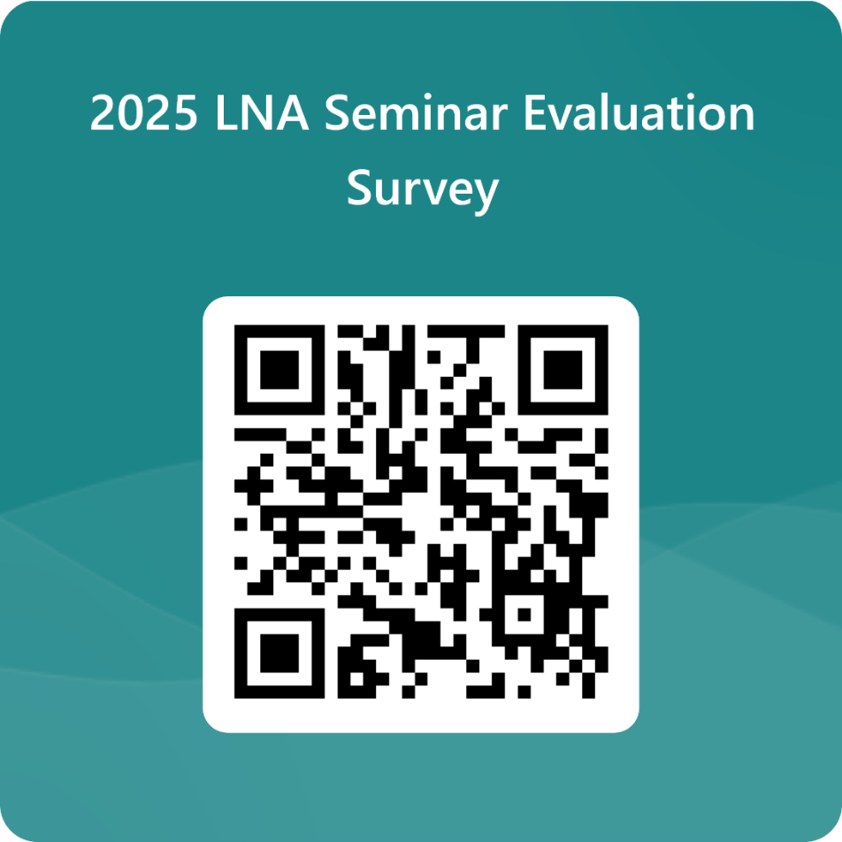

Appendices

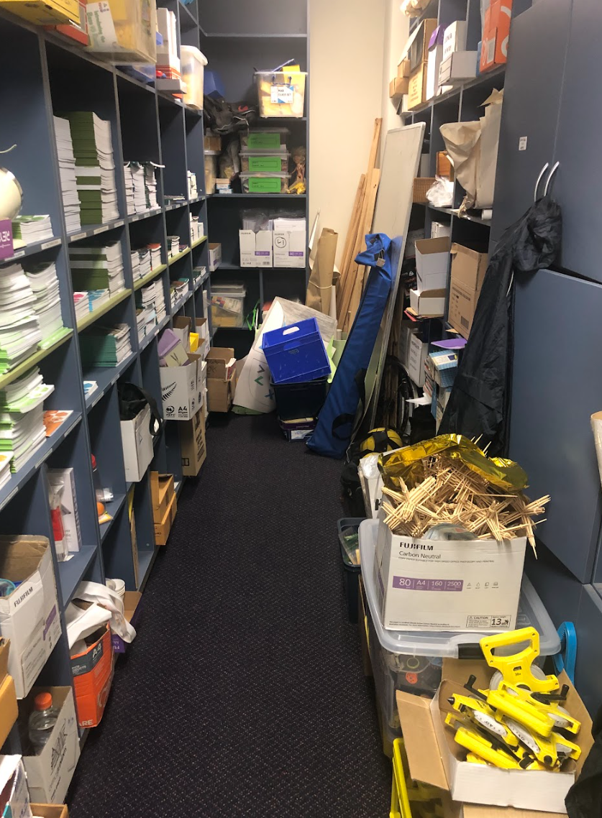

Memorandum of Understanding – draft template

The following is a draft template for a Memorandum of Understanding (MOU) that could be used between a school and a consented external provider (which may be another school). It is a suggestion only and should be adapted to suit specific arrangements negotiated between the school and the outside provider. To protect all parties, the MOU must be agreed and signed before the delivery of any standards commences.

- This Memorandum is between (the school and its provider code) and (the external provider and its provider code). The following arrangements have been agreed between (the school) and (the external provider) to enable the students of (the school) to be taught and assessed against standards in the domains listed below for which (the external provider) has NZQA Accreditation/Consent to Assess.

The standard(s) to be assessed are as follows:

- (The external provider) as provider of professional services to (the school), ensures that the required standards of teaching, assessment, moderation and quality assurance are maintained by agreeing to:
- provide qualified staff competent with NZ Qualifications and Credentials Framework (NZQCF) procedures to deliver courses and assess students for the standards relating to the courses delivered
- have quality management systems to oversee and deliver courses or programmes of learning that lead to the assessment of the standards
- ensure that the standards are assessed according to NZQA requirements
- have quality management systems in place for assessment and moderation procedures
- have procedures for regular and timely reporting of results to the school and ensure that results will be reported to the school by (date)
- have administrative responsibility for the enrolment of students in their courses
- have responsibility for the welfare of students while under their supervision#
- have responsibility for health and safety (Schools should ensure these align with the school’s health and safety, and welfare expectations)
- have responsibility for reporting the attendance and progress of students while attending courses
- have the responsibility for managing student appeals.
- the external provider gives permission for the new school to report results using its provider code for students transferring between schools.

- (The school), as the receiver of academic services from (the external provider), ensures that:

  - it has verified whether (the external provider) has consent to assess the standards specified above
  - it has procedures to collect fees from students and enter them for NZQCF qualifications.
  - it has procedures for the entry of students to NZQCF qualifications
  - it has the responsibility for student welfare when travelling to and from (the external provider)
  - it (or stipulate the person) will oversee the functions of this Memorandum of Understanding
  - it will pay (the external provider) the agreed sum of (financial details) (when and under what terms).

- (The school) and (the external provider) confirm that any advertising and other information provided to prospective students clearly shows that the study or training involved is provided under a sub-contracting arrangement.

- Termination and Amendment of this Agreement
  - This agreement will be in place from (date) until (date), for a maximum of 12 months.
  - This agreement will be reviewed annually for effectiveness by (date)
  - Any amendments to the provision of this agreement must be in writing and signed by both parties.

- Dispute Resolution
  - In the event of any dispute or controversy arising out of, or relating to this Agreement, the two parties agree to exercise their best efforts to resolve the dispute as soon as possible. The parties shall, without delay, continue to perform their respective obligations under this Agreement that are not affected by the dispute.
  - In the event of any dispute or controversy arising out of, or relating to this Agreement, the protection of students will not be compromised in any way.
  - In the event of this arrangement being terminated, the students will be protected financially through (add agreed arrangements here).

Signed for and on behalf of (the school) by its authorised agent:

Date: __________________________________________________

Signed for and on behalf of (the external provider) by its authorised agent:

Date: __________________________________________________

2025 NZC NCEA Internally Assessed Achievement Standards – Review and Maintenance Programme updates
Review and Maintenance Programme (RAMP) work has been undertaken for all three levels of NZC NCEA for 2025. Based on feedback, selected Achievement Standards and supporting materials have been amended for 2025 assessment. It is important to note that not all subjects, Achievement Standards or supporting materials are impacted, and some of the changes are very minor but assist in clarity and interpretation.

Full details are available here: https://ncea.education.govt.nz/reviewed-nzc-achievement-standards-and-assessment-materials-use-2025 and on NCEA.Education and NZQA subject pages.
EN = Explanatory Note, SLO = Subject Learning Outcome
Learning Area | Level | Internal Standard | Changes
English
English | 1 | 91924 | Teacher resource, unpacking, course outlines, SLOs
 | 1 | 91926 | EN2 revised. Was an external in 2024. Unpacking, activities, schedules and conditions changed. Course outlines, SLOs
 | 2 | 91103 | Change to standard wording, activities
 | 3 | 91477 | Change to standard wording, activities and schedules
Te Reo Māori
Te Reo Māori | 1 | 92092 | Unpacking, conditions, SLOs, activities, schedules
 | 1 | 92093 | Unpacking, conditions, activities, schedules
New Zealand Sign Language
New Zealand Sign Language | 1 | 92355 | Unpacking, teacher guidance, conditions
 | 2 | 91801 | EN3, conditions
 | 2 | 91799, 91800, 91801, 91802 | Activities
 | 3 | 91823, 91824, 91825 | Activities
 | 3 | 91822 | Conditions, activities
The Arts
Dance | 1 | 91936 | EN1, EN4, EN5, schedules, SLOs
 | 1 | 91937 | EN1, EN3, EN5, activity, schedules, unpacking, SLOs
Visual Arts | 1 | 91912 | Unpacking, SLOs
 | 1 | 91913 | EN2, activities, unpacking, SLOs
Music | 1 | 91948 | SLOs
 | 1 | 91949 | SLOs

Physical Education
Health Studies | 1 |  | 92008 |  | Revised EN1 criteria, EN 3, EN 4, unpacking, activity, SLO
Health | 3 |  | 91461 |  | Standard wording for consistency, resources
 | 3 |  | 91463 |  | Standard – fewer practices – wording, EN4, resources
Home Economics | 2 |  | 91301 |  | Resource
Physical Education | 1 |  | 92016 |  | Unpacking, conditions, activities, SLOs
 | 2 |  | 91333 |  | Standard updated links, language, definition
 | 3 |  | 91499 |  | Standard criteria, activities
 | 3 |  | 91504 |  | Standard updated links, language
Learning Languages
Gagana Sāmoa | 1 |  | 92033 |  | EN1
Lea Faka-Tonga | 1 |  | 92036 |  | Wording
Te Reo Māori Kūki ‘Airani | 1 |  | 92041 |  | EN1
Vagahau Niue | 1 |  | 92352 |  | EN1
French | 1 |  | All |  | Vocab list
German | 1 |  | 91968 |  | Wording
Japanese | 1 |  | All |  | Vocab list
European Languages | 1 |  | 1.1s |  | Activity unpacking, teacher guidance
 | 1 |  | 1.2s |  | Unpacking repetition
 | 2 |  | 2.3s |  | EN3, conditions
 | 2 |  | 2.2s, 2.3s, 2.5s |  | Activity guidance, conditions
 | 3 |  | 3.2s, 3.3s, 3.5s |  | Activities
Asian Languages | 1 |  | 1.1s |  | Unpacking, teacher guidance
 | 1 |  | 1.2s |  | Unpacking
 | 2 |  | 2.3 |  | EN3, conditions
 | 2 |  | 2.2s, 2.3s, 2.5s |  | Conditions, activities
 | 3 |  | 3.2s, 3.3s, 3.5s |  | Conditions, activities
Pacific Languages | 1 |  | 1.1s |  | Unpacking, teacher guidance
 | 2 |  | 2.3s |  | EN3, conditions
 | 2 |  | 2.2s, 2.3s, 2.5s |  | Activities
 | 3 |  | 3.2s, 3.3s, 3.5s |  | Conditions, activities
Mathematics and Statistics
Mathematics and Statistics | 1 |  | 91944 |  | EN1, activities, schedules, unpacking, SLO
 | 1 |  | 91945 |  | Unpacking, SLO
Science
Agricultural and Horticultural Science |  | 1 |  | 91928 | EN3, activity, conditions, SLO
Biology |  | 3 |  | 91604 | EN2 wording and criteria, resources
 |  | 3 |  | 91607 | EN3 criteria, resources
Chemistry and Biology |  | 1 |  | 92020 | Conditions, unpacking
 |  | 1 |  | 92021 | Purpose statement, EN1, EN5, activities, resources, schedules, unpacking
Science |  | 1 |  | 91920 | Unpacking, conditions, course outlines, SLOs
 |  | 1 |  | 91921 | EN1, EN4, unpacking, conditions, activities, schedules, course outlines, SLOs
Social Sciences
Commerce |  | 1 |  | 92028 | EN1, EN4, EN5, activities, unpacking
 |  | 1 |  | 92029 | EN1, EN2, EN5, conditions, activities, unpacking
Geography |  | 1 |  | 91932 | Course outlines, SLOs
 |  | 1 |  | 91933 | Course outlines, SLOs
 |  | 2 |  | 91241 | EN2 lots of changes to criteria, EN4, resources
 |  | 2 |  | 91244 | EN2, EN3, EN4, EN5, resources
 |  | 2 |  | 91246 | EN2, EN3, EN4, EN5, EN6, activities, resources
 |  | 3 |  | 91430 | EN2, EN3, EN4, EN5, EN6, resources
 |  | 3 |  | 91432 | EN2, EN3, EN4, EN5, EN6 resources
History |  | 1 |  | 92024 | Unpacking
 |  | 1 |  | 92025 | Typo in activity
 |  | 2 |  | 91229 | EN intent clarification, resources
 |  | 3 |  | 91434 | EN4 added, resources
 |  | 3 |  | 91435 | EN2, EN4, resources
Media Studies |  | 2 |  | 91250 | EN2, EN3, EN4, activities
Social Studies |  | 1 |  | 92048 | Title, ENs updated, unpacking, conditions, activities, schedules, SLOs
 |  | 1 |  | 92051 | Standard to reflect mode switch to internal, unpacking, conditions, activities, SLOs
Technology
Design and Visual Communication |  | 1 |  | 92000 | Unpacking, activities, SLOs
Digital Technologies |  | 2 |  | 91896 | Merit criteria, resources
 |  | 3 |  | 91902 | EN added
 |  | 3 |  | 91906 | Criteria edited, resources
 |  | 3 |  | 91907 | Criteria edited, resources
Materials and Processing Technology |  | 1 |  | 92013 | Activities, unpacking, SLOs

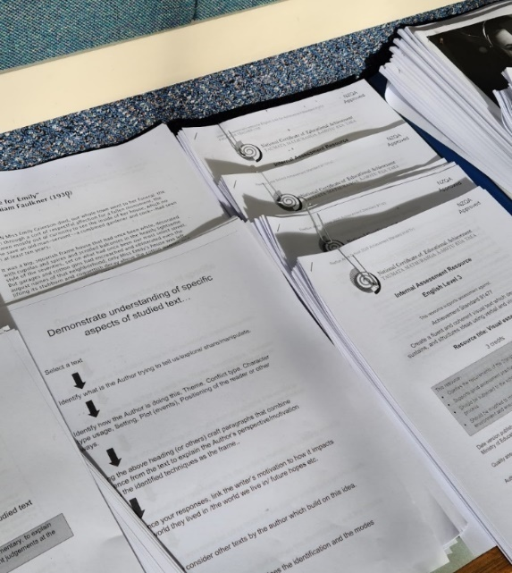

2025 External assessments
Review and Maintenance Programme (RAMP) work has been undertaken for all three levels of NZC NCEA for 2025. Based on feedback, selected Achievement Standards and supporting materials have been amended for 2025 assessment. It is important to note that not all subjects, Achievement Standards or supporting materials are impacted, and some of the changes are very minor but assist in clarity and interpretation.
For resources and full details of changes, see NCEA.Education and NZQA subject pages.
Level 1 sample assessment material for external assessments in 2025 - NZQA, 2025 Assessment specifications :: NZQA
Reviewed NZC Achievement Standards and assessment materials for use in 2025 - MOE
S = Submission, KM = Kete Manarua, P = Portfolio, | T = Tūmahi Aromatawai Pātahi, CAA = Common Assessment Activity, CAT = Common Assessment Task, E = Exam

Learning Area | Level | External Standard | 2024 | 2025 | Change | Due Date
Literacy and Numeracy, Te Reo Matatini me te Reo Pāngarau
Literacy Reading |  | 32403 | CAA x2 | CAA x2 |  | 19-30 May and 1-12 September
Literacy Writing |  | 32405 | CAA x2 | CAA x2 |  | 19-30 May and 1-12 September
Te Reo Torohū |  | 32413 | T/KM | T x 2 |  | 19-30 May and 25 Aug – 5 September
Te Reo Whakaputa |  | 32415 | T/KM | KM x 3 |  | To be confirmed
Numeracy |  | 32406 | CAA | CAA x2 |  | 19-30 May and 1-12 September
Te Reo Pāngarau |  | 32412 | T/KM | T x 2  KM x 1 |  | TAPā: 19-30 May and 25 Aug – 5 September  KM: Final date for submission: 29 October
English
English | 1 | 91925 | Internal | E | Repetition of evidence requirement removed from EN1
 | 1 | 91926 | S | Internal | Changes due to mode switch, EN2 edited for clarity (further details in internal assessments doc)
 | 1 | 91927 | E | E | Wording in EN3 changed, unpacking
English | 2 | 91098 | E | E
 | 2 | 91099 | E | E
 | 2 | 91100 | E | E
English | 3 | 91472 | E | E
 | 3 | 91473 | E | E
 | 3 | 91474 | E | E
English | Schol | 93001 | E | E
Te Reo Māori / Te Reo Rangatira
Te Reo Māori | 1 | 92094 | E | T |  | TAPā in exam period
 | 1 | 92095 | KM | KM |  | Final date for submission 29 Oct 2025
 | 2 | 91286 | E | E
 | 2 | 91287 | E | E
 | 3 | 91652 | E | E
 | 3 | 91653 | E | E
 | Schol | 93003 | E | E
Te Reo Rangatira | 1 | 92075 | T | T |  | 9 September 2025
 | 1 | 92076 | T | T |  | 10 September 2025
 | 2 | 91777 | E | E
 | 2 | 91779 | E | E
 | 3 | 91804 | E | E
 | 3 | 91806 | E | E
 | Schol | 93009 | E | E
New Zealand Sign Language
New Zealand Sign Language | 1 | 92357 | S | S |  | Final date for submission 29 Oct 2025
 | 1 | 92358 | S | S |  | Final date for submission 29 Oct 2025
The Arts
Dance | 1 | 91938 | S | P | SLOs | Final date for submission 29 Oct 2025
 | 1 | 91939 | S | P | SLOs | Final date for submission 29 Oct 2025
 | 2 | 91211 | E | E
 | 2 | 91212 | E | E
 | 3 | 91594 | E | E
 | 3 | 91595 | E | E
 | Schol | 93311 | P | P |  | Final date for submission 29 Oct 2025
Drama | 1 | 91942 | S | P |  | Final date for submission 29 Oct 2025
 | 1 | 91943 | S | P |  | Final date for submission 29 Oct 2025
 | 2 | 91215 | E | E
 | 2 | 91219 | E | E
 | 3 | 91514 | E | E
 | 3 | 91518 | E | E
 | Schol | 93304 | E | E |  | Final date for submission 29 Oct 2025
Music | 1 | 91950 | S | P | Unpacking doc updated | Final date for submission 29 Oct 2025
 | 1 | 91951 | S | P | EN4 revised for consistency, unpacking doc updated | Final date for submission 29 Oct 2025
 | 2 | 91275 | E | E
 | 2 | 91276 | E | E
 | 2 | 91277 | E | E
 | 3 | 91420 | E | E
 | 3 | 91421 | E | E
 | 3 | 91423 | E | E
 | Schol | 93305 | P | P |  | Final date for submission 29 Oct 2025
Te Ao Haka | 1 | 91978 | T/KM | T |  | 2 September 2025
 | 1 | 91979 | T/KM | KM |  | Final date for submission 29 Oct 2025
 | 2 | 91982 | T/KM | T |  | 3 September 2025
 | 2 | 91983 | T/KM | KM |  | Final date for submission 29 Oct 2025
 | 3 | 91986 | KM | KM |  | Final date for submission 29 Oct 2025
 | 3 | 91987 | T/KM | T |  | 4 September 2025
 | Schol | 93700 | KM | KM |  | Final date for submission 29 Oct 2025
Visual Arts | 1 | 91914 | S | P | SLOs | Final date for submission (verification) 22 Oct 2025
 | 1 | 91915 | S | P | SLOs | Final date for submission (verification) 22 Oct 2025
 | 2 | 91320 Design | P | P |  | Final date for submission (verification) 29 Oct 2025
 | 2 | 91321 Paint | P | P |  | Final date for submission (verification) 29 Oct 2025
 | 2 | 91322 Photo | P | P |  | Final date for submission (verification) 29 Oct 2025
 | 2 | 91323 Print | P | P |  | Final date for submission (verification) 29 Oct 2025
 | 2 | 91324 Sculpt | P | P |  | Final date for submission (verification) 29 Oct 2025
 | 3 | 91455 Design | P | P |  | Final date for submission 6 Nov 2025
 | 3 | 91456 Paint | P | P |  | Final date for submission 6 Nov 2025
 | 3 | 91457 Photo | P | P |  | Final date for submission 6 Nov 2025
 | 3 | 91458 Print | P | P |  | Final date for submission 6 Nov 2025
 | 3 | 91459 Sculpt | P | P |  | Final date for submission 6 Nov 2025
 | Schol | 93306 Paint | P | P |  | Final date for submission 6 Nov 2025
 | Schol | 93307 Design | P | P |  | Final date for submission 6 Nov 2025
 | Schol | 93308 Sculpt | P | P |  | Final date for submission 6 Nov 2025
 | Schol | 93309 Print | P | P |  | Final date for submission 6 Nov 2025
 | Schol | 93310 Photo | P | P |  | Final date for submission 6 Nov 2025
Health and Physical Education
Health Studies | 1 | 92010 | E | E | Wording in unpacking doc changed
 | 1 | 92011 | S | E | Wording in unpacking doc changed
Health | 2 | 91235 | E | E
 | 2 | 91238 | E | E
 | 3 | 91462 | E | E
 | 3 | 91465 | E | E | Updated EN3
Home Economics | 2 | 91300 | E | E
 | 2 | 91304 | E | E
 | 3 | 91470 | E | E
 | 3 | 91471 | E | E
Physical Education | 1 | 92018 | S | P | Updated definitions in standard to align with other standards, unpacking, SLOs | Final date for submission 29 October 2025
 | 1 | 92019 | S | P | Updated definition in standard to align with other standards, unpacking, SLOs | Final date for submission 29 October 2025
Health and Physical Education | Schol | 93501 | S | S |  | Final date for submission 29 October 2025
Learning Languages
Gagana Sāmoa / Samoan | 1 | 92034 | E | E | Unpacking doc updated
 | 1 | 92035 | E | E | Unpacking doc updated
 | 2 | 91143 | E | E
 | 2 | 91146 | E | E
 | 3 | 91563 | E | E
 | 3 | 91566 | E | E
 | Schol | 93010 | E | E
Gagana Tokelau | 1 | 92349 | E | E | Unpacking doc updated
 | 1 | 92350 | E | E | Unpacking doc updated
Lea Faka-Tonga | 1 | 92038 | E | E | Unpacking doc updated
 | 1 | 92039 | E | E | Unpacking doc updated
 | 2 | 91674 | E | E
 | 2 | 91677 | E | E
 | 3 | 91679 | E | E
 | 3 | 91682 | E | E
Te Reo Māori Kūki ‘Airani / Cook Islands Māori | 1 | 92042 | E | E | Unpacking doc updated
 | 1 | 92043 | E | E | Unpacking doc updated
 | 2 | 91113 | E | E
 | 2 | 91116 | E | E
 | 3 | 91538 | E | E
 | 3 | 91541 | E | E
Vagahau Niue | 1 | 92353 | E | E | Unpacking doc updated
 | 1 | 92354 | E | E | Unpacking doc updated
French | 1 | 91966 | E | E | Unpacking doc updated
 | 1 | 91967 | E | E | Unpacking doc updated
 | 2 | 91118 | E | E
 | 2 | 91121 | E | E
 | 3 | 91543 | E | E
 | 3 | 91546 | E | E
 | Schol | 93004 | E | E
German | 1 | 91970 | E | E | Unpacking doc updated
 | 1 | 91971 | E | E | Unpacking doc updated
 | 2 | 91123 | E | E
 | 2 | 91126 | E | E
 | 3 | 91548 | E | E
 | 3 | 91551 | E | E
 | Schol | 93006 | E | E
Spanish | 1 | 91974 | E | E | Unpacking doc updated
 | 1 | 91975 | E | E | Unpacking doc updated
 | 2 | 91148 | E | E
 | 2 | 91151 | E | E
 | 3 | 91568 | E | E
 | 3 | 91571 | E | E
 | Schol | 93007 | E | E
Chinese (Mandarin) | 1 | 91954 | E | E | Unpacking doc updated
 | 1 | 91955 | E | E | Unpacking doc updated
 | 2 | 91108 | E | E
 | 2 | 91111 | E | E
 | 3 | 91533 | E | E
 | 3 | 91536 | E | E
 | Schol | 93005 | E | E
Japanese | 1 | 91958 | E | E | Unpacking doc updated
 | 1 | 91959 | E | E | Unpacking doc updated
 | 2 | 91133 | E | E
 | 2 | 91136 | E | E
 | 3 | 91553 | E | E
 | 3 | 91556 | E | E
 | Schol | 93002 | E | E
Korean | 1 | 91962 | E | E | Unpacking doc updated
 | 1 | 91963 | E | E | Unpacking doc updated
 | 2 | 91138 | E | E
 | 2 | 91141 | E | E
 | 3 | 91558 | E | E
 | 3 | 91561 | E | E
Latin | 2 | 91194 | E | E
 | 2 | 91195 | E | E
 | 3 | 91506 | E | E
 | 3 | 91507 | E | E
 | Schol | 93008 | E | E
Mathematics and Statistics
Mathematics and Statistics | 1 | 91946 | S | E | SLOs updated
 | 1 | 91947 | E | E | SLOs updated
 | 2 | 91261 | E | E
 | 2 | 91262 | E | E
 | 2 | 91267 | E | E
Calculus | 3 | 91577 | E | E
 | 3 | 91578 | E | E
 | 3 | 91579 | E | E
 | Schol | 93202 | E | E
Statistics | 3 | 91584 | E | E
 | 3 | 91585 | E | E
 | 3 | 91586 | E | E
 | Schol | 93201 | E | E
Science
Agricultural and Horticultural Science | 1 | 91930 | E | E | Revised EN2, updated unpacking doc
 | 1 | 91931 | S | E | Unpacking updated to align with mode change
 | 2 | 91290 | E | E
 | 2 | 91294 | E | E
 | 2 | 91297 | E | E
 | 3 | 91530 | E | E
 | 3 | 91531 | E | E
 | 3 | 91532 | E | E
 | Schol | 93105 | E | E
Biology | 2 | 91156 | E | E
 | 2 | 91157 | E | E
 | 2 | 91159 | E | E
 | 3 | 91603 | E | E
 | 3 | 91605 | E | E
 | 3 | 91606 | E | E
 | Schol | 93101 | E | E
Chemistry | 2 | 91164 | E | E
 | 2 | 91165 | E | E
 | 2 | 91166 | E | E
 | 3 |  | E | E
 | 3 |  | E | E
 | 3 |  | E | E
 | Schol | 93102 | E | E
Chemistry and Biology | 1 | 92022 | S | E | EN3 and EN4 updated, unpacking doc updated
 | 1 | 92023 | E | E
Earth and Space Science | 2 | 91191 | E | E
 | 2 | 91192 | E | E
 | 2 | 91193 | E | E
 | 3 | 91413 | E | E
 | 3 | 91414 | E | E
 | Schol | 93104 | E | E
Physics, Earth and Space Science | 1 | 92046 | S | E
 | 1 | 92047 | E | E
Physics | 2 | 91170 | E | E
 | 2 | 91171 | E | E
 | 2 | 91173 | E | E
 | 3 | 91523 | E | E
 | 3 | 91524 | E | E
 | 3 | 91526 | E | E
 | Schol | 93103 | E | E
Science | 1 | 91922 | E | E | SLO updated
 | 1 | 91923 | S | E | SLO updated
Social Sciences
Accounting | 2 | 91174 | E | E
 | 2 | 91176 | E | E
 | 2 | 91177 | E | E
 | 3 | 91404 | E | E
 | 3 | 91406 | E | E
 | 3 | 91408 | E | E
 | Schol | 93203 | E | E
Art History | 2 | 91180 | E | E
 | 2 | 91181 | E | E
 | 2 | 91182 | E | E
 | 3 | 91482 | E | E
 | 3 | 91483 | E | E
 | 3 | 91484 | E | E
 | Schol | 93301 | E | E
Business Studies | 2 | 90843 | E | E
 | 2 | 90844 | E | E
 | 2 | 90845 | E | E
 | 3 | 91379 | E | E
 | 3 | 91380 | E | E
 | 3 | 91381 | E | E
Classical Studies | 2 | 91200 | E | E
 | 2 | 91201 | E | E
 | 2 | 91203 | E | E
 | 3 | 91394 | E | E
 | 3 | 91395 | E | E
 | 3 | 91396 | E | E
 | Schol | 93404 | E | E
Commerce | 1 | 92030 | E | E | Changes to AS title, EN1, EN2, and unpacking doc
 | 1 | 92031 | S | E | Changes to EN1 and unpacking doc
Economics | 2 | 91222 | E | E
 | 2 | 91223 | E | E
 | 2 | 91224 | E | E
 | 3 | 91399 | E | E
 | 3 | 91400 | E | E
 | 3 | 91403 | E | E
 | Schol | 93402 | E | E
Education for Sustainability | 2 | 91733 | E | E
 | 2 | 90814 | E | E
 | 3 | 90831 | S | S |  | Final date for submission 29 October 2025
 | 3 | 91736 | S | S |  | Final date for submission 29 October 2025
Geography | 1 | 91934 | S | E | Unpacking doc and SLO updated
 | 1 | 91935 | E | E | Changes to EN3 and EN5, updated unpacking doc, SLOs
 | 2 | 91240 | E | E
 | 2 | 91242 | E | E
 | 2 | 91243 | E | E
 | 3 | 91426 | E | E
 | 3 | 91427 | E | E
 | 3 | 91429 | E | E
 | Schol | 93401 | E | E
History | 1 | 92026 | E | E
 | 1 | 92027 | S | E | Unpacking doc updated due to mode change
 | 2 | 91231 | E | E
 | 2 | 91233 | E | E
 | 2 | 91234 | E | E
 | 3 | 91436 | E | E
 | 3 | 91438 | E | E
 | 3 | 91439 | E | E
 | Schol | 93403 | E | E
Media Studies | 2 | 91248 | E | E
 | 2 | 91251 | E | E
 | 3 | 91490 | E | E
 | 3 | 91493 | E | E
 | Schol | 93303 | E | E
Psychology | 3 | 91876 | E | E
 | Schol | 93405 |  | E | New in 2025
Religious Studies | 1 | 91918 | E | E
 | 1 | 91919 | S | E | Unpacking doc updated to reflect mode switch
 | Schol | 93603 | E | E
Social Studies | 1 | 92050 | E | E | SLO updated
 | 1 | 92051 | S | Internal | SLO updated
 | 1 | 92049 | Internal | E | Standard, SLO, unpacking changed to reflect mode switch
 | 2 | 91279 | E | E
 | 2 | 91281 | E | E
 | 3 | 91596 | E | E
 | 3 | 91598 | E | E
Technology
Design and Visual Communication | 1 | 92002 | S | P |  | Final date for submission 29 October 2025
 | 1 | 92003 | S | P |  | Final date for submission 29 October 2025
 | 2 | 91337 | P | P |  | Final date for submission 29 October 2025
 | 2 | 91338 | P | P |  | Final date for submission 29 October 2025
 | 2 | 91339 | P | P |  | Final date for submission 29 October 2025
 | 3 | 91627 | P | P |  | Final date for submission 29 October 2025
 | 3 | 91631 | P | P |  | Final date for submission 29 October 2025
 | Schol | 93602 | P | P |  | Final date for submission 29 October 2025
Digital Technologies | 1 | 92006 | E | E
 | 1 | 92007 | S | P | Changes to EN1, EN3, EN4 | Final date for submission: 12 September 2025
 | 2 | 91898 | CAT | E
 | 2 | 91899 | CAT | CAT |  | T3 week 9, 8 – 12 September
 | 3 | 91908 | CAT | E
 | 3 | 91909 | CAT | CAT |  | T3 week 9, 8 – 12 September
 | Schol | 93604 |  | E | New in 2025
Materials and Processing Technology | 1 | 92014 | S | P | SLOs | Final date for submission 29 October 2025
 | 1 | 92015 | S | P | SLOs | Final date for submission 29 October 2025
Technology | 2 | 91358 | S | S |  | Final date for submission 29 October 2025
 | 2 | 91359 | S | S |  | Final date for submission 29 October 2025
 | 2 | 91360 | S | S |  | Final date for submission 29 October 2025
 | 2 | 91363 | S | S |  | Final date for submission: 29 October 2025
 | 3 | 91612 | S | S |  | Final date for submission: 29 October 2025
 | 3 | 91613 | S | S |  | Final date for submission: 29 October 2025
 | 3 | 91614 | S | S |  | Final date for submission: 29 October 2025
 | 3 | 91617 | S | S |  | Final date for submission: 29 October 2025
 | Schol | 93601 | S | S |  | Final date for submission: 29 October 2025


School Quality Assurance and Support – online workshops for schools 2025
Each of these online workshops will be hosted by School Relationship Managers.
You can find all the resources for each session here.
Content | Audience | Dates and links | Agenda
Results Release and Data | PN, Data manager | - Fri 17th Jan, 10 - 10.45 am  - Tues 21st Jan, 10 - 10.45 am  - Tues 28th Jan, 10 – 10.45am | - Downloading results  - Adding late 2024 internal assessment results  - Reviews and Reconsiderations  - Reports and Statistics  - Course endorsement  - University Entrance completion
New PNs | New PNs | - Mon 3rd Feb, 2.30 – 3.15 pm  - Tues 4th Feb, 3.30 – 4.15 pm | - Data, contacts, ESA  - PN role, support and resources, key dates
New Kura PNs | New Kura PNs | Tues 11th Feb, 3.30 – 4.15 pm | - Data, contacts, ESA  - PN role, support and resources, key dates
Term 1 PN priorities | All PNs | - Weds 12th Feb, 3.30 – 4.15 pm  - Thurs 13th Feb, 3.30 – 4.15 pm  - Fri 14th Feb, 10 – 10.45 am | - Mark books, entries, courses, data  - Monitoring quality assurance  - Reports, self-review
Special Assessment Conditions (SAC) | SAC responsibility | - Tues 25th Feb, 11 am – 12 pm  - Tues 25th Feb, 3 – 4 pm  - Thurs 27th Feb, 11 am – 12 pm  - Thurs 27th Feb, 3 – 4pm | - Questions & answers for new PNs and SENCOs  - Introduction to SAC  - Making applications / notifications
Leading National Assessment seminar (LNA) Online | Missed the in-person LNA | Weds 12th Mar, 9 – 11 am | - LNA content
Data & entries Q&A | PN, Data manager | Tues 18th Mar, 2 – 3 pm | - PN and/or data managers  - 2025 courses, entries, data files  - 2024 cleanup
Co-requisite management and entries (Literacy, Numeracy, Te Reo Matatini, Te Reo Pāngarau) | PN, Co-requisite responsibility | - Weds 2nd April, 2 – 3pm  - Thurs 3rd April, 2 – 3pm | - Preparing for the CAAs & TAPā
Term 2 PN priorities | All PNs | - Tues 29th April, 3.30 – 4.15 pm  - Weds 30th April, 3.30 – 4.15 pm  - Thurs 1st May, 10 – 10.45 am | - Data files  - Monitoring moderation  - CAAs
Assessment Master basics | CAA Administrator | - Tues 6th May, 2 – 3 pm  - Weds 7th May, 2 – 3 pm | - Demonstrate key functions and any new features.
Term 3 PN priorities | All PNs | - Tues 15th July, 3.30 – 4.15 pm  - Weds 16th July, 3.30 – 4.15 pm  - Thurs 17th July, 10 – 10.45 am | - Derived grade exams  - CAAs  - Externals file
Special Assessment Conditions (SAC) | SAC responsibility | - Tues 22nd July,11 am – 12 pm  - Tues 22nd July, 3 – 4 pm  - Thurs 24th July, 11 am – 12 pm  - Thurs 24th July, 3 – 4 pm | - SAC and exams  - Making entries, attaching conditions, preparations for externals
Data & entries | PN, Data manager | Tues 5th Aug, 2 – 3 pm | - Externals entry file – what to check for  - Resolving data issues
CAAs, TAPā, and Assessment Master | PN, Lit/Num responsibility, CAA Administrator | - Tues 12th Aug, 2 – 3 pm  - Weds 13th Aug, 2 – 3 pm | - Preparing for the CAAs – targeting new PNs and/or curriculum leaders  - AM functions and new features
Term 4 PN priorities | All PNs | - Tues 7th Oct, 3.30 – 4.15 pm  - Weds 8th Oct, 3.30 – 4.15 pm  - Thurs 9th Oct, 10 – 10.45 am | - Data checks  - Exam processes  - Quality assurance – Derived grades, external moderation
Submitted externals / portfolios | PN, subject leaders | - Thurs 16th Oct, 2 – 3 pm  - Fri 17th Oct, 2 – 3 pm | - Managing, saving, uploading, submitting portfolio assessments
Term 4 PN wrap-up | All PNs | - Weds 12th Nov, 11 – 11.45 am  - Thurs 13th Nov, 11 – 11.45 am | - 1 Dec data file  - Visual Art  - Review Quality Assurance processes
Results and Data Q&A | All PNs | - Weds 3rd Dec, 11 – 11.45 am  - Thurs 4th Dec, 11 – 11.45 am | - Downloading results  - Adding late 2025 results  - Questions and answers

Schedule 4:3.1 of the NZQA Assessment Rules for Schools, TEOs assessing against Achievement Standards and NCEA Co-requisite Standards, and Candidates 2025.

