
Leading
National Assessment

Kaitakawaenga ki te Tumuaki
Principal’s Nominee



Pukapuka Aratohu
Handbook

Table of Contents
Topic | Page
Leading National Assessment - the Principal’s Nominee’s spheres of influence | 4
Role and responsibilities of the Principal’s Nominee | 5
Action items by month | 6
Your Provider Login | 8
Navigating MyNZQA | 9
Navigating School administration | 11
Navigating Reports | 13
Navigating Exams and assessment | 17
Consent to Assess | 22
Obligations associated with the use of a provider code | 23
Managing assessment through an external provider | 25
Tracking progress towards NCEA | 27
University Entrance requirements | 28
Calculating endorsements | 29
Managing and monitoring internal and external moderation | 30
Managing National Assessment Reviews (MNA) | 35
Links to key resources and guidelines | 36
The NZQA website | 38
Navigating subject resources | 39

Leading National Assessment

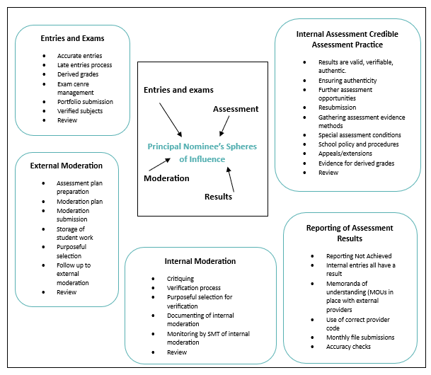

Your critical role
This handbook will help you carry out the role of Principal’s Nominee, while becoming familiar with key tasks and activities. As Principal’s Nominee you play an important part in maintaining the credibility and integrity of the NCEA qualification.

Your role and responsibilities
The Principal’s Nominee
On an annual basis, the Principal of a School with Consent to Assess (accreditation) must nominate a staff member to be the Principal's Nominee.
The role
The Principal’s Nominee (or designate) must carry out the following duties:
- maintain and monitor quality assurance practices within the School to ensure the validity and credibility of assessment for qualifications
- report internal assessment results for all qualifications after internal moderation has been completed
- manage or have oversight of external digital assessments
- ensure the integrity of assessment data submitted to NZQA, including Candidate eligibility, reported results and Candidate entries for external assessment
- ensure that assessment data including Candidate information is forwarded to NZQA to meet published deadlines
- consider and make applications to NZQA on behalf of Candidates for special assessment conditions for Level 2 and 3 Candidates; use the notification process for Level 1 candidates to ensure the school engages in and complies with the external moderation process and that issues identified by the external moderation process are resolved through the completion of an action plan
- develop and manage the School’s Breaches of the Rules for internal assessment and school-based external assessment, including the provision of an appeal process
- receive and reconcile Candidate fees for international students, and forward these in full to NZQA to meet published deadlines
- manage derived grade applications to NZQA on behalf of Candidates
- liaise with and support the School’s staff and Examination Centre Manager to ensure that the integrity of external assessment is not compromised
- ensure the availability of suitable accommodation and equipment for the conduct of all external assessments
- maintain the currency of the school’s assessment policy and procedures to reflect NZQA requirements and communicate them to staff, students and families
- respond to NZQA communications and requests for information
- facilitating NZQA visits and reviews.

While other school staff may assist the Principal’s Nominee to ensure all aspects of the role are completed, the Principal’s Nominee remains responsible for ensuring those staff members carry out their duties appropriately, and for all communication with NZQA.
Action items by month
Although each school has its own administrative arrangements, this information is provided as a guide to the role of Principal's Nominee.
The calendar of Key Dates and special assessment conditions timeline are published each year by NZQA and should be referred to for specific dates.
A Data Submission is due by the first day of the month starting from April.
External moderation of new standards will occur the same year as the assessment, and therefore schools will get most of their moderation feedback in the year that they assess a standard.
A full list of action items for PNs by calendar month is available. The calendar for January to April is shown below:
January
- Enter late internal results from the previous year via the Add Results facility through the MyNZQA provider login, (See EmailLink from January)
- Check the portfolios submitted to NZQA for External Assessment, other than Level 3 Visual Arts, have been returned to school
- After results release, return portfolios (or any other external assessment material sent to school by NZQA) to candidates
- Download results file from the File Downloads section of the NZQA Provider login for loading into the school’s management system (SMS)
- Download from the SMS provider the Standards File for the current year
- Apply for credit inclusion (Rules, 7.4) for students who need credits to complete qualification(s)
- Remind staff that Cut Scores and Assessment Schedules are available for external standards
- Download school's National Qualifications Statistics and Principal's Report when available
- Update the school contact information
- Check that all teachers who leave have their access to the school's secure area removed
- Provide new staff with access to the MyNZQA Provider Login and set up ESL access for staff to include Pūtake and access to the external moderation app
- Update staff / student handbooks to reflect NZQA updates
- Ensure new Learning Support staff (e.g. SENCO) have access to the Special Assessment section through the school’s MyNZQA Provider login
- Check with Learning Support staff that SAC applications for first time candidates are being submitted for NCEA Levels 2 and 3. For NCEA Level 1 students, check that Learning Support staff are aware of the notification process.
- Review procedures and documentation for internal assessment processes
- Remind staff to complete Teacher Surveys on previous year's examinations
- Check, and where necessary, update organisation and contact details held by NZQA, see school admin, page 9.

February
- Familiarise yourself with the calendar of Key dates
- Ensure readers and writers are trained to be examination assistants
- Establish markbooks ensuring that the school has consent to assess for all of the standards being offered. Remind teachers to check assessment specifications for standards offered and review exclusions
- Check MyNZQA Provider login for the External Moderation plan. Inform relevant staff of standards selected for moderation and how/when material will be collated and submitted. Notify School Relationship Manager of any issues.
- Ensure course outlines reflect the intended assessment programme
- Check the accuracy of the student information held on the SMS including twins, name changes, names with special characters and student addresses
- Scholarship results release
- Ensure students and staff are aware of the closing date for reviews and reconsiderations of NCEA external scripts
- Publish assessment procedures for both staff and students
- Check MOUs are in place for outside providers
- PN seminars start
- Complete entry of any previous year's internal results via the website before the link closes on the 28th February.

March
- Web Entry Schools' access opens to enter candidate and course information
- Make sure students and staff are aware of the closing date for reviews and reconsiderations of Scholarship scripts
- Check accuracy of mark books for external and internal standards, including versions, against the school's consent to assess before first File Submission
- Ensure that student details and course information are correct on the SMS.
- Distribute NZQA candidate information sheets
- Remind the SAC coordinator and Learning Support staff of the new Notification Gateway
- Check if a new Examination Centre Manager will be required.

April
- First Datafile Submission to NZQA
- Check Batch Information after file submission
- Check Key Indicators from Provider Login
- Remind SAC coordinator and Learning Support staff that the first deadline for First Time Ever SAC applications for Level 2 and 3 candidates is the end of Term 1
- Advertise to staff that Assessment reports are available for the previous year's external assessment on Subject Resource pages
- Public release of statistics
- Establish the school timing for payment of fees and advertise Fees and Financial Assistance to the school community
- Check entries for candidates undertaking study with Te Aho o Te Kura Pounamu (The Correspondence School), a Health School or other provider

Your Provider Login

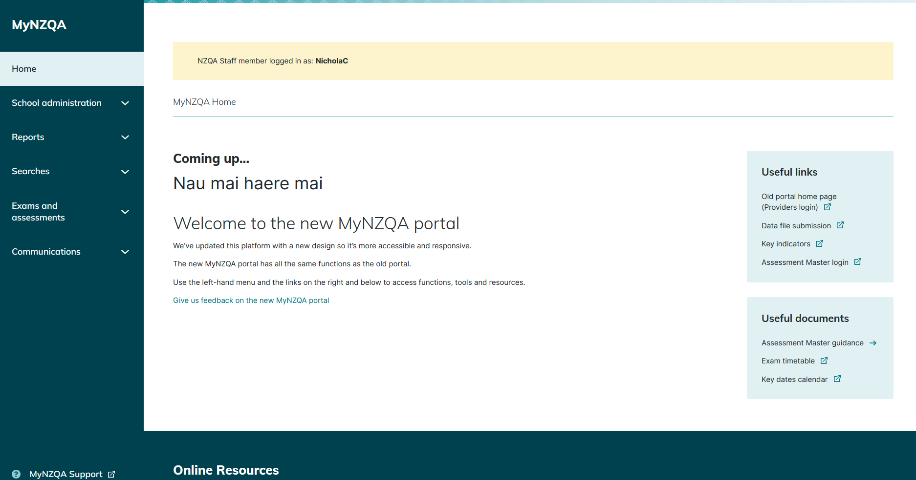

This will take you to the old version of the site
Te Aka – Guidance and resources for 2023 NCEA pilots
Pūtake – NZQA’s learning management system

Using your data
Your Provider Login (MyNZQA) provides a wealth of data to help you gain a full picture of your school’s assessment outcomes, including longitudinal comparisons and comparisons with other schools. Use your data to help you:
Track and/or review:
- students’ progress towards their qualification,
- students’ results/qualifications/endorsements by cohort/level/gender/ethnicity,
- your school’s level of achievement compared to similar schools,
- your school’s/departments’ previous years’ achievement and progress towards strategic
goals.
Inform planning
- inform strategic goal setting for schools/departments/groups,
- inform course planning based on previous achievement in particular standards.
Support students by
- celebrating student achievement,
- supporting learner access through the MyNZQA Learner Login,
- ensuring provider codes are properly reported,
- monitoring derived grades
- identifying students ‘at risk’.
Make sure you are familiar with the following sections of your Provider Login, to help you with the review and monitoring aspects of the PN role.
Navigating MyNZQA
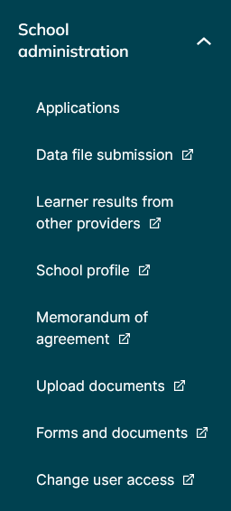
Applications – Apply for consent to assess additional standards and Third Party Consent applications
Data file submission – submit your data file and check for errors. Includes instructions. (See page 11)
Learner results from other providers – use when a student transfers to your school (see page 12)
School profile – Maintain organisation and contact details, including emergency contact and update as soon as there is a change
Memorandum of agreement – a pro rata payment from NZQA for administering assessment, including examinations
Upload documents – code attestations and view and download Digital Practice Exam files
Forms and documents – Find resources for schools including credit inclusion, exams, fees, entries, moderation, SAC and candidate information sheets
Change user access – request access for a new user or change access for an existing user
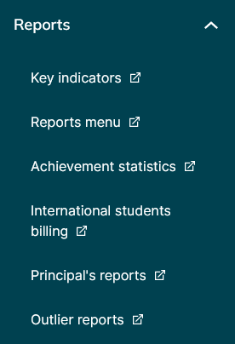
Key Indicators – See page 13
Reports menu – See page 14
Achievement statistics – See page 14
International students billing – shows fees your school must pay on behalf of international students gaining NCEA results
Principal’s reports – Compares your school’s last five years of student achievement
Outlier reports – Internal External comparison and Derived Grade comparison
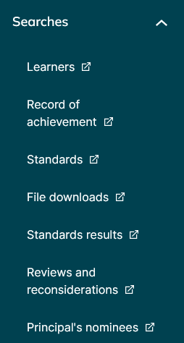
Learners – complete a candidate search
Record of achievement – view a student’s record of achievement (NB updates at results release, so some results not visible during current school year)
Standards – search and view standards and courses provided at your school by year
File downloads – view or download consent files, import results files, vocational pathway mapping file
Standards results – search results for all, or particular standards by year of assessment
Reviews and reconsiderations – a summary of students who have applied and the outcome
Principal’s nominees – Find Principal’s Nominees, contact details, and school codes

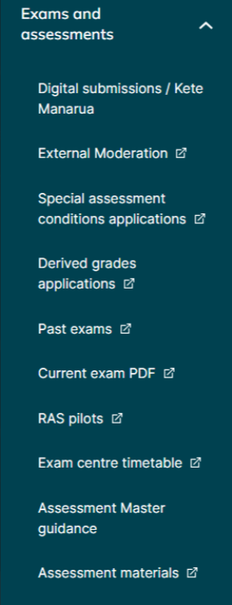
Digital submissions / Kete Manarua – upload digital submissions here
External Moderation – View assessment and moderation plans, moderation reports and annual summaries
Special Assessment Conditions – Make an application
Derived grade applications – will become active at the beginning of Term 3
Past exams – Access past digital exams and past PDF exam content
Current exam PDF – Download files pertaining to exams
RAS pilots – Download files for RAS standards
Exam centre timetable – Details your school’s external exams, showing candidates with SAC, clashes, those requiring special assistance and digital entries
Assessment Master guidance – Support material explaining the digital online platform
Assessment materials – CAAs, pilots, stimulus material and assistive technology info

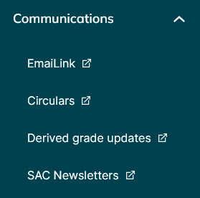
EmailLink – Information about changes and upcoming deadlines for Principal’s Nominees
Circulars – Newsletter with information about NZQA processes and requirements
Derived grade updates – no update since 2022
SAC newsletters – Due to be removed
Navigating School administration

Key data needs to be communicated to NZQA at specified times, and other pieces of data need to be retrieved. There are a few key areas that you need to be aware of and develop internal processes to manage.
Data submission
At the beginning of each month starting from April, you are expected to submit data to NZQA. Submitting data files on time ensures student details and entries are processed prior to an assessment event and results are updated in our system. To do this you need to export a data file from your SMS or use Web Entries. You may need to check with your SMS vendor about how to do this. Then:
- Go into your Provider Login on your MyNZQA web page
- Find the “Data File Submission” Link, under School administration, or under Useful links on the right hand side

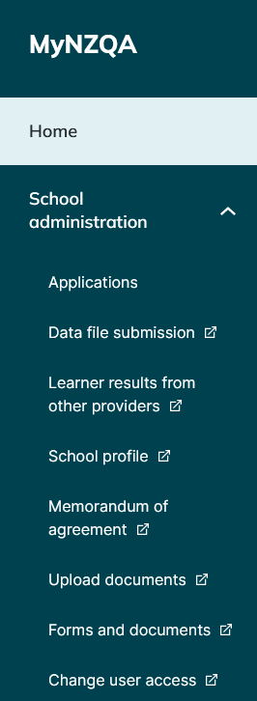

- Click on the link and it will take you to a page where you can attach the file you exported from the SMS. Then you add your contact details and click “Submit”.
- In the same window, you will see the previous files that you have uploaded that year. If you click on those submissions, you will be taken to a screen that details any errors with the submission or warnings of potential issues. It is important to check these after the file has been processed.
- A SMS User Guide for information on file submission and errors can be found under Data File Submission.

Learner results from other providers
When a new student with previous NCEA achievement enrols at your school, you will want to import their ROA into your SMS so you can track their progress.
After agreeing to the privacy requirements, input the student’s NSN and select the years/providers from whom you wish to import data, then download the file and import it into your SMS.
It is important to also contact the student’s previous school and request any standards that may have been assessed but not yet reported to NZQA or reported in the current year.
You can enter them into your SMS using the previous school’s provider code.

Leaving and Transferring students
Students can only have one active secondary school enrolment with NZQA at one time. Therefore, where a student transfers schools, the previous and new school both need to follow the correct process so that the transferring student’s record is accurate.
When a student leaves your school, do not withdraw their NZQA enrolment straight away, but continue reporting results for leavers until you receive a notification from ENROL that they have been enrolled at another school. This ensures that their results are accurate. Follow the process here.

Navigating Reports
Key Indicators
Students will not get the results if there is no consent to assess. Check and fix provider numbers as needed
Useful for comparing entries in last two data submission files
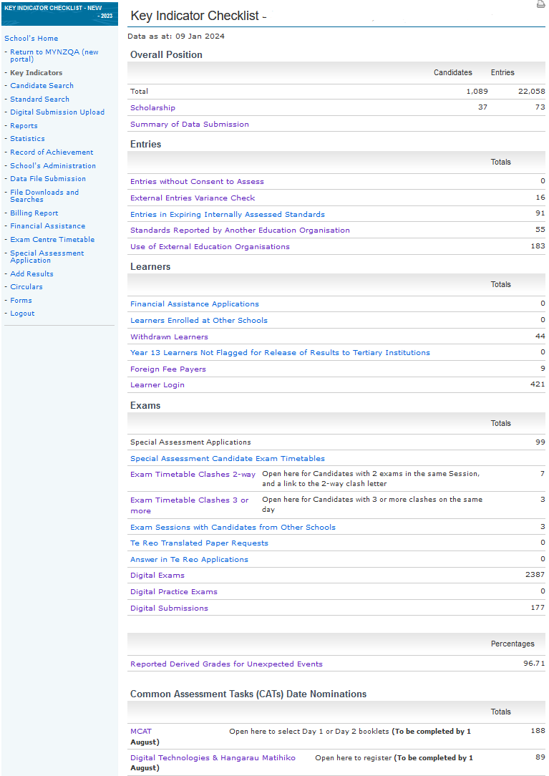
Useful for planning ahead
Check subjects for derived grade entries
Check that the students you expect are listed
Check digitally submitted standards
Check digital entries and who has used their Learner Login
School manages 2-wy clashes. NZQA SRMs manages 3-way clashes.
Check that the students you expect are listed
Check which students have set up and used their Learner Logins
Check that the students you expect are listed
If students are not flagged tertiary institutions may not be able to accept them
Shows external standards where the number of entries is significantly different to previous years
Reports Menu
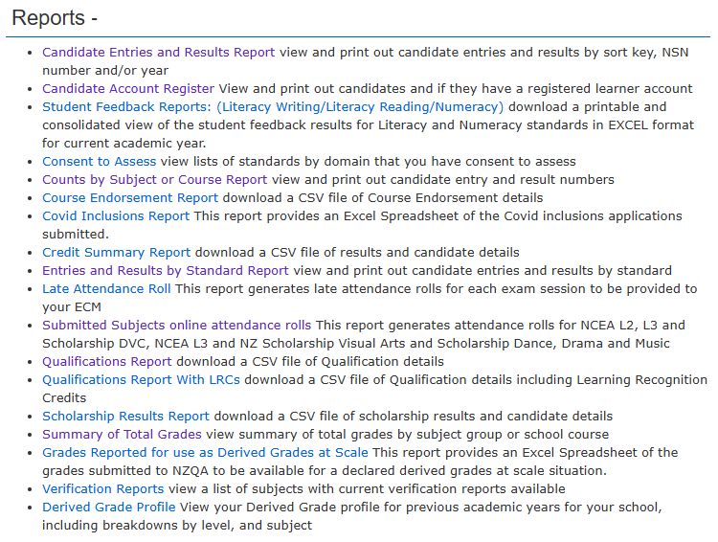
Achievement Statistics
The Achievement Statistics of your Provider Login has links to different collections of data about student achievement. When you generate statistics, you are given the option to select different features that you would like the report to display.
For example, you may want to compare your most recent results to those of previous years to analyse trends, or you may wish to compare your results with other schools in your equity index or region. Statistics allows you to customise data to suit your purpose.
Below you can see how your data is configured in a variety of ways:
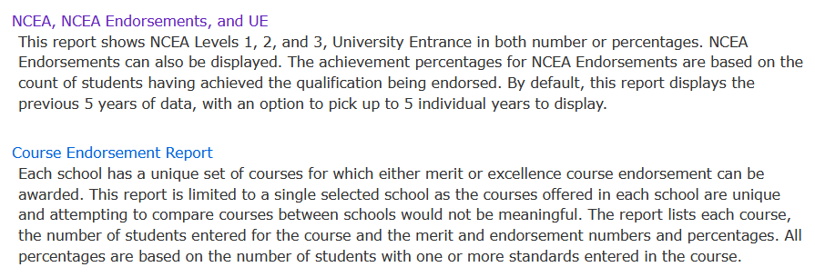
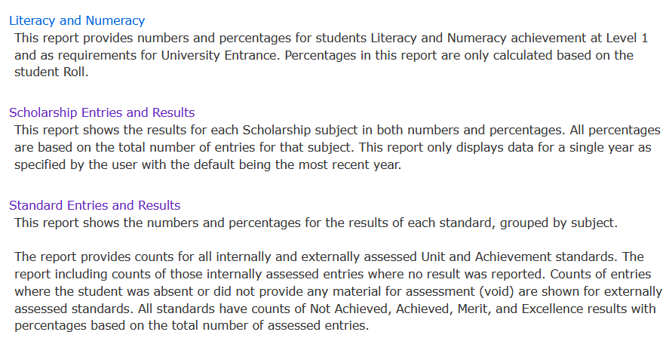
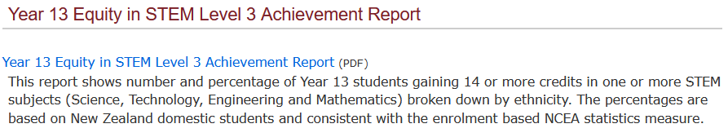

Each link provides a description of the data in the report to help you decide which will be the most appropriate. This is where you customise the data set you wish to create.
When you click the link, you will get a screen that looks like the one below and you can use the filters to select the data you need. You can download a Statistics User Guide at the top of the Statistics page.
Clicking submit will generate a live report, which you can export in the format that suits you.
It is worth noting that, in many of the live reports (prior to export), there are links that can be opened which allow you to drill down into the data in more detail. It may suit your purpose to export different levels of the same report.

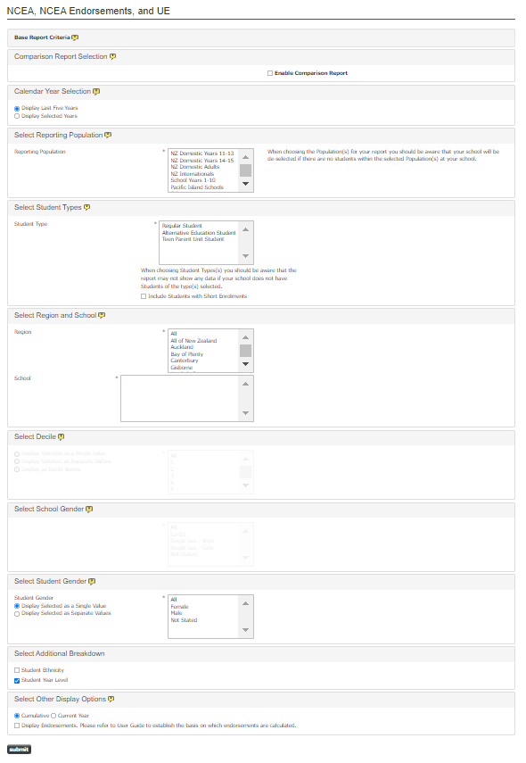
International students billing
Reporting results for international students incurs a fee, which schools are responsible for paying. Be aware that the fee is incurred as soon as you first report an entry for that student to NZQA.
Details about the fee structure can be found on our website.

Navigating exams and assessments

Equity and inclusivity should be addressed in every assessment. Every student should have an equitable opportunity to access assessment and qualifications.
Your school’s assessment policy should directly address issues of equity.

Digital Submissions / Kete Manarua
To submit candidate digital submissions, schools will need to be familiar with accessing and submitting work to the Digital Submission / Kete Manaura Upload link via the MyNZQA Schools' Provider Login.

Information on how to make a digital submission can be accessed through the tile displayed on the NZQA digital submissions page.

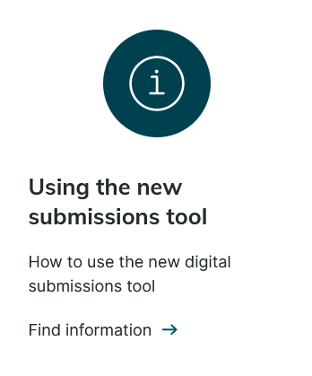
Tips for uploading student work
All technical information, including how to use the new submission tool, is available here.

First steps
- Make sure students have created and can use their MyNZQA Learner Login so that they can upload evidence. (A teacher can upload evidence on behalf of a student.)
- Ensure teachers know how to Verify and Submit student work.
Planning:
- Have a school ‘Due date’ that is well before the NZQA close date of 30 October 2025 so that the teacher has time to resolve issues before only the PN can.
- Stagger assessment due dates to alleviate student and staff workload around submission close date.
- Review your digital storage policies to ensure that at least one teacher has access to student work at any time, including after submission.

When submitting – end T3 / start T4:
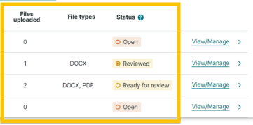

Links must not be submitted (e.g. links to Google docs, Google sites, YouTube, websites, etc) because the evidence they link to could be changed later. Do not submit links within documents either. Instead, the actual files must be uploaded e.g. .mov, .mp4, docx, ppt, etc. The only exception is if the specifications for a standard require a link to be submitted e.g. coding evidence.

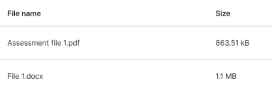
File names should be short and describe what the file is. The student’s NSN, school MoE Number, and standard is automatically added to the files when submitted. File names should not include the student’s full name to ensure their work remains anonymous to the markers.

After the NZQA close date (29th October 2023, Term 4 Week 4), only the PN can submit (using the late submission process).

Frequently asked questions
What about authenticity?
If a breach of assessment rules is suspected that could affect the authenticity of student work, schools must notify NZQA and submit the student work as usual. Once the student work is submitted to NZQA, the school should complete a breach notification form.

What if a student misses an assessment?
There are no derived grades available for submitted standards where the timing is at the school’s discretion. Assessments should be scheduled so that all students can be assessed before the NZQA final submission date. If a student does not have an adequate opportunity to be assessed, they should be marked as Not Submitting.

Should students be provided with special assessment conditions?
Yes, unless they are specifically excluded in the Assessment Specifications for that standard.

What if something goes wrong with the submission process?
Schools should keep a secure digital copy of student work and ensure that it is accessible regardless of staff changes. Reviews and reconsiderations will be available after results release in January, through students’ learner logins.

How do I manage a late entry or late submission?
Make an entry via your SMS. Once processed, the PN can complete a late submission after the close date by contacting NZQA and following the late submission process.
Derived grades applications
If a student misses an external assessment through situations beyond their control, they may be eligible for a Derived Grade. This is where the school derives the student’s final grade based on authentic, standard-specific internal evidence that has been quality assured. Derived grades may be approved in the event of:
- Illness.
- Trauma.
- Misadventure.
More information on the process, eligibility and how to apply can be found on the Derived Grades pages of our website.
Note the online process and status of the derived grade is through the MyNZQA school portal, under Applications.

Unexpected Event Grades
Schools are required to report Unexpected Event Grades (UEGs) to NZQA. These are grades for externally assessed standards which are derived from authentic, standard-specific internal evidence that has been quality assured and can be awarded if students can’t sit exams for unforeseen reasons. More information about the Unexpected Event Grade process can be found here.
It is your responsibility to make sure that these grades are collected and recorded and reported to NZQA using the normal data submission process. The percentage of reported grades for unexpected events can be viewed from your Key indicators page.

Missed Assessment and Late Assessment
Derived Grades are only applied to external assessment.
In the event that a student’s internal assessment is impaired by illness, trauma, or misadventure then schools should manage that assessment through either their missed assessment or late assessment policies, as appropriate.
The flexibility of NCEA means that schools can tailor internal assessment around the needs of students. Your policies should set out how a student can apply, what will be considered, and the decision-making process. The policy should ensure equity of access and consideration for all students.
Special assessment conditions (SAC) applications
A student’s learning difficulties or physical limitations should not impact their access to assessment and qualifications. A range of entitlements are available to support these students. Examples of Special Assessment Conditions are:
- Extra time to complete assessments.
- Someone to read the paper for them (a reader).
- Someone to whom they can dictate their answers (a writer).
- Separate accommodation when required.
- Computer use for improved legibility.
- …and more
Examples of situations where a student could access Special Assessment Conditions are:
- A known learning difficulty (dyslexia/dyspraxia/dyscalculia etc)
- A persistent injury
- Illegible handwriting
- …and more
SAC should be provided for both internal and external assessments as needed throughout the year.
A trial optional Notifications Gateway is available for schools and kura making new SAC applications for students attempting Level 1 standards in 2025. If the trial Notifications Gateway is used, NZQA approval is not needed, and supporting evidence will not need to be submitted. Further information can be found here.
If removing a barrier would enable a student to access assessment, then they can probably access SAC. You can find more information on the Special Assessment Conditions pages of our website, or contact the team by emailing SAC@nzqa.govt.nz.
Breaches of assessment conditions
Schools must have written procedures, based on the principles of natural justice, and fairness, for receiving, investigating and making decisions on reported conduct by a student that might constitute a breach of their internal assessment rules.
These written procedures should include:
- Investigation by the Principal's Nominee of any report of a possible breach of the rules during the assessment using clear and fair timeframes
- Allowing the student the opportunity to provide an explanation
- The student having the right to appeal any decision made by the school under the school's documented appeal process
- The student having the right to privacy about the breach investigation and the outcome of the breach process
- Deciding on any further action to be taken in accordance with the school's written procedures
- Making a written record of the breach investigation which is kept on file until after results are finalised for that year.
Example of behaviours that require a breach investigation include:
- Submitting inauthentic material or work that is not their own
- Demonstrating inappropriate practice, for example: attempting to access information or materials not permitted (e.g. calculators, cell phones, notes), or accessing help from another candidate
- Failing to follow instructions
- Influencing/ assisting/ hindering candidates or disrupting the assessment.
In keeping with natural justice, the outcome of an investigation should correspond to the nature of the possible breach. The student’s intent and level of advantage can be taken into consideration. For example, if a student’s work was plagiarised without their knowledge or intent, you may decide they retain their grade. Conversely, if a student compromises the integrity of their result by submitting an online essay as their own, awarding a Not Achieved grade is appropriate.

Consent to assess
Consent to assess allows education organisations to assess against unit or achievement standards and award credit for them.
Your Consent to Assess could be individual standards or all the standards up to a specified level in a domain listed on the Directory of Assessment Standards.

The standards may be used in micro-credentials, training schemes or programmes leading to qualifications listed at levels 1-7 on the New Zealand Qualifications Framework.
A school or kura must have been granted Consent to Assess by NZQA before they can assess against standards on the Directory of Assessment Standards.

- applying for Consent to Assess Against Standards
- maintaining Consent to Assess
- extension of Consent to Assess for schools wishing to assess against standards to assess beyond the Base Scope of Assessment for Schools (BSAS).
- Subcontracting (Third Party Consent)

Guide to Requirements for Consent to Assess for Schools (PDF, 153KB)

Applications can be made for Consented Third Party (MOU) and Unconsented Third Party through the new portal, School Administration, Applications.

Updating your Consents file
Please note: If you are using Kamar, then this process is automatic, and you do not need to follow the steps as outlined below. Kamar is using API to update the school's consents file regularly, (at least once a week).
For schools who are not using Kamar or web entries, at the start of each year, you need to import the latest Consents file into your Student Management System. As standards update throughout the year, you should do this several more times throughout the year, including when you get an extension to your consent to assess.
Where a department or teacher can offer standards outside Base Scope, you can apply for an extension to your Consent to Assess, (see above).
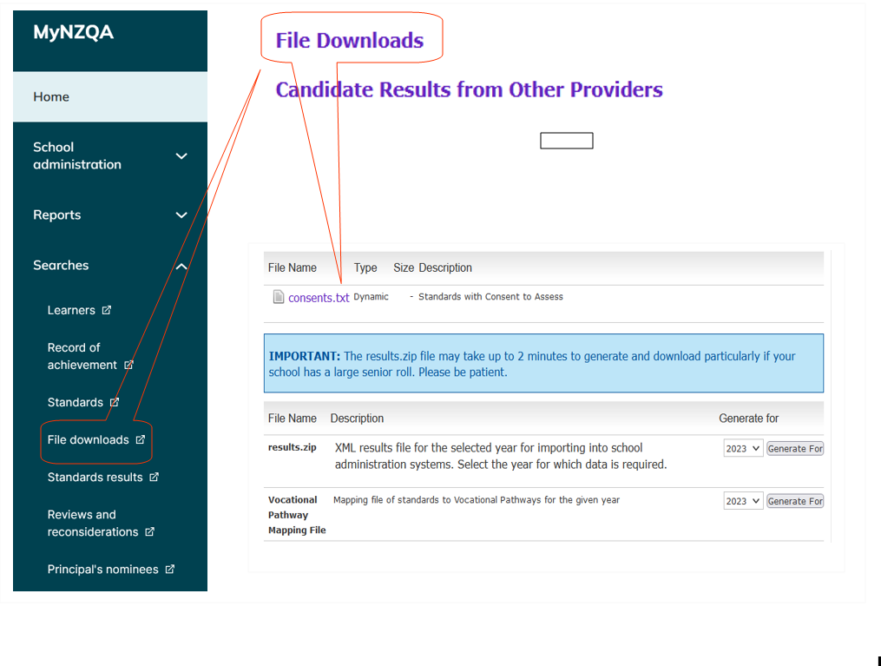
Obligations associated with the use of a provider code
For all reported results, the school must ensure that it uses the correct provider code.
All results for internal assessment reported to NZQA are received with a provider code attached to them. Unless a school enters the external provider code of an external assessor, all of the results being reported to NZQA have the school’s own provider code attached to them by default.
In every instance, the provider code identifies, for the particular assessment, the organisation:
- whose Consent to Assess is being exercised
- that is required to hold a course enrolment for each of the students being assessed
- that undertakes the assessment and awards the grade to the particular student
- whose appeal procedures, and other assessment procedures are in play
- that attests that the student work is authentic
- that is responsible for all aspects of internal moderation
- that is responsible for ensuring samples of student achievement are adequately stored to meet moderation requirements and to respond to student appeals

Whose provider code is to be used when an external provider is the assessor?

Your school has consent? | External provider has consent? | Provider code used
Yes | Yes | Report result to NZQA with external provider code
Yes | No | Apply to NZQA for approval of a subcontracting arrangement
No | Yes | Report result to NZQA with external provider code
No | No | Non-starter, not able to assess

School employees are able to exercise the school’s Grant of Consent to Assess
The school’s grant of Consent to Assess can be lawfully exercised only by individuals who are employed by the school’s Board of Trustees.
A school cannot sub-contract its Consent to Assess to an organisation, or individual who is not employed by the school’s Board, and that does not hold Consent to Assess for particular standard(s), without NZQA approval.

Take care not to unintentionally breach the rules
Schools that have been granted NZQA Consent To Assess must comply with the Assessment and Examination Rules for Schools with Consent to Assess (Assessment Rules) and the Consent to Assess Against Standards on the Directory of Assessment Standards Rules 2021 (CAAS Rules).
A school is in breach of these rules if another organisation undertakes all or some of the responsibilities listed above but the school reports results to NZQA with its own provider code.
In all cases, the provider whose code is being used to report results must hold NZQA Consent to Assess for the particular standard(s). Results must not be reported unless the provider has Consent to Assess. Results from unconsented providers do not count for the award of a qualification.
Managing assessment through an external provider

Your school must have a Memorandum of Understanding with every external provider you
engage with to assess your students. This must be updated each school year and be available during your MNA review or during school visits from your School Relationship Manager (SRM).
MOU Checklist | ü
Names of the parties to the agreement
Specific standards being assessed (number, title, version)
Consent checked for the standards being offered
Who manages the quality assurance systems?
Who is responsible for on-going monitoring?
Are assessment procedures noted in the MOU e.g. appeals, late procedures etc?
Are internal moderation arrangements noted in the MOU?
Are external moderation arrangements noted in the MOU?
Who is responsible for candidate entries?
Who reports results or other information to NZQA?
Who is responsible for fee payment, if any?
Date and format for reporting
Who looks after administration such as student enrolment, student welfare, decisions relating to progress, assessment, etc?
Agreement about financial arrangements and provision of resources (physical and human)
Method of resolving any differences which might arise between the two parties
Means by which students are protected should the arrangement terminate

To protect all parties, it is best for the MOU to be signed and agreed before any assessment takes place.
Note: In every instance where any element is missing from an MOU, a potential risk to the credibility of the reported results may exist.
MOU Tracking (Exemplar)
Tracking your MOUs ensures all MOUs are up-to-date and signed by both parties, assures the BOT that all external providers have Consent to Assess and assists you to report results with the correct Provider Code.

ITO / provider | Provider Code | No. of results | School reports results Y/N | Course | Teacher | Date MOU signed | Finish date | PN sighted | Link to digital copy
BCITO | 8101 | 25 | Y | 2Tech | DJ | 21/2/25 | 21/2/25 | AW 22/2 | MOU file – BCITO

Use of a sub-contractor
A sub-contracting arrangement may be used where your school wishes to use a specialist or expert in a sporting, or other field e.g. skiing, to assess students against a standard, where that specialist does NOT have consent to assess.
NZQA has an approval process to enable your school to use a third party to assess against a standard.
Go here to find out more about how sub-contracting works and how to apply for approval.
You should discuss the proposed arrangement with your School Relationship Manager, who will advise you.
Your school, the consent holder, should apply to engage in an unconsented sub-contract through your MyNZQA portal.

Tracking progress towards NCEA
Your school needs to track the progress of students towards their completion of both their individual academic goals and their progress towards qualifications.
Your tracking could include: the number of credits in assessment programmes, the relevance of the programme to students’ career pathways, achievement rates, their courses and levels, etc.
To achieve this, it is important that everybody understands how NCEA works. For school students each certificate is a minimum of 80 credits and
to achieve NCEA Level 1, you need:  - 60 credits at Level 1 or higher, and  - 10 literacy | te reo matatini credits  or from additional standards  and  - 10 numeracy | te pāngarau credits or from additional standards | Please note:  - The literacy corequisite standards are 32403 and 32405. For te reo matatini it is 32414  - The numeracy corequisite standard is 32406 and te pāngarau is 32412  - If students are ready, they can be offered standards at any level, regardless of their school year level, or whether they have completed an NCEA certificate
to achieve NCEA Level 2, you need:  - 60 credits at Level 2 or higher, and  - 10 literacy | te reo matatini credits, and  - 10 numeracy | te pāngarau credits | Please note:  - UE literacy credits are available from some Level 2 achievement standards. Start tracking for relevant L2 students
to achieve NCEA Level 3, you need:  - 60 credits at Level 3 or higher, and  - 10 literacy | te reo matatini credits, and  - 10 numeracy | te pāngarau credits | Please note:  - UE requirements are complex. Ensure that students who are aiming for UE have assessment programmes that will allow them to meet the requirements  - Ensure that students have a pathway into their next step beyond school
NOTE:
- Candidates who achieved the literacy or te reo mataini and/or numeracy | te pāngarau requirements for the 2023 academic year will be considered to have met the relevant NCEA corequisite standards in respect of academic years 2024-2027
- Where credits from the additional standards are used towards the corequisite they cannot also be used towards the 60 credit requirement
- Where more than 10 literacy/numeracy credits are achieved through the additional standards, the surplus credits can be used towards the 60 credit requirement
- Credits must be derived from either the corequisite standards or the additional standards, (they cannot be a mix).

University Entrance requirements
University Entrance (UE) is the minimum requirement to go to a New Zealand university.
Students who are aiming for UE through NCEA need to check that their programmes meet not only the minimum requirement, but also the entry requirements for the particular institution they wish to attend, and the programme they wish to study. UE subject requirements are complex. Ensure that your students get good guidance on tracking their progress, and which standards will help them complete the requirements.

Level 3 NCEA and: | - At least 60 credits at Level 3, or above needed  - Can include both Achievement Standards and Unit Standards
Level 1 Numeracy and: | - 10 credits at Level 1 or above, made up of either:  - the corequisite level 1 numeracy standard, 32406, or te pāngarau, 32412 or  through the additional standards
UE Literacy and: | - 10 credits from the standards on this list which includes both Level 2 and Level 3 achievement standards, and a few Level 4 unit standards.  - Students may complete this requirement before Year 13.  - UE Literacy can come from a range of subjects.  - At least 5 credits must be writing.  - At least 5 credits must be reading.  - In your SMS, literacy standards may be flagged as R (reading), W (writing), or B (both). If they are B, they can count towards either reading or writing or both.
14 credits in each of three approved subjects. | - Check that students can get 14 credits from approved standards in each of the UE subjects they are aiming for.  - An approved subject is not the same as a school course. Standards must be Level 3 achievement standards from the same UE approved subject. It is not relevant whether they have been assessed in the same school course.  - The approved subject list is not negotiable. If the 14 credits are not all listed on the approved subject list for a subject, they will not be approved for that subject.  - Some standards appear in more than one subject. When NZQA calculates the award, the standards will be grouped in a way that most advantages the student. Each standard can only be used once.  - Examples of subjects that include standards from other subjects are Mathematics, Technology, and Science. For example, Digital Technologies and DVC are individual subjects. Their standards also appear under Technology/Hangarau and can be combined if needed.  However: Geography and History standards only appear in their ‘own’ list. They can’t be combined with any other standards.

Calculating Endorsements

NCEA endorsements

Certificate Endorsement
NCEA endorsement shows achievement in the qualification.

NCEA endorsed with Excellence
When you gain 50 or more credits at Excellence at the level of the certificate or above, your NCEA certificate will be endorsed with Excellence.

NCEA endorsed with Merit
When you gain 50 or more credits at Merit at the level of the certificate or above, or if you gain 50 or more credits at a mix of Merit and Excellence, your NCEA certificate will be endorsed with Merit.
Credits for an endorsed NCEA certificate (Levels 1, 2 and 3) can be gained over more than one year.

Course Endorsement
Course endorsement shows achievement in a particular course or courses, as defined by the school. Not all subjects will have a course endorsement and each course is set by your school. The school decides which standards make up a course.
Course endorsement is not necessarily a subject endorsement. This a common misconception. Refer to Myth 10 if you would like more information for clarification.
When you gain 14 or more credits at Achieved, (or a mix of Achieved and Merit), you will be awarded an Achieved endorsement for that course.
When you gain 14 or more credits at Merit (or a mix of Merit and Excellence) in a course in a single year, you will be awarded a Merit endorsement for that course.
For example, if you gain 14 or more credits at Merit in your Physical Education course, you will be awarded Merit for Physical Education.
When you gain 14 or more credits at Excellence in a course in a single year, you will be awarded an Excellence endorsement for that course.
N.B. To be awarded an endorsement, in most courses, you need at least three credits from internal assessment and three from external assessment.
Standards contributing to course endorsement must be assessed within one academic year.
Managing and monitoring internal and external moderation

The Internal Moderation process

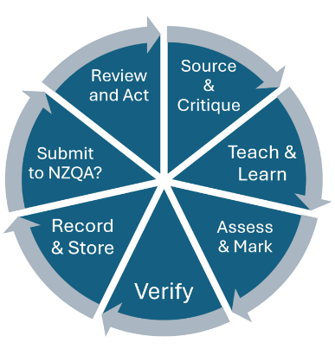
Internal and external moderation is a continuous process

You need evidence that all the results your school reports have been subject to internal moderation. Your quality assurance systems are there to ensure that assessment is valid, authentic, and verifiable and that your grades are accurate.
There is an internal moderation cover sheet available, that you may adapt to suit your school and use to record evidence for individual standards. (KAMAR has this built into its system).
You must ensure that:
- All assessment material is critiqued before use.
Teachers must ensure that the assessment tasks they use meet the requirements of the standard and Conditions of Assessment (on subject resource pages) and provide the opportunity for students to present evidence at all grades.
If you are using publicly available tasks, they should be modified and contextualised to fit your school’s context and student needs.
Each level 1 subject includes mātauranga Māori indicated in the learning matrix and other teaching and learning materials. Through a frame on the NCEA.education website, Mātauranga Māori EN2 will identify the second explanatory note in standards that include it. If there’s no frame, that Explanatory Note 2 is treated as a current practice explanatory note.
- Judgements are consistent with the standard.
Teachers should be familiar with the advice available for each standard. This is available on subject pages on the NZQA website. They should also access the online assessor support available – including standard-specific, up-to-date advice from moderators.
Teachers can request clarification of an internally assessed standard prior to teaching and assessing or at any other time by using the form available.
- For each standard, a sufficient sample of each teacher's grade judgements is verified.
Teacher judgements for every standard need to be checked to make sure that they are consistent with the standard. The verifier must be a subject specialist with standard-specific knowledge. Your SRM can help you find a verifier at another school if your teachers are struggling to find one.
Work for grade verification should be strategically selected, not randomly, not all of it, and not a set number. The number of pieces of student work required for verification depends on the teacher experience with the standard. There are scenarios to assist with determining sufficiency. For each standard, assessment materials are retained, along with a selection of student work for the purpose of external moderation.
Schools must have a policy for the retention of assessment material. It should ensure that:
- material is available to meet the requirements of the external moderation process during the year a standard is assessed
- annotated samples of student work is retained to provide markers with benchmarks for comparison and exemplar purposes
- evidence of internal moderation is available until the end of the following academic year
- the school can confirm the accuracy of results reported to NZQA
- All advice from external moderation is actioned before the standard is assessed again.
External moderation feedback helps you to ensure that your internal moderation processes are working. Always follow up on moderation reports, to ensure that any required actions are taken, and feedback is used to inform further assessment.

Monitoring your Internal Moderation processes.
Schools must have monitoring systems to ensure that the results they report have been subject to their internal moderation process. Evidence of internal moderation and the school’s monitoring of it must be retained until the end of the following academic year.
As a PN, the monitoring of internal moderation is a critical part of maintaining your school’s consent to assess
You need evidence that:
- All assessment material is critiqued and recontextualised / modified as necessary, before use.
- Judgements are consistent with the standard.
- For each standard a sufficient sample of each teacher's grade judgements is independently verified to provide confidence that they are assessing to the standard.
- Assessment materials are retained for each standard, along with a selection of student work for the purpose of external moderation.
- Conversations around borderline scripts have been captured.
- All advice from external moderation is actioned before the materials are used again.

When you set up your moderation monitoring systems, consider:
- Can you combine functions? One example is using a digital system that combines internal moderation tracking, and digital storage. This will make the process of submitting work for external moderation easier.

- Who will oversee each part of the process? You don’t have to do everything. Teachers, HODs, and SLT also have roles in monitoring and reviewing moderation. You need to ensure that the evidence exists, but you can delegate the storage of evidence and recording of the verification process to subject leaders.

- How will your system cope with the unexpected? A system that has checks and balances throughout the year will help you cope with staff members leaving, missing work, and changes to assessment programmes, and where possible a digital/online system is preferable.

- What do you need assistance with? Your SRM can help you find grade verifiers outside your school, discuss your processes and answer your questions. If you would like to check with a colleague in a school near you, use the list of PNs in your Provider Login under School’s Administration.

Whole school online spreadsheet (exemplar)
You must have a process to track that every standard for which you report a result has been through a credible and robust internal moderation process.
The template below is an example of the type of system PNs might use to monitor the school’s internal moderation over the course of the year. You could give Heads of Department editing rights and get them to include links to material that is stored on school shared drives.
Department | Course | Standard | Assessor | Verifier | Date verified | Date grades entered | Link to assessment documents | Link to assessed work | Link to verification notes or cover sheet | HOD signoff | PN check
English | 1ENG | 91100 | AW | JP (OBHS) | 14/04/2025 | 15/04/2025 | Teams Asst | ENG100 Classroom | Eng Dept minutes | AW | JB

Encourage Heads of Department and Teachers-in-Charge to use a similar system to record and monitor that all standards assessed and reported against by their department have been internally moderated. (see exemplar below)

Department / subject online spreadsheet (exemplar)
Date | Standard | V | Task Critiqued | Student | Marker | Grade | Verifier | Grade | Decision | Selection Reason and Comment: | Where stored:
09/11 | 90856 | 2 | Yes TKI  Adapted | Tania | JP | M | JG | High A | High A | Grade boundary; Student has discussed each of the 4 techniques in depth, but not how they work together as required for Merit. | Add link to school cloud location.  (preferred)  or physical location (for agreed student work)

Monitoring External Moderation
You need evidence that:
- materials are submitted for external moderation as requested by NZQA
- moderation reports are used to validate and/or improve assessment quality
- external moderation outcomes are used to evaluate the effectiveness of internal moderation processes.

External moderation of internally assessed standards ensures that assessment judgements are at the national standard. It provides evidence of the effectiveness of your school’s quality assurance processes and informs your self-review.
Assessment Plan
- In Term 4, you will get an email inviting you to complete your Assessment Plan for the following year. You can suggest the standards that you want feedback on. Look at your school’s moderation history and talk to your staff to determine the standards to suggest.
- Your SRM will use your suggestions to help select the standards for your Moderation Plan.
- Note: not all standards you request in your Assessment Plan can be added to your External Moderation Plan. This is at NZQA’s discretion, but you will have the opportunity to negotiate any changes to the plan before it becomes final. Some standards will also be selected for the purposes of exemplars. You will be guided through this process by your School Relationship Manager early in the new school year.
External Moderation Plan
- By the end of February you will get an email saying that your External Moderation Plan is ready. This is a list of standards that will be externally moderated by NZQA.
- Check your plan and ensure that all teachers are familiar with it.
- Make sure every teacher who needs it has access to the External Moderation Application through their provider login. This can be changed by your ESL delegated authoriser.
- Ensure that each standard is submitted, including:
  - a copy of the task and any supporting resources
  - a copy of the assessment schedule
  - selected samples of student work, following the selection requirements.
- External moderation should be uploaded and sent through to us as they have been completed and no later than 20 October. (Anything after this date, please inform your School Relationship Manager).
- If any error notifications are received during the submission process, the training and support material guide can be consulted.
Most work is submitted digitally for external moderation. It is still possible to send work physically, but you will need to arrange (and track) your own courier bags.
You must have a monitoring system to ensure that external moderation feedback is acted on and issues are resolved. Teachers must address issues that are identified in the external moderation results report, including the use of invalid tasks and lack of agreement by the moderator with assessor judgements. Encourage them to use the request for clarification of an internally assessed standard or appeals process as needed.
System for Monitoring External Moderation
The template below is an example of a system you can use to monitor external moderation feedback. Feel free to create your own system or adapt the template for your use.
Dept | Standard | HOD/TIC | Consistency | Agreement rate | Moderator comments in your own words | Link to action plan, and updates | Success criteria | Initial and date when actions completed | PN check and comment
PE | 90962 | MP | NC | 4/6 | Didn’t have enough evidence of consistent effort for Ex – needed further explanation of factors influencing participation | PE Dept minutes | Exemplar included in instructions, teaching time on explaining participation and kinds of evidence to use | MP 17/5 | AW Actions complete, verifier changed.

Schools must address issues that are identified in the external moderation results report, including the use of invalid tasks and lack of consistency with the standard as identified by the moderator.
Using External Moderation to support self-review
Using a template may be useful for monitoring the feedback received from external moderation, the actions that have been taken and the credibility of the items actioned.

Managing National Assessment
MNA reviews

What is a Managing National Assessment (MNA) review?
NZQA reviews the assessment systems of secondary schools at least once every five years to:
- ensure that assessment is valid, fair, consistent, reliable, accurate, to the national standard and in accordance with the Assessment Rules
- confirm that the requirements for the consent to assess are being maintained
- the report includes:

- a summary of the review findings and any actions required for the school to maintain its Consent to Assess
- comments on the effectiveness of the school’s management and review of assessment practice, moderation, data and communication.
- The leaflet How effectively does your school ensure the credibility of assessment for national qualifications? summarises what is included in the MNA review and how NZQA determines the next MNA review date.

Who is involved in the MNA review?
The Principal, relevant Senior Leaders, the Principal’s Nominee, a representative group of Heads of Learning or lead teachers of NCEA and about 3 Level 1-3 students. The final MNA report is shared with the BOT Presiding Member, and you can find your school’s MNA report published on the NZQA website.

When does the MNA review occur?
Generally, every three to five years. This varies according to the outcome of the previous review and / or at NZQA’s discretion.
Where does the MNA review take place?
The review is generally carried out at your school on a mutually agreed date.
Why must schools participate in MNA reviews?
To confirm your school’s ongoing Consent to Assess.
How is the MNA review organised?
Preparation for the visit, the type of documentation you will need to supply, and the structure of the review day are all described here.
Links to key resources and guidelines

- A list of Action items for Principal's Nominees by calendar month.

- This also acts as a guide/checklist for Principal's Nominees.

- Each year, NZQA runs Leading National Assessment seminars for Principal's Nominees. These provide opportunities to share good practice in managing assessment for qualifications and update PNs on NZQA policy and processes.

- NZQA has produced an Effective Assessment Practice Guide that provides schools with ideas for effective assessment for qualifications under the leadership of Principal's Nominees.
- Handbooks and Guides to processes:
  - Special Assessment Conditions (SAC) online tool guide
  - Guide to the NZQA External Moderation Application
  - Date File Submission – See your Provider Login, under Data File Submission
    - SMS User Guide
    - Web Entries User Guide
  - Adding and amending internal assessment results – See your Provider Login, under Add Results
  - Submitted subject administrative guidelines – under relevant subject, resources for externally assessed standards (See subject pages)

- News – general updates, on the NZQA Home page:
  - Assessment Matters – circulars on assessment, operations and logistics
  - EmaiLink - Information for Principal's Nominees about any changes and upcoming deadlines
  - Seminar resources
    - Kaupapa Māori Kura Leaders Seminar
    - Teachers New to NCEA Seminar
    - Leading National Assessment Seminars
    - New Principal’s Nominees Online Seminars.

- Logging in:
Education Sector Logon (ESL) School Delegated Authoriser
  - School NZQA Provider Login Access – Quick Reference Guide (see below)
  - Support for online Delegated Authorisers (How to Guide)

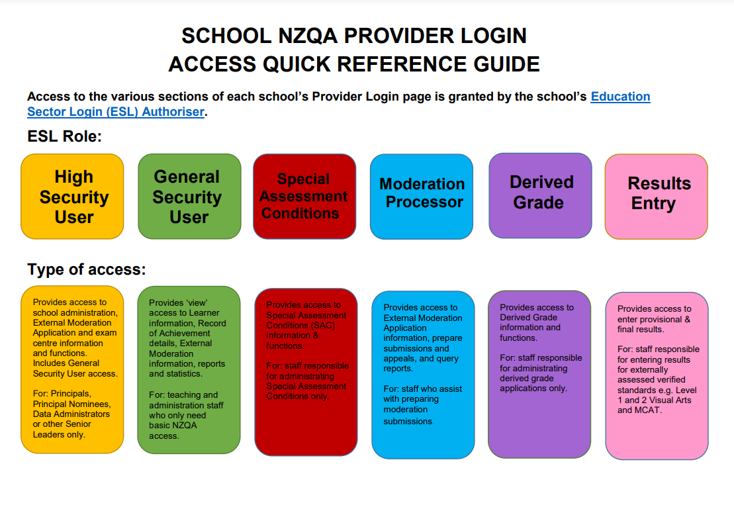
- Myths about NCEA Assessment

#1 The number of credits assessed
#2 Assessment practice and gathering evidence
#3 Managing authenticity
#4 Resubmission (see below)
#5 Further assessment opportunity
#6 Internal moderation
#7 Selection of work for external moderation
#8 Profiles of Expected Performance (PEPs)
#9 Derived Grades
#10 Courses and programmes

The NZQA Website:
Schools and Teachers

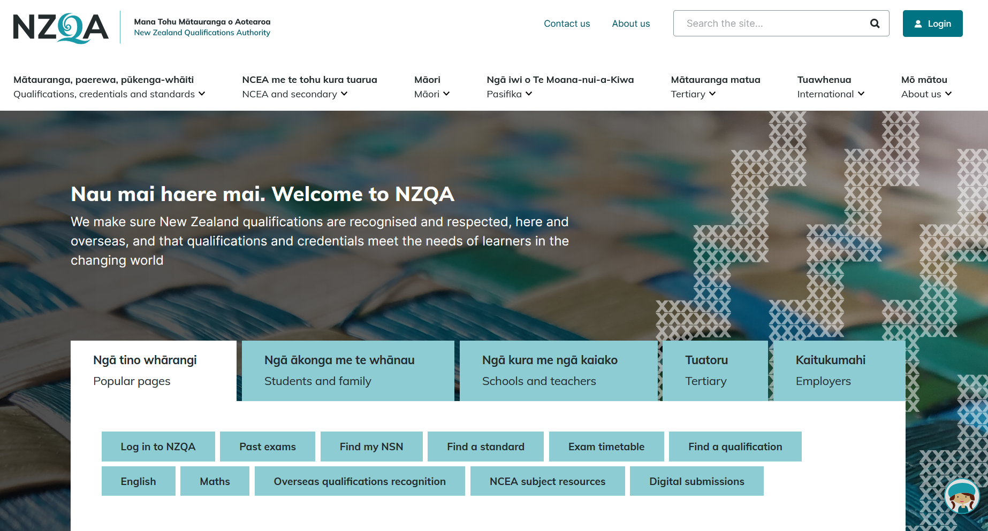

Activity 1

Navigate your way around the website to find:

- a standard and who has consent to assess it
- links to Pūtake (the NZQA Learning Management System) and other assessor training from the moderation team
- UE requirements – literacy and approved subjects
- the approved calculator list
- preparing for exams and who does what
- payment of fees for International fee paying candidates to NZQA
- who is eligible for SAC
- information on how to prevent and detect academic fraud

Navigate subject resources

NCEA Subject Resources
Subject resource pages are available for all New Zealand Curriculum and Te Marautanga o Aotearoa subjects and learning areas:

Types of Documents
Each NCEA subject resource page may include some or all of the following types of documents:

Assessment report | An overview of the performance of candidates in the external standards of a subject, for use by teachers and candidates.
Assessment schedule | The markers' guide – what was accepted or looked for in candidate answers.
Assessment specifications | Provide the assessment parameters for each externally assessed achievement standard. Should be read alongside the applicable standards. Cover information such as format of examination paper and context of questions (where appropriate), as well as equipment candidates can bring and use. For portfolio subjects, the specifications cover submission date, and type and volume of materials that may be submitted as evidence.
Cut scores | Defines how the different levels of performance were separated from each other. For Grade Score Marking, these are the cut scores between the grades N, A, M, and E.
Examination paper | The set of questions to be answered by candidates in the exam room. In some cases, there will be a single document; in others there may be separate documents.
Exemplar of examination paper | An actual student answer script, with annotations from the marker indicating why the script was assessed in the way it was.
Exemplar for internally assessed standard | An extract of student evidence, with commentary by the moderator explaining key aspects of the standard (for teacher use).
The standard  (unit or achievement) | Defines the learning outcomes (what the learner will be able to do, or explain, or demonstrate, or understand, etc), as well as the assessment criteria.
New content will be added as it is developed or becomes available. NZQA thanks the students whose work has been published as exemplars.Standards and previous exam documents (and associated reports, schedules, etc.) are also available by searching: search NCEA standards.

Te Reo Matatini me te Pāngarau
E ngā mana, e ngā reo, nau mai rā ki te paetukutuku nei o Te Reo Matatini me te Pāngarau.

Haere ki te Te Reo Matatini me te Pāngarau

Ringa Toi Exhibition
Ringa Toi is an annual exhibition that showcases the artwork of secondary school students with a focus on Toi Māori. Read more.

Te Reo Māori Translation
Te Reo Māori translation subjects

Glossaries For Translated NCEA External Examinations
Science  English–Māori (PDF, 1.4MB)  Māori–English (PDF, 1.4MB) | Mathematics  English–Māori (PDF, 165KB)  Māori–English (PDF, 168KB) | Social Studies  English–Māori (PDF, 204KB)  Māori–English (PDF, 206KB)

Navigating a subject page

English subject resources

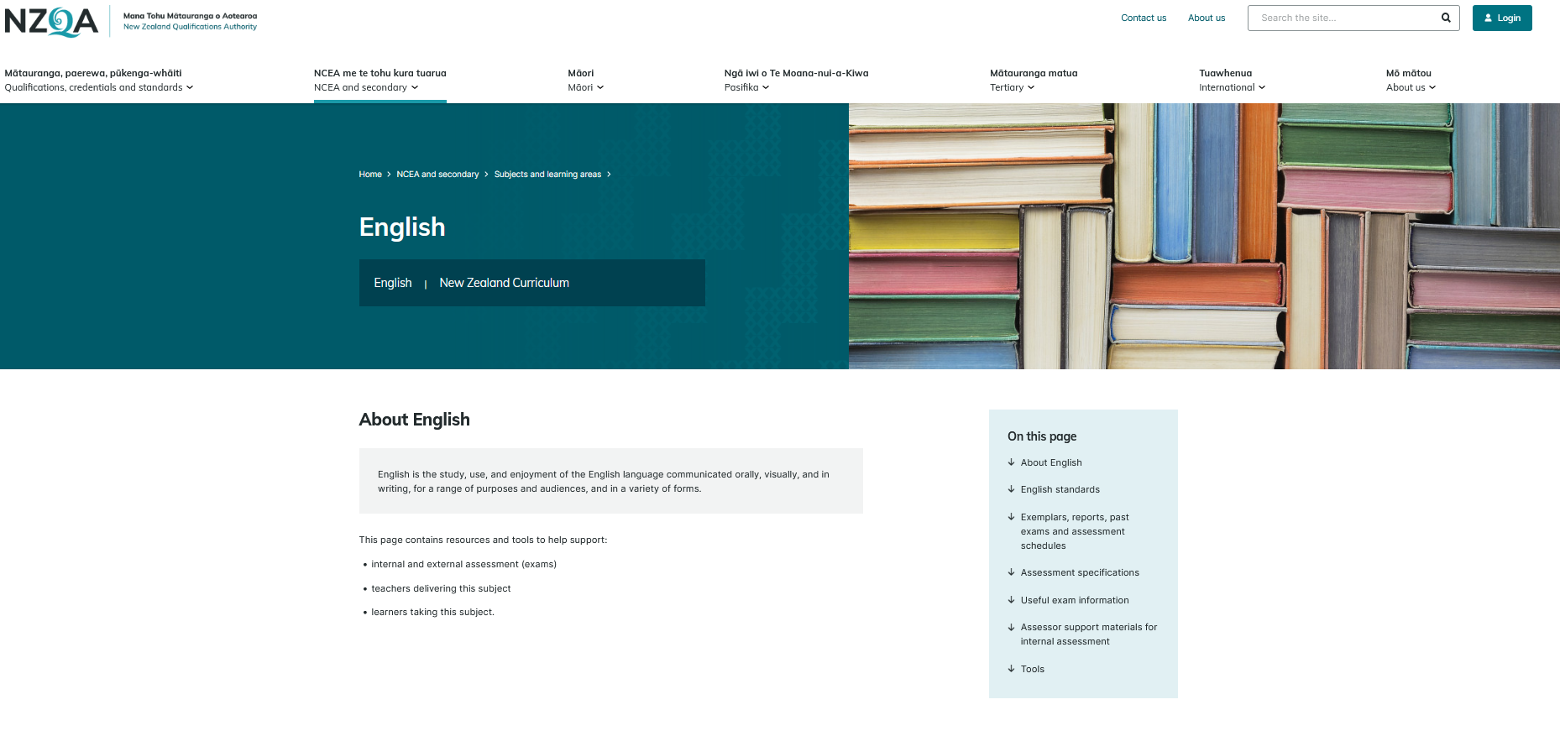
Activity 2

Navigate to the English webpage to find:

- Assessment Specifications for 91926
- Request for clarification of a standard
- Level 1 assessment matrix

Show: All subjects

Answers to activities

Activity 1
- a standard and who has consent to assess it
NCEA and secondary, search for a standard

- links to Pūtake and other assessor training from the moderation team
NCEA and secondary, NCEA for teachers and schools, assessor support, Online workshops, courses and modules

- UE requirements – literacy and approved subjects
NCEA and secondary. Understanding secondary qualifications and awards, University entrance

- the approved calculator list
NCEA and secondary, student assessment hub, scroll down to How to prepare for assessments then Approved calculator list

- preparing for exams and who does what
NCEA and secondary, managing national assessment in schools, examination management

- payment of fees for International fee paying candidates to NZQA
NCEA and secondary, NCEA for teachers and schools, managing school data

- who is eligible for SAC
NCEA and secondary, NCEA for teachers and schools, scroll down

- information on how to prevent and detect academic fraud
NCEA and secondary, NCEA for teachers and schools, assessment and moderation of standards, academic integrity
Note, Pūtake has a short course called Tāku Reo, Tāku Mahi - My voice , my work

Activity 2
- Assessment Specifications for 91926

- Request for Clarification of a standard

- Level 1 assessment matrix
This takes you to the NCEA page for the new level 1 standards

