NZQA Assessment Support Material

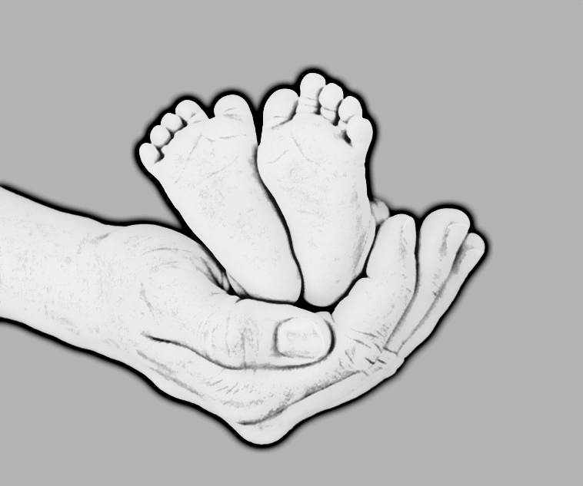
Unit standard 28092
Title | Analyse the effect of significant life events at different life stages on personal financial income
Level | 2 | Credits | 3 | Version | 3

Student guidelines

You will be assessed on how well you:
- Identify and explain source(s) of income based on three different life stages for given scenarios.
- Explain the reasons for and consequences of the changes on income source(s) at each of three different life stages.
- Analyse the effects of a significant life event on personal financial income at each of three different life stages.
- Explain and justify potential solution(s) to minimise/maximise the effect on personal financial income presented by significant life events.

AWARD of Grades
 | - For award with Achieved, you must for each of three different life stages: identify income sources; provide an explanation of why sources of income change and the consequences of the change in income; analyse the significant life event in terms of its effect on income sources and potential solution(s) to minimise/maximise the effect on personal financial income.

AWARD of Grades
- For award with Merit, you must for each of three different life stages: identify income sources; provide an explanation of why sources of income change and the consequences of the change in income, by providing supporting examples; analyse the effect of the significant life event in terms of its effect on income sources and potential solution(s) to minimise/maximise the effect on personal financial income.
- For award with Excellence, you must for each of three different life stages: identify income sources; provide an explanation of why sources of income change and the consequences of the change in income, by providing supporting examples; analyse the effect of the significant life event in terms of its effect on income sources and potential solution(s) to minimise/maximise the effect on personal financial income; provide a justification of the suitability of potential solution(s) to minimise/maximise the effect of the significant life event on personal financial income.

Conditions of ASsessment
 | This is an open book assessment. You may use any information to help you complete the task(s). Answers must be in your own words.  Your assessor will provide you with information regarding timeframes for this assessment.

 | Task one
Complete the table below to answer the following for each of the three (3) life stages:

- What sources of income might someone have for this life stage?
- What are the reasons that income sources might change during each of the life stages and what are the consequences of that change?
- Give supporting examples of each of the consequences identified for ii).

Life stage 1 – Education/industry training/early employment

Life stage 2 – Mid-career

Life stage 3 – Retirement

Task two

- For each of the following scenarios (three (3) scenarios in total) complete the tables on the following pages.
Analyse how the significant life event in the scenario will affect the income source(s) of the person or family during the life stage. Include:
- The effect of the significant life event on income source(s).
- Two potential solutions to minimise/maximise the effect of the life event on their personal financial income.
- Justification of the suitability of the potential solutions.

 | Scenarios

Education/Early employment | Kahu has finished his final year of university and is looking for work. He wants to leave home and go flatting as soon as he can get work.

Mid-career | Prarthna and Aaron have two children at high school. Prarthna has been working part time and Aaron has been working fulltime for the last several years.  Unfortunately, Aaron is about to be made redundant, and his redundancy pay is only $3,500. They have $7,000 in savings.

Retirement | Janet is in her 60s. She is divorced and has one adult son in his thirties, and is looking to retire in a few years when she inherits $50,000 from her uncle.  Janet lives in her own mortgage free apartment and has always been very careful with her money. However, because of serious health problems she has no other savings.  Both her parents are still alive. They are fit and healthy in their mid-80s.

