Supported Learning Assessment Support Material
Unit standard | 29302
Title | Demonstrate interpersonal skills in familiar contexts
Level | 1 | Credits | 4 | Version | 3


Ākonga/learner guidelines
ĀKONGA/LEARNER’S INFORMATION
First and last name
NSN number
Date

Demonstrate interpersonal skills in familiar contexts
Instructions for the ākonga/learner:
- Do ALL parts of this assessment.
- Ask your assessor if you need help to understand something better.
- Answer in a way that is easiest for you (e.g. drawing, recording voice memos, speaking to your helper, taking photos).
Conditions of Assessment

- You will complete assessment with the assessor.
- The assessment will take place over a timeframe set by the assessor.
- Before the assessment tasks, an introduction to the assessment should be given, using the examples provided.
- Assessments should be carried out in situations that are limited in range, repetitive, and familiar and employed within closely defined contexts. They should be conducted in authentic situations that are relevant to the ākonga/learner’s day-to-day living that may include but is not limited to workplace, educational setting or within the community.

Demonstrate interpersonal skills in familiar contexts


Assessment Task
For this assessment, in class time, your teacher will observe you talking to:

Your teacher will observe your use of interpersonal skills. Interactions occur naturally, and you may not know you are being observed. Your teacher will discuss the observation with you after it has taken place.

Interpersonal Skills

Interpersonal skills include actively listening, sharing ideas, resolving conflict, negotiating. The diagram shows some examples of skills that are used every day when interacting with others.

Think back over the last few days and write down some of the interpersonal skills

you have used (including who you used them with and where you were):

The skills needed for interpersonal communication also includes messages which are expressed through non-verbal behaviours. Non-verbal communication includes facial expressions, the tone and pitch of the voice, gestures displayed through body language and the physical distance between the people communicating. These non-verbal signals can give clues and additional information and meaning over and above spoken (verbal) communication.
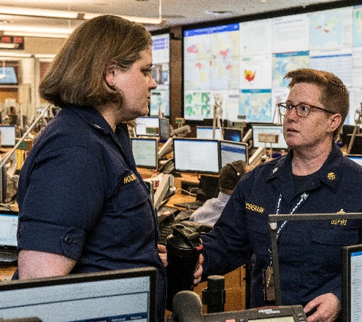 |  | 
 | 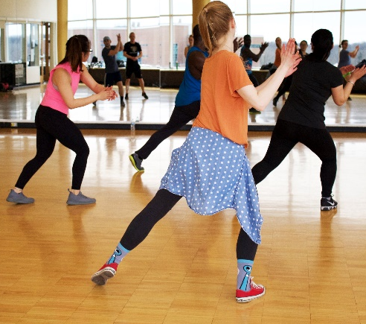 | 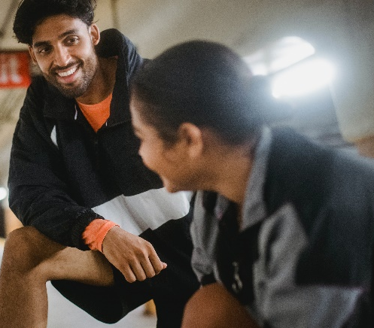

Make a note of some of the non-verbal behaviours that the people in the photos are using to help them with their interpersonal communication:

Assessment/Observation 1 – Two interactions with one familiar person
The following observation sheet will be completed by your assessor:

- Interactions | - Interpersonal Skills observed | - Comments on ākonga/learner performance
Example:  Discussing plans to go on a planned trip with friend (Chris). | - Sharing ideas.  - Negotiating.  - Nodding in agreement. | Tama was also able to plan a trip with his classmate by sharing ideas.  They negotiated on aspects of the plan they would both enjoy.
Interaction 1 with…

Interaction 2 with…

Assessment/Observation 2 – Interaction with a group of familiar people

The following observation sheet will be completed by your assessor:

- Interactions | - Interpersonal Skills observed | - Comments on ākonga/learner performance
Example:  Working with classmates to host an afternoon tea (with food and tea and coffee) for families of the class. | - Resolving conflict.  - Working with others. | Tama had to work with his class to host an afternoon tea for families. He had a disagreement with his classmates over his role on the day; however, Tama was able to resolve this by talking through an alternative role he could take and the sharing of responsibilities on the day. He worked closely with others which ensured the success of the event.
Interaction 1 with a group of familiar people…

Interaction 2 with a group of familiar people…

OUTCOMES AND PERFORMANCE CRITERIA

Outcome 1: Demonstrate interpersonal skills in familiar contexts.

Range: Interpersonal skills may include but are not limited to – actively listening, sharing of ideas, resolving conflict, negotiating.

Performance criteria:
1.1 - Interpersonal skills are appropriate to the desired outcomes and the context, when relating to one other familiar person.
Range: Evidence of two interpersonal skills for each of two situations.

1.2 - Interpersonal skills are appropriate to the desired outcomes and context, when relating to a group of familiar people.
Range: Evidence of two interpersonal skills in one group setting.

ĀKONGA/LEARNER EVIDENCE- Name:_____________________________
Situation 1 -  Interpersonal skills are appropriate to the desired outcomes and the context, when relating to one other familiar person.  Evidence of two interpersonal skills issue for each of two situations. | Situation 2 -  Interpersonal skills are appropriate to the desired outcomes and context, when relating to a group of familiar people.  Evidence of two interpersonal skills in one group setting.
Achieved ☐ Not Achieved ☐ | Achieved ☐ Not Achieved ☐

Overall Performance Outcome: Achieved ☐ Not Achieved ☐
  - Assessor’s Attestation:
I confirm the following:
- the ākonga/learner has adequacy of knowledge and performance.
- the assessment complied with relevant health and safety practices.
- the ākonga/learner’s likely repeatable competence in the future.

Assessor Name: |  | Assessor Signature:
Date: |  | Position Held:

