Supported Learning Assessment Support Material
Unit standard | 29304
Title | Describe elements of own culture, and basic rights and responsibilities of residing in Aotearoa New Zealand
Level | 1 | Credits | 4 | Version | 4


Ākonga/learner Guidelines

ĀKONGA/LEARNER’S INFORMATION
First and last name
NSN number
Date

Describe elements of own culture, and basic rights and responsibilities of residing in Aotearoa New Zealand

Instructions for the ākonga/learner
- Do ALL parts of this assessment.
- Ask your assessor if you need help to understand something better.
- Answer in a way that is easiest for you (e.g. iPad computer, cell phone, speaking to your helper, camera).

Conditions of Assessment
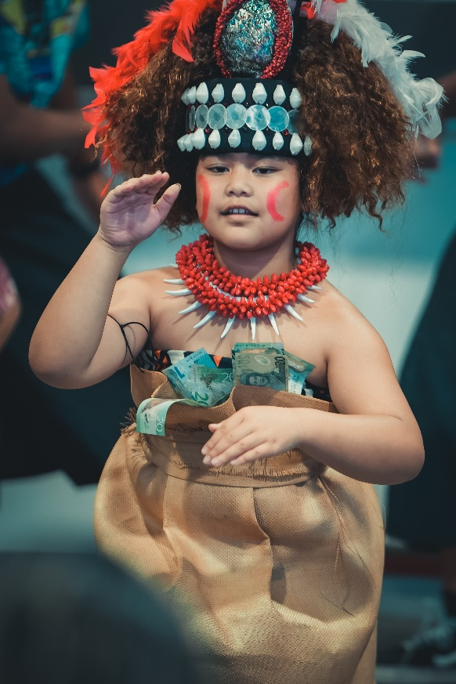
- The assessment will be done by the ākonga/learner.
- The assessment will take place over a timeframe set by the assessor.
- Assessments should be carried out in situations that are limited in range, repetitive, and familiar and employed within closely defined contexts. They should be conducted in authentic situations that are relevant to the ākonga/learner’s day-to-day living that may include but is not limited to workplace, educational setting or within the community.

Describe elements of own culture, and basic rights and responsibilities of residing in Aotearoa New Zealand



Assessment Task
This assessment task has three parts. You will be asked to:

Assessment – Part 1

CULTURE
Culture is about a group of people that share similar beliefs about the world and have a similar way of doing things. Culture usually comes from the family group that we belong to, the country that we live in, or the activities we engage in.

1a. What is your culture?

1b. Describe your family history (whakapapa). You should include:

- where your parents and grandparents are from
- when your family first came to Aotearoa New Zealand
- what part of Aotearoa New Zealand, or iwi and hapū you are from
- anything else you think is important here (about your family)


Cultural practices
Cultural practices might be related to food, language, dress, celebrations, traditions, customs (tikanga), music, e.g. Most Cambodian people are Buddhist. When there is something important happening in their lives (like doing a test), they go to the temple to pray for blessings.

1c. Describe four cultural practices that you do as part of your culture
Cultural practice 1:
What is this cultural practice about?

Cultural practice 2:
What is this cultural practice about?

Cultural practice 3:
What is this cultural practice about?

Cultural practice 4:
What is this cultural practice about?

Assessment – Part 2
2. Describe two basic human rights that people who live in Aotearoa New Zealand have.
A human right is something that all people are given. These rights are for all people who live in Aotearoa New Zealand. These rights relate to:
Equity   | Disability rights   |   Voting
Income Support   | The right to a passport   | 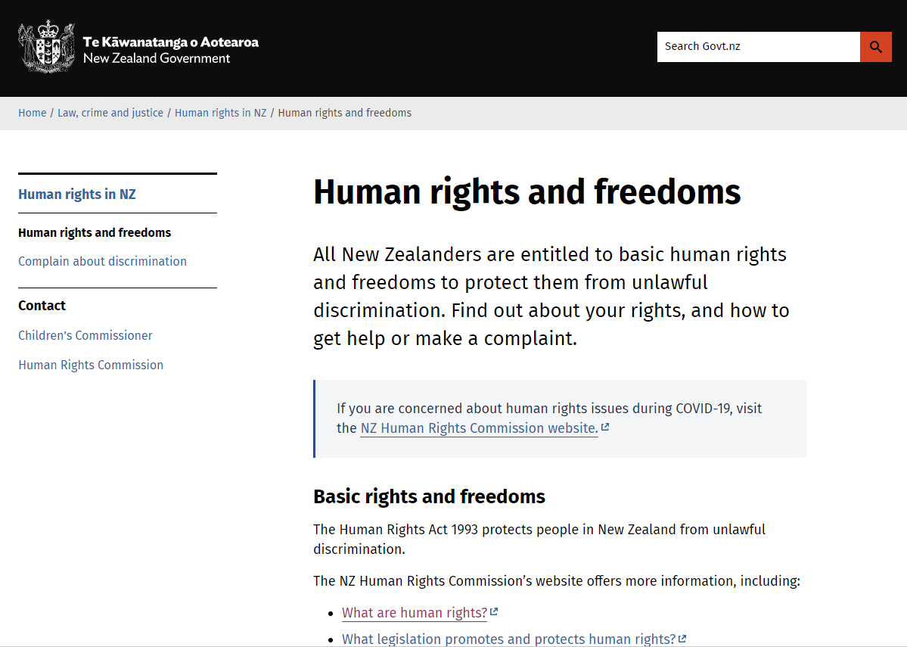  Any other human rights that are acknowledged by the Aotearoa New Zealand government.

Basic human right 1:
What is this basic human right about?
Basic human right 2:
What is this human right about?
Assessment – Part 3
In this part, you will describe the basic responsibilities that people who live in Aotearoa New Zealand have.
What is a responsibility?
A responsibility is something that you should do or a way you should behave. There are three key responsibilities that all New Zealanders have:
- Following all Aotearoa New Zealand laws
- Using bicultural practices (having attitudes, customs, and practices that respect the relationship between Māori and other cultures)
- Looking after the environment

3a. Following all Aotearoa New Zealand laws
Why should people follow all Aotearoa New Zealand laws? Give an example.
3b. Bicultural practices
Why should people use bicultural practices? Give an example.
3c. Looking after the environment
Why should people look after the environment? Give an example.
OUTCOMES AND PERFORMANCE CRITERIA
Outcome 1: Describe elements of own culture, and basic rights and responsibilities of being a citizen of Aotearoa New Zealand.
Performance criteria:
1.1 - Own culture is described in terms of family history/whakapapa and cultural practices.
Range: Cultural practices may include but are not limited to – tikanga, celebrations, traditions, religion, food, language, dress; evidence of four cultural practices.
1.2 - Basic human rights are described in terms of being a citizen of Aotearoa New Zealand, and a consumer of health and consumer services.
Range: basic human rights may include but are not limited to – equality, disability rights, education, voting, income support, the right to have a passport; evidence of two basic human rights.
1.3 - Basic responsibilities are described in terms of being a citizen of Aotearoa New Zealand.
Range: Evidence of one responsibility from each of – abiding and upholding laws, bicultural practices, environmental sustainability.
ĀKONGA/LEARNER EVIDENCE - Name:_____________________________
1.1  Own culture is described in terms of family history/whakapapa and cultural practices.  Cultural practices may include but are not limited to – tikanga, celebrations, traditions, religion, food, language, dress; evidence of four cultural practices. | 1.2  Basic human rights are described in terms of being a citizen of Aotearoa New Zealand, and a consumer of health and consumer services.  Basic human rights may include but are not limited to – equality, disability rights, education, voting, income support, the right to have a passport; evidence of two basic human rights. | 1.3  Basic responsibilities are described in terms of being a citizen of Aotearoa New Zealand.  Evidence of one responsibility from each of – abiding and upholding laws, bicultural practices, environmental sustainability. | Assessor Grade

Overall Performance Outcome: Achieved ☐ Not Achieved ☐

Overall comments:

Assessor’s Attestation:
As assessor of this unit standard, I confirm that:
- the assessment complied with relevant health and safety, and legislative requirements
- the candidate has met the unit standard requirements
- it is likely that the candidate has repeatable competence in the future.
Assessor Name: |  | Assessor Signature:
Date: |  | Position Held:

