Supported Learning Assessment Support Material
Unit standard | 29305
Title | Set personal goals and carry out a plan designed to achieve personal goals
Level | 1 | Credits | 5 | Version | 3



Ākonga/learner Guidelines
ĀKONGA/LEARNER’S INFORMATION
First and last name
NSN number
Date

Set personal goals and carry out a plan designed to achieve personal goals
Instructions for the ākonga/learner:
- Do ALL parts of this assessment.
- Ask your assessor if you need help to understand something better.
- Answer in a way that is easiest for you (e.g. iPad computer, cell phone, speaking to your helper, camera).

Conditions of Assessment

- Part One and Two of the assessment will be done with the assessor.
- Part Three of the assessment will be done by the ākonga/learner.
- Part Four of the assessment will be done with the assessor.
- The assessment will take place over a timeframe set by the assessor.
- Assessments must be carried out in situations that are limited in range, repetitive, and familiar and employed within closely defined contexts. They must be conducted in authentic situations that are relevant to the ākonga/learner’s day-to-day living that may include but is not limited to workplace, educational setting or within the community.

Set personal goals and carry out a plan designed to achieve personal goals
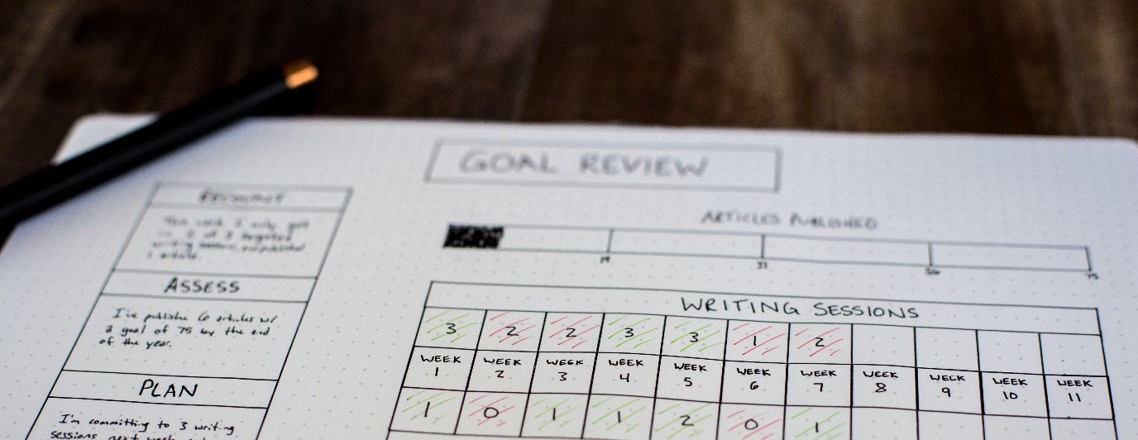


Assessment Task
This assessment task has four parts. You need to:

Assessment – Part 1
Set at least two personal goals based on your wants and needs, each within a different context. Here are some contexts you can choose from:
  Home |   School
Work   | 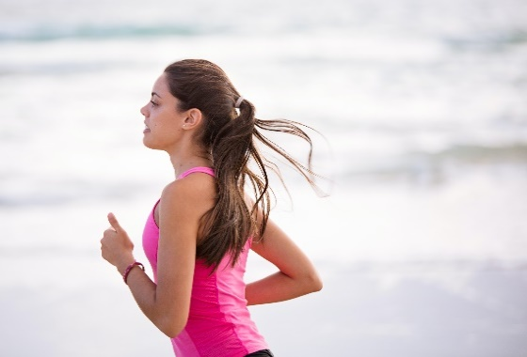  Other contexts, like sports or music

- Context | - Goal
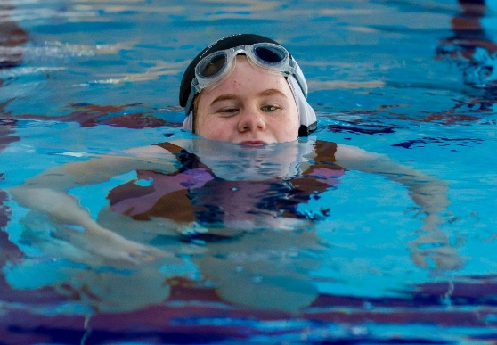  Example:  Fitness | 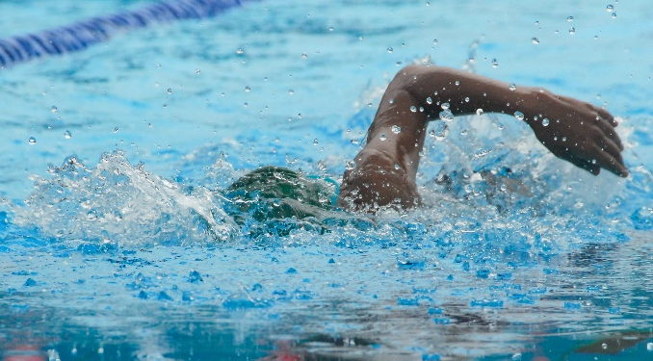  Be able to swim one length of the pool.

Assessment – Part 2 and Part 3
Break each goal into achievable steps and carry out your plan.

Example:
My plan to compete in a bike race
Name: Atawhai Kingi
- Steps  (plan and write each step) | - How will you do this step? | - How long will it take? | - Tick when completed | - Get your helper to date and sign when you have completed it
Step 1:  Enter into the race | Go to the stadium and tell them I want to enter into the Weet-Bix Triathlon. | One hour |  | Chris Brain  31.01.22
Step 2:  Get fit for riding my bike. | I will go on a bike ride every day. | When I go for a bike ride, I will go for at least an hour. | x | Chris Brain  05.03.22
Step 3:  Turn up for the race. | I will get mum to drop me off at the starting line before the race starts. | It takes 20 minutes to drive to where the race starts. |  | Chris Brain  19.05.22
Step 4:  Complete the race. | I will bike in the race until I have finished it. | The race could take me 1–2 hours to finish. |  | Chris Brain  11.12.22

Plan One - to achieve a personal goal
My plan is to…

Ākonga/learner’s name:
- Steps: | - How will you do this step? | - How long will it take? | - Tick when completed | - Assessor to sign and date when you have completed it
Step 1:
Step 2:
Step 3:
Step 4:
Plan Two - to achieve a personal goal
My plan is to…

  - Ākonga/learner’s name:
- Steps: | - How will you do this step? | - How long will it take? | - Tick when completed | - Assessor to sign and date when you have completed it
Step 1:
Step 2:
Step 3
Step 4:

Assessment – Part 4
Evaluate your plan.

Example:
  - Did you achieve your goal?
(You do not have to achieve your goal to be awarded this standard)
Yes
  - How did your plan help you with your goal?
My plan made me enter the race, train for it, and turn up to the race on time.
  - What did you like about your plan?
  - I liked that I entered the race before I started training. It helped me break down the race into steps that were easy to do.
  - How could you make your plan better?
  - I could plan to bike only three days a week. Planning to bike every day was too much work and I didn’t always do it.

Evaluation of Goal 1:
  - Did you achieve your goal?
(You do not have to achieve your goal to be awarded this standard)
  - How did your plan help you with your goal?
  - What did you like about your plan?
  - How could you make your plan better?

Evaluation of Goal 2:
  - Did you achieve your goal?
(You do not have to achieve your goal to be awarded this standard)
  - How did your plan help you with your goal?
  - What did you like about your plan?
  - How could you make your plan better?

OUTCOMES AND PERFORMANCE CRITERIA
Outcome 1: Set personal goals.
Performance Criteria
1.1: Personal goals are set in terms of identified wants and needs.
Range: Goals must be – specific, measurable; contexts for wants and needs may include but are not limited to – social, practical, educational, physical, vocational needs; evidence of two goals are required, each in a different context.
1.2: Goals are broken down into achievable steps.
Outcome 2: Carry out a plan designed to achieve set goals.
Performance Criteria
2.1: Plan is carried out towards achieving goals within a specified timeframe.
Range: Evidence of at least three steps are carried out for each goal.
2.2: Plan is evaluated in terms of its effectiveness.
ĀKONGA/LEARNER EVIDENCE - Name:_____________________________
Outcome 1 - Personal goals are set in terms of identified wants and needs.  Goals must be – specific, measurable; contexts for wants and needs may include but are not limited to – social, practical, educational, physical, vocational needs; evidence of two goals are required, each in a different context. |  | Outcome 1 -  Goals are broken down into achievable steps. | Outcome 2 -  Plan is carried out to achieve set goals.  Evidence that at least three steps have been carried out for each goal. | Outcome 2 -  Plan is evaluated in terms of its effectiveness. | Assessor Grade

Overall Performance Outcome: Achieved ☐ Not Achieved ☐
Overall comments:
  - Assessor’s Attestation:
I confirm the following:
- the ākonga/learner has adequacy of knowledge and performance
- the assessment complied with relevant health and safety, and legislative requirements
- the ākonga/learner’s likely repeatable competence in the future.
Assessor Name: |  | Assessor Signature:
Date: |  | Position Held:

