Supported Learning Assessment Support Material

Unit standard | 29308
Title | Use functional numeracy skills in a range of day-to-day contexts
Level | 1 | Credits | 5 | Version | 3

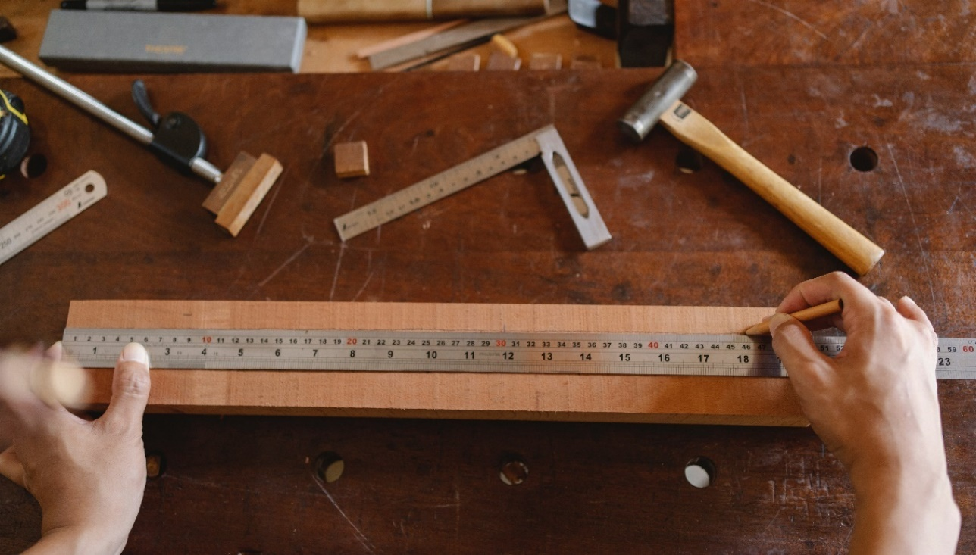

Ākonga/learner Guidelines
ĀKONGA/LEARNER’S INFORMATION
First and last name
NSN number
Date

Use functional numeracy skills in a range of day-to-day contexts
Instructions for the ākonga/learner:
- Do ALL parts of this assessment.
- Ask your assessor if you need help to understand something better.
- Answer in a way that is easiest for you (e.g. iPad computer, cell phone, speaking to your helper, camera).

Conditions of Assessment

- The assessment will be done by the ākonga/learner.
- The assessment will take place over a timeframe set by the assessor.
- Before the assessment tasks, an introduction to the assessment should be given, using the examples provided.
- Assessments must be carried out in situations that are limited in range, repetitive, and familiar and employed within closely defined contexts. They must be conducted in authentic situations that are relevant to the ākonga/learner’s day-to-day living that may include but is not limited to workplace, educational setting or within the community.

Use functional numeracy skills in a range of day-to-day contexts
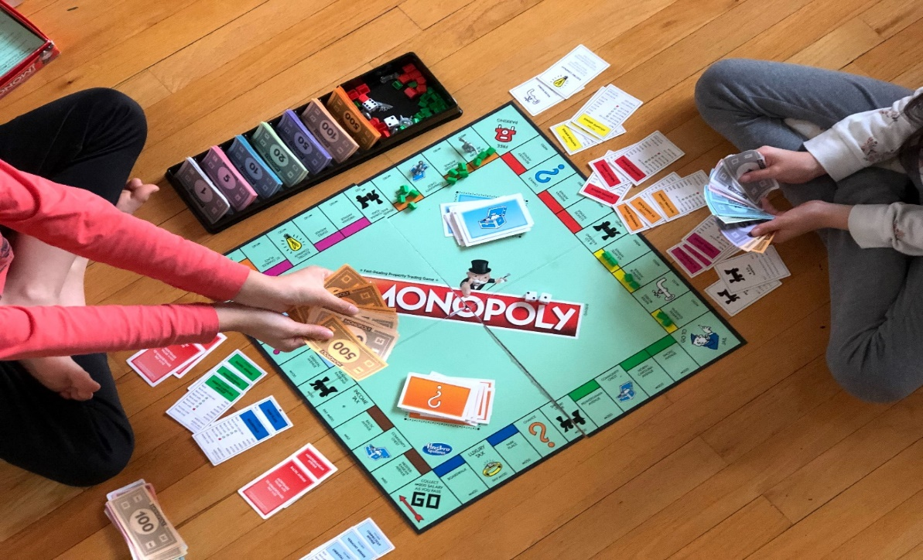

Assessment Task
This assessment task has four parts. You will be asked to apply two numeracy skills in each of the following four contexts:

Assessment Task
Throughout the assessment, you must use the following numeracy skills at least once:
- Number skills (including addition, subtraction, multiplication, and division)

- Measurement
- Time

You can also use the following numeracy skills:
- Statistics
- Sequences
- Comparisons
- Any other valid numeracy skill

Ākonga/learners should ask their teacher to show them examples on how to apply these skills and how to show what they have done.

- Context | - Numeracy Skills |  | - Measurement |  | - Time | - Other
  - Daily life
  - Community
  - Work or education
  - Recreation
  - Other
- Type of calculation |  | - Not a calculation x |  | - A calculation
Numeracy skills:  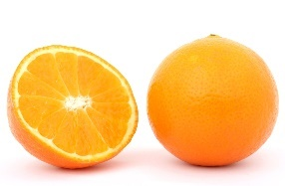 |  | Saying a fact  Example: I bought two oranges for $3. |  | Doing difficult calculations  Example: I bought two oranges for $1.50 each. These cost $3.00 altogether.
Measurement:  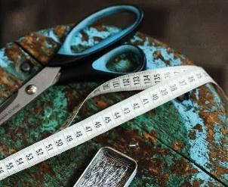 |  | Saying how long or heavy something is  Example: I am 1.58 cm tall. |  | Measuring the length or weight of something  Example: I measured my friend’s height with a tape measure. She is 1.63 cm tall.
Time: 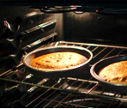 |  | Saying how long it took you to do something  Example: The cake took 45 minutes to bake |  | Calculating how long something took  Example: I started baking a cake at 9:30 and finished at 10:46. It took me 1 hour and 16 minutes to bake the cake.

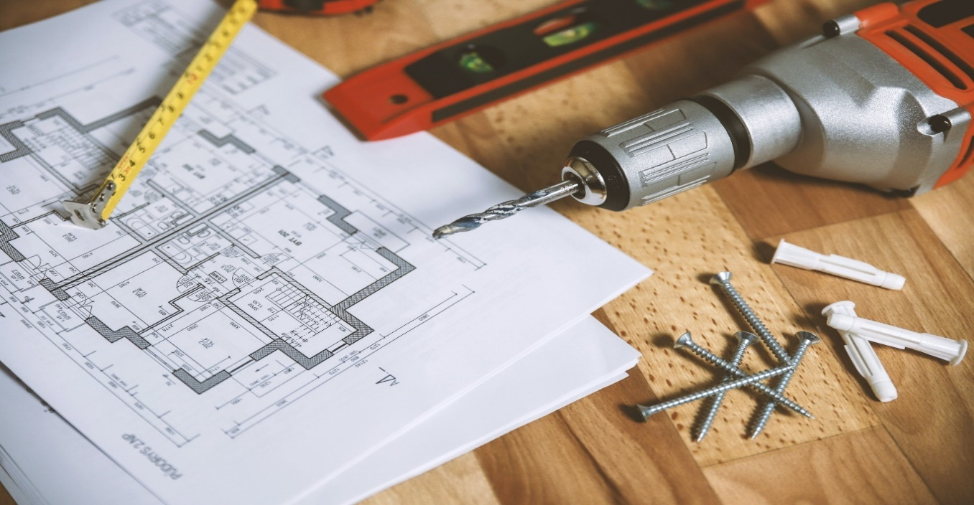

Assessment – Part 1
Use two different numeracy skills to carry out tasks in your daily life. Examples of tasks where you could use numeracy skills in your daily life include:
  Cooking food |   Gardening
  Being on time |   Helping around the house
The ākonga/learner will use the following table to show the skills that they used, and the evidence they provided.
Explain the day-to-day task | Explain the numeracy skill used. You must use the following skills at least once:  - A number skill  - Measurement  - Time | Explain how you provided evidence of using this skill
Task 1:

Task 2:

Assessment – Part 2
Use two different numeracy skills to carry out tasks in the community. Examples of tasks where you could use numeracy skills in the community include:
  Shopping |   Attend a community event, like a parade
  Using transportation, like a train or bus |   Going to restaurants or cafes
The ākonga/learner will use the following table to show the skills that they used, and the evidence they provided.
Explain the day-to-day task | Explain the numeracy skill used. You must use the following skills at least once:  - A number skill  - Measurement  - Time | Explain how you provided evidence of using this skill
Task 1:

Task 2:

Assessment – Part 3
Use two different numeracy skills to carry out tasks at work or your place of study. Examples of tasks where you could use numeracy skills at work, or your place of study include:
  Calculating the cost of something | 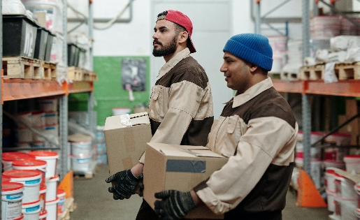  Counting stock
  Calculating how long something will take |   Measuring liquids or other items
The ākonga/learner will use the following table to show the skills that they used, and the evidence they provided.
Explain the day-to-day task | Explain the numeracy skill used. You must use the following skills at least once:  - A number skill  - Measurement  - Time | Explain how you provided evidence of using this skill
Task 1:

Task 2:

Assessment – Part 4
Use two different numeracy skills to carry out tasks during your free time. Examples of tasks where you could use numeracy skills during your free time include:
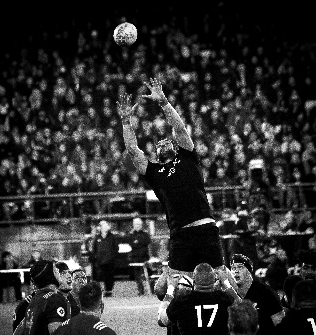  At sports events | 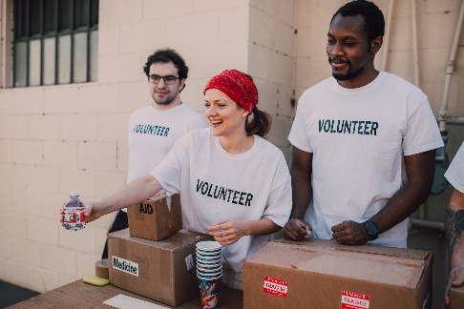  At a community or religious group
  As you are enjoying a hobby, passion, or interest |   When you are with your friends
The ākonga/learner will use the following table to show the skills that they used, and the evidence they provided:
Explain the day-to-day task |  | Explain the numeracy skill used. You must use the following skills at least once:  - A number skill  - Measurement  - Time |  |  | Explain how you provided evidence of using this skill
Task 1:
Task 2:
OUTCOMES AND PERFORMANCE CRITERIA

Outcome 1: Use functional numeracy skills in a range of day-to-day contexts
Range: Numeracy skills must include number (addition, subtraction, multiplication, division), measurement, time; and may include but are not limited to – statistics, sequences, comparisons; contexts may include but are not limited to – daily living activities, community, work, education, recreation.

Performance Criteria:
1.1 - Numeracy skills are applied to carry out day-to-day tasks.
Range: Evidence of two numeracy skills for each of the four different contexts.

ĀKONGA/EVIDENCE - Name:_____________________________
Context 1  Evidence of two numeracy skills. | Context 2  Evidence of two numeracy skills. | Context 3  Evidence of two numeracy skills. | Context 4  Evidence of two numeracy skills. | Assessor Grade

Overall Performance Outcome: Achieved ☐ Not Achieved ☐
  - Assessor’s Attestation:
I confirm the following:
- the ākonga/learner has adequacy of knowledge and performance
- the assessment complied with relevant health and safety, and legislative requirements
- the ākonga/learner’s likely repeatable competence in the future.

Overall comments

Assessor Name: |  |  | Assessor Signature:
Date: |  |  | Position Held:

