Unit standard | 29309
Title | Plan a personal work pathway
Level | 1 | Credits | 4 | Version | 3

Supported Learning Assessment Support Material

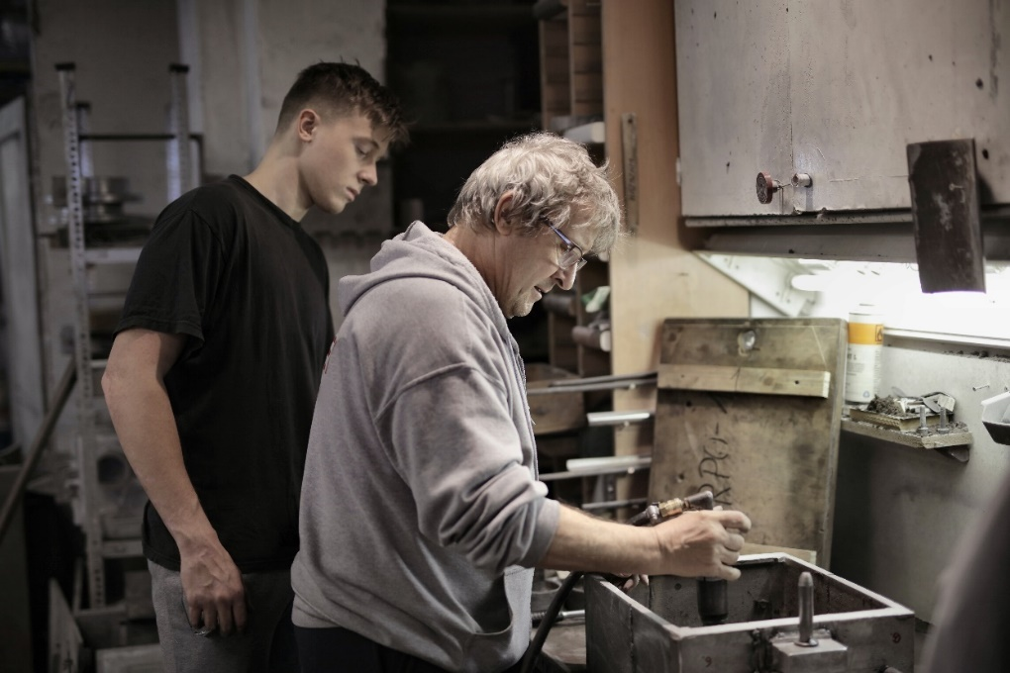

Ākonga/learner guidelines
ĀKONGA/LEARNER’S INFORMATION
First and last name
NSN number
Date

Plan a personal work pathway
Instructions for the ākonga/learner:
- Do ALL parts of this assessment.
- Ask your assessor if you need help to understand something better.
- Answer in a way that is easiest for you (e.g. iPad computer, cell phone, speaking to your helper, camera).

Conditions of Assessment
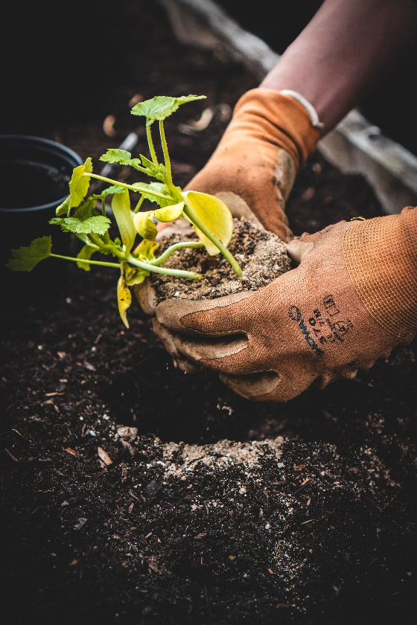
- Part One of the assessment will be done in conjunction with the assessor.
- Parts Two and Three of the assessment will be carried out by the ākonga/learner.
- The assessment will take place over a timeframe set by the assessor.
- Assessments must be carried out in situations that are limited in range, repetitive, and familiar and employed within closely defined contexts. They must be conducted in authentic situations that are relevant to the ākonga/learner ’s day-to-day living that may include but is not limited to workplace, educational setting or within the community.

Plan a personal work pathway



Assessment Task
This assessment task has three parts. You will be asked to:

Assessment – Part 1
- Identify at least two goals that relate to a job that you want to do. This could be:
- a position you want to have at a workplace
- something you want to learn at a workplace; and/or
- tasks you want to do in a workplace.
- Select goals that are:
- realistic and appropriate to who you are
- based on an actual workplace where you want to get a job.

Example:
I want to work on a farm, like my uncle.
I have two main goals:
- Getting permanent work as an assistant on a farm.
- Learning how to drive a quad bike and a tractor.

My workplace goals:
Goal 1

Goal 2:

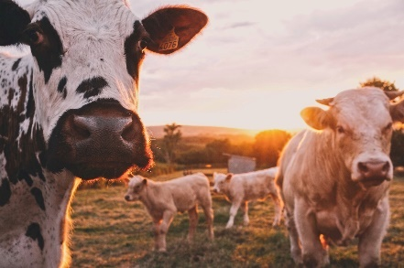

Assessment – Part 2
Do at least three types of research to develop a work pathway for the goals you selected in Part 1.
Write the results of your research in the table below.

- Name: | - Research on work pathway
- Example:  - Type of research 1:  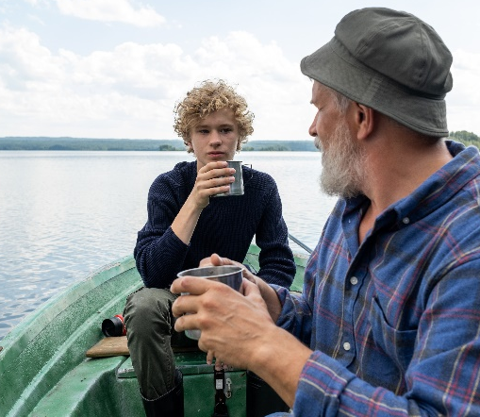  Talking to people face-to-face | - What did you find out from the research that you did?  I decided to talk to my uncle who is a dairy farmer. He said that to work on a farm, I should start of doing part time work on a farm. He said that after a few months of doing part time work, I should have the skills I need to apply for full time work as an assistant.
  - How did the research help you with your work pathway?
I now know that it would be better to do some part time work before I start to look for full time work as a farm assistant. My uncle has said I can do some part time work on his farm.

Type of research 1: | What did you find out from the research that you did?
Type of research 1: | How did the research help you with your work pathway?

Assessment – Part 3
So far, you have:

- selected at least two goals that you want to achieve at a specific workplace
- researched each of these goals related to a job you want to do.

In this part of the assessment, you will need to break down the goals in your work pathway into three or more achievable steps. An achievable step is one that you can do easily.

Complete the following table for each of the goals that you selected in Part 1.

Use the research you did in Part 2 to help you break each goal into achievable steps.

Example:

- Goal: | - Getting permanent work as an assistant on a farm.
Step 1: | Firstly, I will do some volunteer work on my uncle’s farm for the next three months. I will work there every Saturday and Sunday so I can see what working on a dairy farm is like.
Step 2: | Next, I will make a CV. I will include the good qualities that I have and also include that I have worked on a farm for three months.
Step 3: | Lastly, I will apply for jobs using TradeMe Jobs and Seek. I will also ask my uncle if he knows anyone who needs a fulltime farm assistant.

Goal 1:
Step 1:
Step 2
Step 3:

Goal 2:

Step 1:

Step 2:

Step 3:

OUTCOMES AND PERFORMANCE CRITERIA

Outcome 1: Plan a personal work pathway.

Performance criteria:
1.1 - Work place goals are identified in terms of the desired outcomes, realistic and appropriate to ākonga/learner ’s own personal circumstances.

1.2 - Work pathway is informed by research.
Range: Research may include but is not limited to – identification of personal attributes, skills and interest; exploration of aspirations; work experience; onsite visits; internet search, face to face interviews; evidence of three different types of research for two goals.

1.3 - Goals within planned pathway are broken down into achievable steps.
Range: Evidence of at least three steps for each goal identified.

ĀKONGA /LEARNER EVIDENCE - Name:_____________________________
1.1  Workplace goals are identified in terms of the desired outcomes, realistic and appropriate to ākonga/learner ’s own personal circumstances. | 1.2  Work pathway is informed by research.  Research may include but is not limited to – identification of personal attributes, skills and interest; exploration of aspirations; work experience; onsite visits; internet search, face to face interviews;  evidence of three different types of research for two goals. | 1.2  Goals within planned pathway are broken down into achievable steps.  Evidence of at least three steps for each goal. | Assessor Grade

Overall Performance Outcome: Achieved ☐ Not Achieved ☐
  - Assessor’s Attestation:
I confirm the following:
- the ākonga/learner has adequacy of knowledge and performance
- the assessment complied with relevant health and safety, and legislative requirements
- the ākonga/learner’s likely repeatable competence in the future.
Overall comments

Name: |  | Signature:
Date: |  | Position Held:

