Supported Learning Assessment Support Material

Unit standard | 29311
Title | Act in accordance with the basic rights and responsibilities needed for work
Level | 1 | Credits | 8 | Version | 3



Ākonga/learner Guidelines
ĀKONGA/LEARNER’S INFORMATION
First and last name
NSN number
Date

Act in accordance with the basic rights and responsibilities needed for work
Instructions for the ākonga/learner:

- Do ALL parts of this assessment.
- Ask your assessor if you need help to understand something better.
- Answer in a way that is easiest for you (e.g. drawing, recording voice memos, speaking to your helper, taking photos).

Conditions of Assessment

 | - You will complete all parts of the assessment (with support if required).  - Part Two of the assessment will be completed by the workplace supervisor.  - The assessment will take place over a timeframe set by the assessor.  - Assessments should be carried out in situations that are limited in range, repetitive, and familiar and employed within closely defined contexts. They should be conducted in authentic situations that are relevant to the ākonga/learner’s day-to-day living that may include but is not limited to workplace setting or within the community.

Act in accordance with the basic rights and responsibilities needed for work

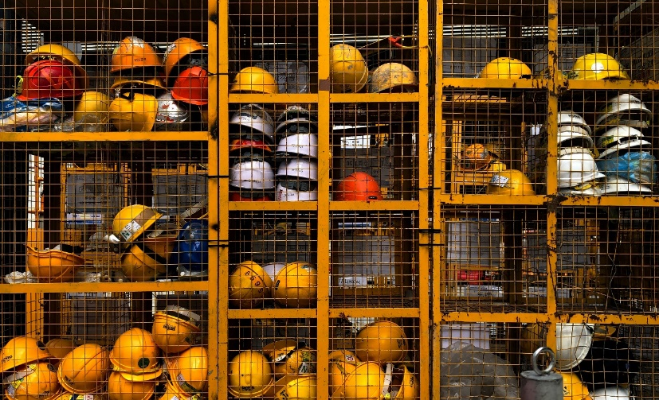

Assessment Task
You will carry out this assessment at your place of work:
- Complete Part 1 and Part 2 on your own (with support if required).
- Your supervisor or manager will need to complete Part 3 with you or for you.

This assessment task has three parts:

Act in accordance with the basic rights and responsibilities needed for work

Assessment – Part 1

For this assessment you need to identify at least four basic employee rights in accordance with the Employment Relations Act 2000 and your employment agreement and you need to demonstrate at least four work responsibilities relevant to your workplace context.
1a. The workplace context should be beyond the school gates and may include but is not limited to – voluntary, community, and paid employment. Please record some information about your place of work and your role:
What is the name of your place of work? What type of organisation is it?
For example: ‘Pete’s Pets’, which is a pet store.

What is your job title or role at work? What kinds of duties do you have?
For example: Customer Service. I have to greet the customers, help them to find what they are looking for, make recommendations, and process payment for their purchases.

What is the name and role of the manager or supervisor who will be your assessor?
For example: Peter Rutherford, Manager ‘Pete’s Pets’.

‘Rights’ are freedoms you are entitled to. Examples of employee rights may include but are not limited to – provision of a safe working environment, induction and support, and fair treatment as an employee. Your rights are protected by law.
‘Work responsibilities’ are expectations the employer has of you as an employee in relation to your role, and in accordance with your employment agreement. Examples of ‘work responsibilities may include but are not limited to – being punctual, explaining absences, following workplace protocol, and being respectful.
These activities are not required to pass the assessment, but to get you started thinking about what we mean by ‘rights’.

1b. Create a poster or collage of the difference between ‘wants’ and ‘needs’. For example, a kitten might be something you would like, but it’s not something you need.

1c. If you were working as a cleaner, what sorts of things might you need and what would you want that wasn’t necessary but would be great to have?

Put a circle around the items that might be needed to work as a house cleaner and put a cross through the items you think are nice to have, but not necessary for the job.








1d. Thinking about your workplace and your job, what are the kinds of ‘wants’ and ‘needs’ you have?

WANTS | NEEDS
For example: your favourite music playing. | For example: equipment and safety gear.

1e. Think about the kinds of ‘rights’ employees have. Share your ideas with a partner.

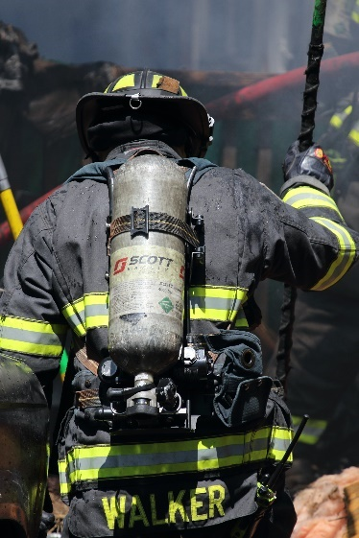





1f. Carry out some research into employee rights and the Employment Relations Act 2000 and note some of the resources used:
e.g. Employment New Zealand Learning Modules https://employment.elearning.ac.nz

1g. What are some of your rights as an employee? Please identify at least four basic employee rights in accordance with the Employment Relations Act 2000 and your employment agreement:

1.
2.
3.
4.

Assessment – Part 2

For this assessment you need to demonstrate at least four work responsibilities relevant to your workplace context.

2a. Think about the sort of responsibilities people might have as employees. Work with a partner or in a small group to brainstorm some of the different kinds of responsibilities employees have that employers might expect.

2b. Circle or highlight below any responsibilities that your employer expects of you in terms of your current role with them:

GET TO WORK ON TIME | ACT IN GOOD FAITH | BE HONEST
WEAR SAFETY GEAR | RESPECT PRIVACY | SAY IF YOU WILL BE AWAY
STAY FOCUSED ON TASK | BEHAVE REASONABLY | WEAR A UNIFORM
BE RESPECTFUL | KEEP OTHERS SAFE | FOLLOW PROCEDURES
2c. For this assessment you need evidence that you have demonstrated at least four responsibilities relevant to your workplace context. Think about what evidence could be collected of your mahi/work.
  Feedback or report from your manager |   Keep a work log, or journal
  Regular reporting to your supervisor |   Photo/video evidence of your mahi/work

2d. Evidence may include a work log, workplace feedback, and/or attestation by the employer. What kind of evidence could be collected to show demonstration of these responsibilities?
Workplace responsibilities | What kind of evidence could be collected for these example skills and expected practices?
Wear the correct PPE (Personal Professional Equipment) safety gear when at work and working. | - Photo or video evidence  - work log or journal  - workplace feedback or report  - something else:  ___________________________________________
Be careful in your mahi (work) so that your work is of a high quality. | - Photo or video evidence  - work log or journal  - workplace feedback or report  - something else:  Positive customer feedback  ___________________________________________
Act in good faith, being honest, having integrity, and working without hidden motives. | - Photo or video evidence  - work log or journal  - workplace feedback or report  - something else:  ___________________________________________
Work the negotiated days and hours (starting and finishing on time and taking breaks as agreed). | - Photo or video evidence  - work log or journal  - workplace feedback or report  - something else:  ___________________________________________

Assessment – Part 3

3a. You now need to discuss and decide with your supervisor or manager which four responsibilities they will look to verify that you have applied in a workplace context. The plan can be recorded here:

To be completed with the supervisor or manager who will verify your mahi/work.
Which responsibilities are going to be assessed? | What evidence will be collected to show you have demonstrated these responsibilities? | Verifier to initial and date to confirm this plan
- photo or video evidence
- work log or journal
- workplace feedback or report
- something else:

- photo or video evidence
- work log or journal
- workplace feedback or report
- something else:

- photo or video evidence
- work log or journal
- workplace feedback or report
- something else:

- photo or video evidence
- work log or journal
- workplace feedback or report
- something else:

Supervisor/manager signature and date: _______________________________________
Employee signature:_______________________________________________________
3b. Your supervisor or manager needs to verify that there is evidence that you have demonstrated at least four agreed workplace responsibilities.

Verification to be completed by the supervisor or manager.
Which workplace responsibilities were assessed? | What evidence will be collected to show these responsibilities were demonstrated? | Verifier to initial and date to confirm responsibilities demonstrated
- photo or video evidence
- work log or journal
- workplace feedback or report
- something else:

- photo or video evidence
- work log or journal
- workplace feedback or report
- something else:

- photo or video evidence
- work log or journal
- workplace feedback or report
- something else:

- photo or video evidence
- work log or journal
- workplace feedback or report
- something else:

Supervisor or manager to sign:
I verify that there is evidence of at least four responsibilities have been demonstrated in the workplace context.

Supervisor or manager signature and date: _____________________________________
Employee signature:___________________________________
OUTCOMES AND PERFORMANCE CRITERIA

Outcome 1: Act in accordance with the basic rights and responsibilities needed for work.

Performance criteria:
  - Basic employee rights are identified in accordance with the Employment Relations Act 2000 and employment agreement. Range may include but are not limited to – provision of a safe working environment, induction and support, fair treatment of employees; four rights are identified.

1.2 Work responsibilities demonstrated are relevant to the specific workplace and in accordance with the basic rights of an employee. Range responsibilities may include but are not limited to – being punctual, explaining absences, following workplace protocol; four responsibilities are demonstrated.

ĀKONGA/LEARNER EVIDENCE - Name: _____________________________________

At least four basic employee rights have been identified in accordance with the Employment Relations Act 2000 and employment agreement. | At least four work responsibilities relevant to the specific workplace and in accordance with the basic rights of an employee, have been demonstrated.
Achieved ☐ Not Achieved ☐ | Achieved ☐ Not Achieved ☐

Overall Performance Outcome: Achieved ☐ Not Achieved ☐
Assessor’s Attestation:
I confirm the following:
- the ākonga/learner has adequacy of knowledge and performance.
- the assessment complied with relevant health and safety, and legislative requirements.
- the ākonga/learner’s likely repeatable competence in the future.
Overall comments

Name: |  | Signature:
Date: |  | Position Held:

