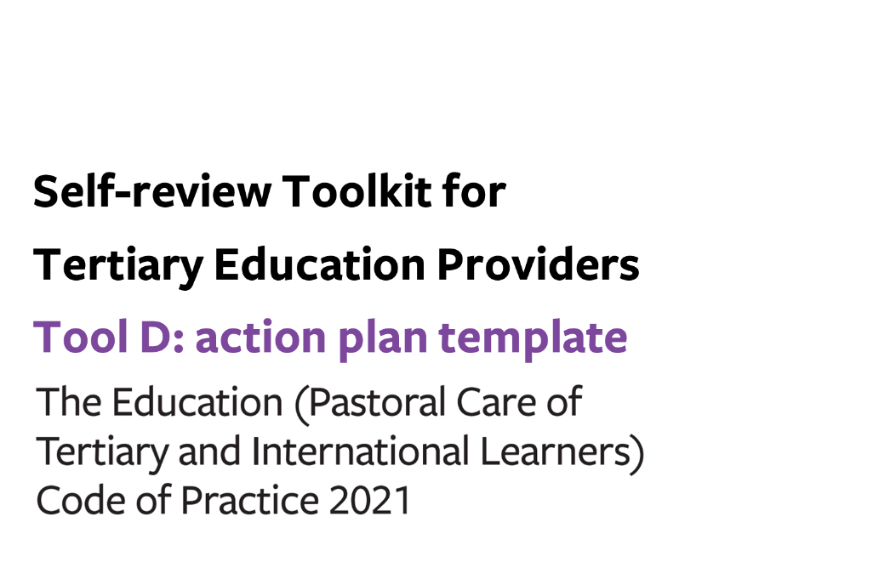


Tool D: action plan template (the Code)

For the period: DD/MM/YYYY to DD/MM/YYYY
- Based on our analysis, what do we need to do differently in the coming year?
- Who is responsible for implementing the planned next steps, and by when?
- How will we monitor our plan to ensure that it is implemented?
- How will we know that the actions we took were successful?

If your organisation does not provide student accommodation and/or is not a Code signatory, remove the parts in this tool relating to Student Accommodation (Outcomes 5-7) and/or International Learners (Outcomes 8-12).

Organisational structures to support a whole-of-provider approach to learner wellbeing and safety

 | Action/s to be taken | Owner | Due date | Plan for monitoring implementation | Measures of success
Outcome 1:
A learner wellbeing and safety system
Outcome 2:
Learner voice

Wellbeing and safety practices for all tertiary providers

 | Action/s to be taken | Owner | Due date | Plan for monitoring implementation | Measures of success
Outcome 3:
Safe, inclusive, supportive, and
accessible physical and digital learning environments
Outcome 4: Learners are safe and well

Additional wellbeing and safety practices in tertiary student accommodation (in relation to domestic and international tertiary learners)
 | Action/s to be taken | Owner | Due date | Plan for monitoring implementation | Measures of success
Outcome 5:
A positive, supportive and inclusive
environment in student accommodation
Outcome 6: Accommodation administrative
practices and contracts

Outcome 7:
Student accommodation facilities and services

Additional wellbeing and safety practices for tertiary providers (signatories) enrolling international learners

 | Action/s to be taken | Owner | Due date | Plan for monitoring implementation | Measures of success
Outcome 8:
Responding to the distinct wellbeing and
safety needs of international tertiary learners

Outcome 9:
Prospective international tertiary
learners are well informed

Outcome 10:
Offer, enrolment, contracts, insurance and visa
Outcome 11: International learners receive appropriate
orientations, information and advice
Outcome 12:
Safety and appropriate supervision of
international tertiary learners

