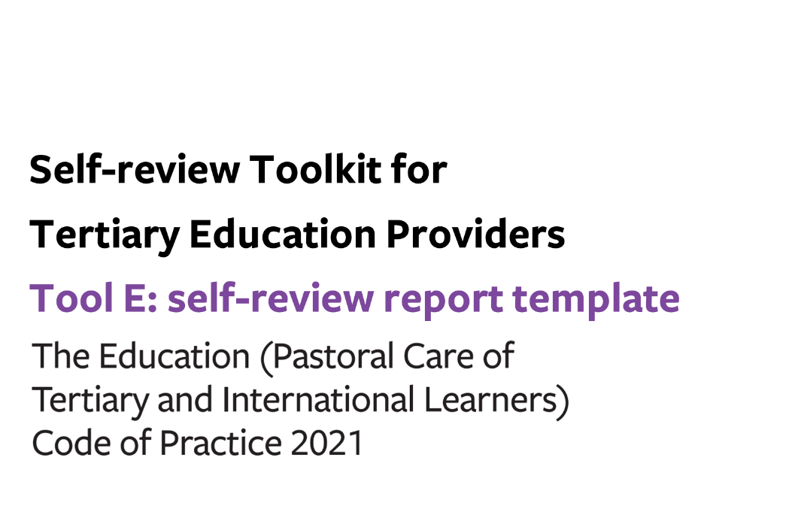


Tool E: self-review report template
Use this optional template to shape your summary self-review report on your self-review of performance against the requirements of the Code.
If your organisation does not provide student accommodation and/or is not a Code signatory, remove the parts in this tool relating to Student Accommodation (Outcomes 5-7) and/or International Tertiary Learners (Outcomes 8-12).

TEO information
TEO Name |  |  |  |  | MoE number
Code contact | Name |  |  |  | Job title
 | Email |  |  |  | Phone number
Current enrolments | Domestic learners |  | Total # | # |  | 18 y/o or older |  | #
 |  |  | Total # |  |  | Under 18 y/o |  | #
 | International learners |  | Total # | # |  | 18 y/o or older |  | #
 |  |  | Total # |  |  | Under 18 y/o |  | #
Current residents | Domestic learners |  | Total # | # |  | 18 y/o or older |  | #
 |  |  | Total # |  |  | Under 18 y/o |  | #
 | International learners |  | Total # | # |  | 18 y/o or older |  | #
 |  |  | Total # |  |  | Under 18 y/o |  | #
Report author(s)

Stage of implementation for each outcome
Indicate the stage of implementation that most reflects your organisation’s current level of understanding and practice for each outcome, based on the continuum provided in Appendix 1.
Organisational structures to support a whole-of-provider approach to learner wellbeing and safety
 | Rating
Outcome 1:  A learner wellbeing and safety system | Well implemented / Implemented / Developing / Early stages
Outcome 2:  Learner voice | Well implemented / Implemented / Developing / Early stages
Wellbeing and safety practices for all tertiary providers
 | Rating
Outcome 3:  Safe, inclusive, supportive, and accessible physical and digital learning environments | Well implemented / Implemented / Developing / Early stages
Outcome 4:  Learners are safe and well | Well implemented / Implemented / Developing / Early stages

Additional wellbeing and safety practices in tertiary student accommodation (in relation to domestic and international tertiary learners)

 | Rating
Outcome 5:  A positive, supportive and inclusive environment in student accommodation | Well implemented / Implemented / Developing / Early stages
Outcome 6:  Accommodation administrative practices and contracts | Well implemented / Implemented / Developing / Early stages
Outcome 7:  Student accommodation facilities and services | Well implemented / Implemented / Developing / Early stages

Additional wellbeing and safety practices for tertiary providers (signatories) enrolling international learners

 | Rating
Outcome 8:  Responding to the distinct wellbeing and safety needs of international tertiary learners | Well implemented / Implemented / Developing / Early stages
Outcome 9:  Prospective international tertiary learners are well informed | Well implemented / Implemented / Developing / Early stages
Outcome 10:  Offer, enrolment, contracts, insurance and visa | Well implemented / Implemented / Developing / Early stages
Outcome 11:  International learners receive appropriate orientations, information and advice | Well implemented / Implemented / Developing / Early stages
Outcome 12:  Safety and appropriate supervision of international tertiary learners | Well implemented / Implemented / Developing / Early stages

Summary of performance under each outcome

Organisational structures to support a whole-of-provider approach to learner wellbeing and safety
 | Summary of performance based on gathered information (i.e. how effectively is your organisation doing what it needs to be doing?) | How do you know? (i.e. note supporting evidence with analysis to make sense of what it means)
Outcome 1:
A learner wellbeing and safety system

Outcome 2:
Learner voice

Wellbeing and safety practices for all tertiary providers
 | Summary of performance based on gathered information (i.e. how effectively is your organisation doing what it needs to be doing?) | How do you know? (i.e. note supporting evidence with analysis to make sense of what it means)
Outcome 3:
Safe, inclusive, supportive, and accessible physical and digital learning environments

Outcome 4:
Learners are safe and well

Additional wellbeing and safety practices in tertiary student accommodation (in relation to domestic and international tertiary learners)
 | Summary of performance based on gathered information (i.e. how effectively is your organisation doing what it needs to be doing?) | How do you know? (i.e. note supporting evidence with analysis to make sense of what it means)
Outcome 5:
A positive, supportive and inclusive environment in student accommodation

Outcome 6: Accommodation administrative practices and contracts

Outcome 7:
Student accommodation facilities and services

Additional wellbeing and safety practices for tertiary providers (signatories) enrolling international learners
 | Summary of performance based on gathered information (i.e. how effectively is your organisation doing what it needs to be doing?) | How do you know? (i.e. note supporting evidence with analysis to make sense of what it means)
Outcome 8:
Responding to the distinct wellbeing and safety needs of international tertiary learners

Outcome 9:
Prospective international tertiary learners are well informed

Outcome 10:
Offer, enrolment, contracts, insurance and visa

Outcome 11: International learners receive appropriate orientations, information and advice

Outcome 12:
Safety and appropriate supervision of international tertiary learners

Findings from gap analysis of compliance with key required processes

Organisational structures to support a whole-of-provider approach to learner wellbeing and safety
Identified gaps in compliance with key required processes
Outcome 1:
A learner wellbeing and safety system

Outcome 2: Learner voice

Wellbeing and safety practices for all tertiary providers
Identified gaps in compliance with key required processes
Outcome 3:
Safe, inclusive, supportive, and accessible physical and digital learning environments

Outcome 4: Learners are safe and well

Additional wellbeing and safety practices in tertiary student accommodation (in relation to domestic and international tertiary learners)
Identified gaps in compliance with key required processes
Outcome 5:
A positive, supportive and inclusive environment in student accommodation

Outcome 6: Accommodation administrative practices and contracts

Outcome 7: Student accommodation facilities and services

Additional wellbeing and safety practices for tertiary providers (signatories) enrolling international learners
Identified gaps in compliance with key required processes
Outcome 8: Responding to the distinct wellbeing and safety needs of international tertiary learners

Outcome 9: Prospective international tertiary learners are well informed

Outcome 10: Offer, enrolment, contracts, insurance and visa

Outcome 11: International learners receive appropriate orientations, information and advice

Outcome 12: Safety and appropriate supervision of international tertiary learners

Summary of action plan
Include information on how actions will be monitored for implementation and success.
Organisational structures to support a whole-of-provider approach to learner wellbeing and safety
 | Action/s to be taken | Owner | Due date | Plan for monitoring implementation | Measures of success
Outcome 1:
A learner wellbeing and safety system

Outcome 2:
Learner voice

Wellbeing and safety practices for all tertiary providers
 | Action/s to be taken | Owner | Due date | Plan for monitoring implementation | Measures of success
Outcome 3:
Safe, inclusive, supportive, and accessible physical and digital learning environments

Outcome 4:
Learners are safe and well

Additional wellbeing and safety practices in tertiary student accommodation (in relation to domestic and international tertiary learners)
 | Action/s to be taken | Owner | Due date | Plan for monitoring implementation | Measures of success
Outcome 5:
A positive, supportive and inclusive environment in student accommodation

Outcome 6: Accommodation administrative practices and contracts

Outcome 7:
Student accommodation facilities and services

Additional wellbeing and safety practices for tertiary providers (signatories) enrolling international learners

 | Action/s to be taken | Owner | Due date | Plan for monitoring implementation | Measures of success
Outcome 8:
Responding to the distinct wellbeing and safety needs of international tertiary learners

Outcome 9:
Prospective international tertiary learners are well informed

Outcome 10:
Offer, enrolment, contracts, insurance and visa

Outcome 11:
International learners receive appropriate orientations, information and advice

Outcome 12:
Safety and appropriate supervision of international tertiary learners

